

Case Report

A Rare Case Report of Synchronous Gastric Cancer and Jejunal Gastrointestinal Stromal Tumor

Utpal Baruah*, Biswajit Deuri, Mayank Pahwa, Sheshank Kumar
Department of General Surgery, Nemcare super speciality hospital Guwahati, Assam, India

*Corresponding Author: Utpal Baruah, Department of General Surgery, Nemcare super speciality hospital Guwahati, Assam, India

Received: 26 April 2026; Accepted: 04 May 2026; Published: 22 May 2026

Citation: Utpal Baruah, Biswajit deuri, Mayank Pahwa, Sheshank Kumar. A Rare Case Report of Synchronous Gastric Cancer and Jejunal Gastrointestinal Stromal Tumor. Journal of Surgery and Research 9 (2026): 182-184.

Abstract
Mucinous adenocarcinoma of stomach and synchronous jejunal gist is a rare entity and here we present a case of 63 year old female with mucinous gastric adenocarcinoma in antropyloric region of stomach and gastrointestinal stromal tumor at proximal jejunum just distal to duodenojejunal flexure and the complexity faced in surgical management of the above case.

Keywords: Synchoronous; Jejunal GIST; Mucinous adenocarcinlma of stomach

Introduction
Histologically, human GC can be mainly divided into well differentiated (intestinal) and poorly differentiated (diffuse) types according to the presence or absence of tubular tissues [1]. In brief, the well differentiated carcinomas contain papillary, well-differentiated, and moderatelydifferentiated subtypes. While, the poorly differentiated carcinomas include mucinous, signet ring cell, poor-differentiated and undifferentiated subtypes. Mucinous gastric carcinoma (MGC) is a specific subtype of poorly differentiated gastric carcinoma [2]. The incidence of GISTs in the alimentary tract is very low (2 in 100,000) and is about 1% of all gastrointestinal (GI) malignancies [3]. However, jejunal GIST is extremely rare, accounting for 0.1-3% of all GI tumors [4]. The synchronous occurrence of mesenchymal tumors and other primary gastrointestinal malignancies has been rarely reported in the literature [1,2].

Case Presentation
A 63 year old female presented with pain in epigastric region since 9 months usually after intake of food, decreased apetite and ocassional watery vomiting episodes there was no history of hematemesis jaundice weight loss or altered bowel habits she is k/c/o hypertension since 10 years, no significant family history ,Initially she underwent cect abdomen which showed thickening involving antrum of stomach length of involvement 5.9cm, maximum thickness 13mm,and a hetrogenous enhancing mass in proximal jejunum 41mm×44mm,upper gi endoscopy large ulcerative lesion with slough at base figure (a) , PET scan showed hypermetabolic nodular wall thickening in antropyloric region suggestive of ca stomach and hypermetabolic mass in proximal jejunum suggestive of gist d/d metastatic deposits figure (b)

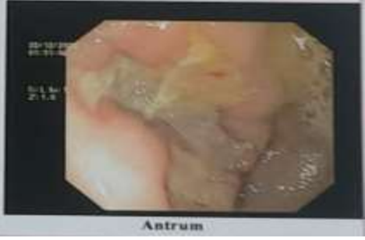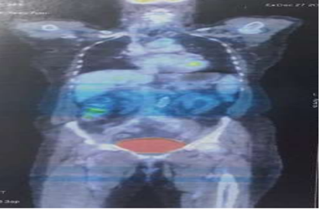
- (b)
Ulceroproliferatrive growth 5×3 cm in pylorus serosa figure (c), perigastric lymphadenopathy , no evidence of distant metastasis , large mass in proximal jejunum 6×4 cm 2-3 cm from dudenojejunal flexure figure (d) ,Patient underwent diagnostic laprascopy with lap assisted D2 gastrectomy , excision of proximal jejunal GIST , duodenojejunostomy , roux en y gastrojejunostomy Histologically gastric growth showed mucinous carcinoma involving subserosal connective tissue 11/12 gastric lymph nodes showed metastatic deposits pathological staging pT3 N3a figure (e) Jejunal growth shows spindle cell tumour located outside muscle wall of jejunum , immunohistochemistry showed ckit positive, DOG1 positive figure (f)

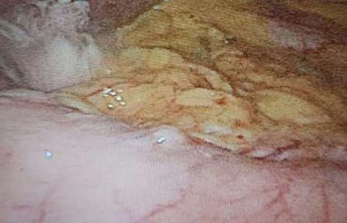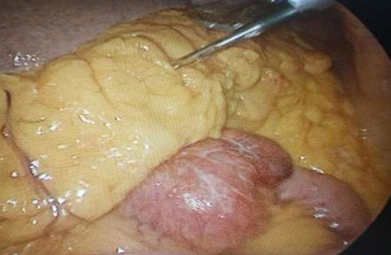
(c) (d)

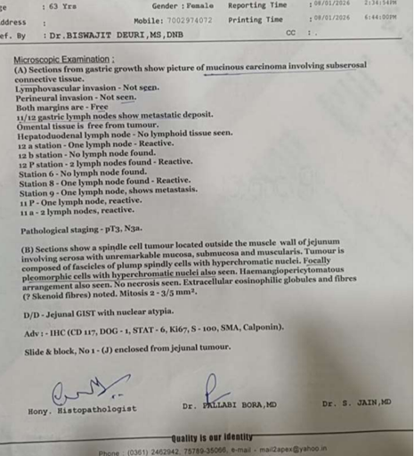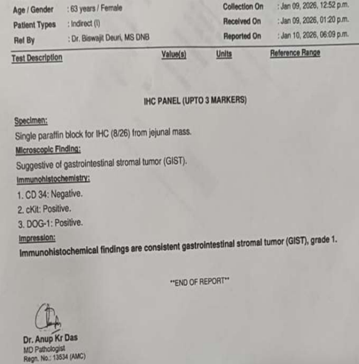
(e) (f)
Discussion
GISTs are rare tumors with an estimated incidence of 1.5/100,000/year. This only covers the clinically relevant GISTs, since it is likely that a much higher number of microscopic lesions could be found pathologically, if looked for [5]. Statistically, GISTs are most common in the stomach (60-84.8%), followed by small intestine (10.5 30%), colon and rectum (3.5-5%), and esophagus (1.2-5%) [16,17]. The most important manifestation of stromal tumors is their indolent, slow growing nature, As per the literature, jejunal GISTs are the rarest among all types of GISTs [4] Mucinous gastric carcinoma (MGC) is also a rare histological subtype of undifferentiated gastric carcinoma, accounting for 2.6–6.6% of all gastric cancer cases [6-10], so simulatenous occurrence of jejunal gist and mucinous gastric carcinoma makes it even rarer Entity,Synchronous occurrence of a GIST with a tumor of different histogenesis is very rare and has been documented in the literature mainly in case reports. GISTs have been reported to occur synchronously with colon adenocarcinoma, gastric cancer, lymphoma and carcinoid [11-13]. In our case the gist was in proximal jejunum 6×4 cm 2-3 cm from dudenojejunal flexure which posed a difficulty in construction of biliopancreatic limb patient underwent excision of gist with duodenojejunostomy with jejunum being ananstamosed with 3 rd part of Duodenum ,for gastric cancer part patient underwent D2 gastrectomy with roux en y gastrojejunostomy At present, the etiology of Gastric cancer co-occurrence with GIST is unclear. Some researchers believe that it is an accidental phenomenon [11-14], and others believe that several unknown carcinogens induce simultaneous proliferation and tumorigenesis of epithelial and stromal cells, such as gene mutation, nitrite, and Helicobacter pylori [3-12]. Through next-generation sequencing, Liu et al. [15] detected that GC and GIST had significantly different gene mutations at the molecular level (TP53 and KIT gene mutations, respectively). Some researchers have hypothesized that there might be a field effect, with etiological cofactors leading to these two lesions [16]. Based on the high correlation between clinical and microscopic GIST and GC, it is believed that GC and GIST may be affected by the same unknown carcinogen, resulting in the simultaneous proliferation of epithelial and stromal cells.For patients with synchronously occurring GC and GIST, studies have shown that regardless of the Fletcher grade of GIST, GC is the main factor affecting the prognosis[17-19].

References
- Cheng L, Wang P, Yang S, et al. Identification of genes with a correlation between copy number and expression in gastric cancer. BMC Med Genomics 5 (2012): 14.
- Choi MG, Sung CO, Noh JH, et al. Mucinous gastric cancer presents with more advanced tumor stage and weaker beta-catenin expression than nonmucinous cancer. Ann Surg Oncol 17 (2010): 3053-3058.
- Joensuu H. Gastrointestinal stromal tumor (GIST) Ann Oncol 17 (2006): 280-286.
- Kramer K, Siech M, Sträter J, et al. [GI hemorrhage with fulminant shock induced by jejunal gastrointestinal stromal tumor (GIST) coincident with duodenal neuroendocrine carcinoma (NET) + neurofibromatosis (NF)-case report and review of the literature] Z Gastroenterol 43 (2005): 281-288.
- Casali PG, Blay JY, ESMO/CONTICANET/EUROBONET Consensus Panel of Experts Gastrointestinal stromal tumours: ESMO Clinical Practice Guidelines for diagnosis, treatment and follow-up. Ann Oncol 21 (2010): 98-102.
- Kunisaki C, Akiyama H, Nomura M, et al. Clinicopathologic characteristics and surgical outcomes of mucinous gastric carcinoma. Ann Surg Oncol 13 (2006): 836-842.
- Kawamura H, Kondo Y, Osawa S, et al. A clinicopathologic study of mucinous adenocarcinoma of the stomach. Gastric Cancer 4 (2001): 83-86.
- Zhang M, Zhu GY, Zhang HF, et al. Clinicopathologic characteristics and prognosis of mucinous gastric carcinoma. J Surg Oncol 102 (2010): 64-67.
- Adachi Y, Mori M, Kido A, et al. A clinicopathologic study of mucinous gastric carcinoma. Cancer 69 (1992): 866-871.
- Hyung WJ, Noh SH, Shin DW, et al. Clinicopathologic characteristics of mucinous gastric adenocarcinoma. Yonsei Med J 40 (1999): 99-106.
- Wronski M, Ziarkiewicz-Wroblewska B, Gornicka B, et al. Synchronous occurrence of gastrointestinal stromal tumors and other primary gastrointestinal neoplasms. World J Gastroenterol 12 (2006): 5360-5362.
- Kaffes A, Hughes L, Hollinshead J, et al. Synchronous primary adenocarcinoma, mucosaassociated lymphoid tissue lymphoma and a stromal tumor in a Helicobacter pylori-infected stomach. J Gastroenterol Hepatol 17 (2002):1033-1036.
- Usui M, Matsuda S, Suzuki H, et al. Somatostatinoma of the papilla of Vater with multiple gastrointestinal stromal tumors in a patient with von Recklinghausen's disease. J Gastroenterol 11 (2002): 947-953.
- Maiorana A, Fante R, Maria Cesinaro A, et al. Synchronous occurrence of epithelial and stromal tumors in the stomach: a report of 6 cases. Arch Pathol Lab Med 124 (2000): 682-686.
- Liu S, Liu H, Dong Y, et al. Gastric carcinoma with a gastrointestinal stromal tumor - A case report and literature review. Med Sci (Paris) 34 (2018):15-19
- Almaça J, Tian Y, Aldehni F, et al. TMEM16 proteins produce volume-regulated chloride currents that are reduced in mice lacking TMEM16A. J Biol Chem 284 (2009): 28571-28578.
- Lee FY, Jan YJ, Wang J, et al. Synchronous gastric gastrointestinal stromal tumor and signet-ring cell adenocarcinoma: a case report. Int J Surg Pathol 15 (2007): 397-400.
- Lin M, Lin JX, Huang CM, et al. Prognostic analysis of gastric gastrointestinal stromal tumor with synchronous gastric cancer. World J Surg Oncol 31 (2014): 12-25.
- Fletcher CD, Berman JJ, Corless C, et al. Diagnosis of gastrointestinal stromal tumors: A consensus approach. Hum Pathol 33 (2002): 459-465.
- Lin YL, Tzeng JE, Wei CK, et al. Small gastrointestinal stromal tumor concomitant with early gastric cancer: a case report. World J Gastroenterol 12 (2006): 815-817.
- Hasegawa T, Matsuno Y, Shimoda T, et al. Gastrointestinal stromal tumor: consistent CD117 immunostaining for diagnosis, and prognostic classification based on tumor size and MIB-1 grade. Hum Pathol 33 (2002): 669-676.
- Miettinen M, Lasota J. Gastrointestinal stromal tumors--definition, clinical, histological, immunohistochemical, and molecular genetic features and differential diagnosis. Virchows Arch 438 (2001): 1-12.
- Hyung WJ, Noh SH, Shin DW, et al. Clinicopathologic characteristics of mucinous gastric adenocarcinoma. Yonsei Med J 40 (1999): 99-106.


This article is an open access article distributed under the terms and conditions of the Creative Commons Attribution (CC-BY) license 4.0

