

Case Report

ALK-Positive Inflammatory Myofibroblastic Tumor of the Proximal Tibia Mimicking Metastatic Osteosarcoma: A Case Report

Amara Ahmed*, Diego A L Garcia

University of Florida, Department of Radiology, Gainesville, FL, USA

*Corresponding Author: Amara Ahmed, University of Florida, Department of Radiology, Gainesville, FL, USA

Received: 07 March 2026; Accepted: 09 March 2026; Published: 18 March 2026

Citation: Amara Ahmed*, Diego A L Garcia. ALK-Positive Inflammatory Myofibroblastic Tumor of the Proximal Tibia Mimicking Metastatic Osteosarcoma: A Case Report. Journal of Radiology and Clinical Imaging 9 (2026): 25-28.

Abstract
Inflammatory myofibroblastic tumor (IMT) is a rare mesenchymal neoplasm of intermediate biologic potential, most commonly arising in the lung but capable of occurring at extrapulmonary sites. Primary osseous involvement is rare and may radiographically simulate high-grade sarcoma. We report the case of a 19-year-old male presenting with progressive left knee pain and swelling. Imaging demonstrated an aggressive proximal tibial lesion with cortical destruction, periosteal reaction, suspected osteoid-type matrix mineralization, and soft-tissue extension. Systemic staging revealed bilateral pulmonary nodules and thoracic and lumbar vertebral lesions, highly suspicious for metastatic osteosarcoma. Core needle biopsy with immunohistochemistry and fluorescence in situ hybridization confirmed ALK-positive inflammatory myofibroblastic tumor. During follow-up, the patient developed a secondary pathologic avulsion fracture of the tibial tuberosity due to tumor-related structural weakening. This case highlights the importance of histopathologic and molecular confirmation prior to definitive oncologic therapy in aggressive-appearing bone tumors.

Keywords: Inflammatory myofibroblastic tumor; ALK; Osteosarcoma mimic; Bone tumor

1. Introduction
Inflammatory myofibroblastic tumor (IMT) is classified by the World Health Organization as a tumor of intermediate biologic potential due to its risk of local recurrence and rare metastatic spread [1–3]. Approximately 50–60% of IMTs harbor rearrangements involving the anaplastic lymphoma kinase (ALK) gene, while others demonstrate ROS1, NTRK, or related kinase fusions [4,5]. Although initially described in the lung, IMT has been reported in nearly every anatomic location. Primary involvement of bone is rare and incompletely characterized in radiologic literature. When arising in bone, IMT may demonstrate aggressive imaging features including cortical destruction, periosteal reaction, and soft-tissue extension, closely simulating high-grade sarcoma. We present a case of ALK-positive IMT of the proximal tibia with synchronous pulmonary and vertebral lesions at presentation, radiographically mimicking metastatic osteosarcoma.

2. Case Presentation
A 19-year-old male presented with a three-week history of progressive left knee pain and swelling. There were no history of significant trauma and no constitutional symptoms. Physical examination demonstrated focal tenderness over the anterior proximal tibia and mild limitation of knee flexion and extension. Radiographs revealed an aggressive lesion centered in the proximal tibia extending from the epiphysis through the metaphysis into the proximal diaphysis (figure 1). Imaging demonstrated cortical destruction, aggressive periosteal reaction, and a mixed lytic lesion with areas suggestive of osteoid-type matrix mineralization.

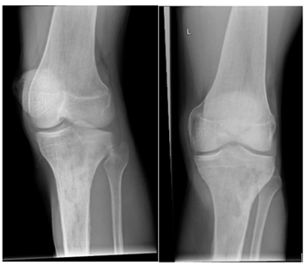

Figure 1: Anteroposterior radiograph of the left knee demonstrating a mixed permeative lesion involving the proximal tibia, with interspersed sclerotic areas. There is associated irregular periosteal reaction along the proximal diaphysis, more conspicuous along the lateral aspect. The imaging appearance is consistent with an aggressive primary bone lesion.

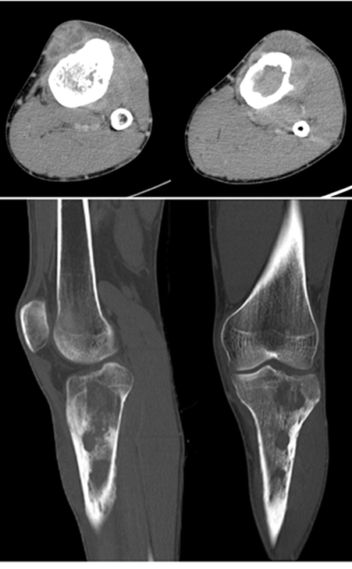

Figure 2: Axial, sagittal, and coronal CT images of the left proximal tibia demonstrating a mixed lytic–sclerotic permeative lesion with better delineation of sclerotic areas along the lateral tibial margin. Irregular periosteal reaction is more clearly visualized. A large extra-osseous soft-tissue component is identified, predominantly along the anterior aspect of the proximal tibia.

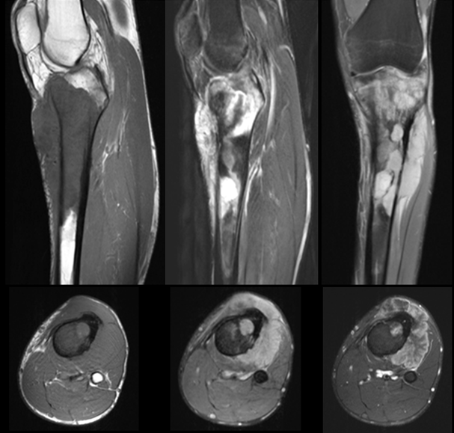
Figure 3: MRI of the left knee. T1-weighted images demonstrate low signal intensity within the proximal tibial marrow. T2-weighted images show heterogeneous intermediate-to-high signal intensity with an extensive extra-osseous soft-tissue component. Post-contrast T1-weighted images demonstrate heterogeneous enhancement of both the intraosseous lesion and associated soft-tissue mass, reflecting aggressive tumor infiltration.

Magnetic resonance imaging demonstrated a heterogeneously enhancing intramedullary mass replacing marrow from the epiphysis to the proximal diaphysis (figure 3). There was cortical disruption, a prominent anterior soft-tissue component, surrounding marrow edema, and involvement of the patellar tendon insertion.

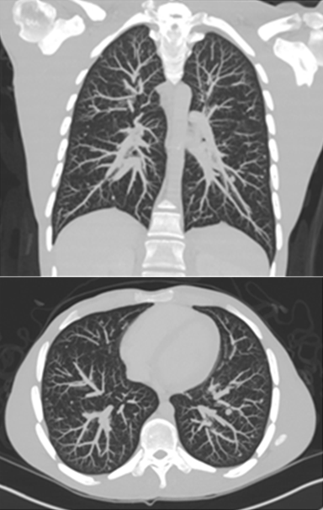

Figure 4: Contrast-enhanced chest CT (axial and coronal views) demonstrating multiple bilateral pulmonary nodules of varying sizes, consistent with multifocal systemic involvement.

Contrast-enhanced chest CT demonstrated multiple bilateral pulmonary nodules of varying size (figure 4). FDG PET/CT revealed hypermetabolic pulmonary nodules and additional lesions involving thoracic and lumbar vertebral bodies. These findings strongly suggest metastatic high-grade osteosarcoma.

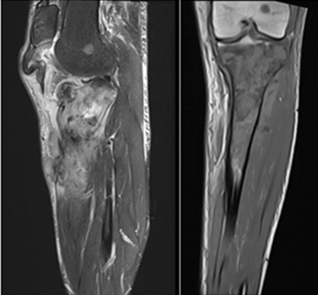

Figure 5: Follow-up MRI demonstrating late complication with pathologic avulsion fracture of the anterior tibial tuberosity secondary to tumor-related structural weakening. A new lesion is also noted in the lateral femoral condyle, raising concern for disease progression.

Core needle biopsy revealed spindle cell proliferation arranged in fascicles within a collagenous stroma accompanied by dense inflammatory infiltrates composed predominantly of lymphocytes and plasma cells. Immunohistochemistry demonstrated diffuse ALK positivity. Fluorescence in situ hybridization confirmed ALK (2p23) rearrangement, establishing the diagnosis of inflammatory myofibroblastic tumor.
Following diagnosis, systemic therapy was initiated. During follow-up, the patient developed acute loss of active knee extension secondary to a pathologic avulsion fracture of the tibial tuberosity attributed to tumor-related structural weakening at the patellar tendon insertion (figure 5). A new lesion was also noted in the lateral femoral condyle, raising concern for disease progression.

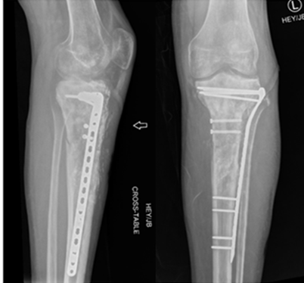
Figure 6: Postoperative radiograph demonstrating resection and fixation of the tibial tuberosity using two screws, in association with prophylactic lateral side-plate construct stabilization. Areas of mineralization are noted within the residual soft-tissue component, likely related to post-treatment changes following adjuvant radiotherapy.

The patient subsequently underwent resection and fixation of the tibial tuberosity (figure 6).

3. Discussion
Primary osseous inflammatory myofibroblastic tumor (IMT) is rare and may present with imaging characteristics that closely simulate high-grade primary bone sarcoma. In adolescents and young adults, an aggressive metaphyseal lesion demonstrating cortical destruction, periosteal reaction, soft-tissue extension, and pulmonary nodules strongly suggest metastatic osteosarcoma. This case highlights how ALK-positive IMT can replicate these radiologic features, creating a substantial diagnostic challenge. High-grade conventional osteosarcoma was the leading initial consideration. Osteosarcoma most commonly arises in the metaphysis of long bones in adolescents and young adults and is characterized radiographically by malignant osteoid matrix production. This typically appears as dense, cloud-like or amorphous ossification, often accompanied by aggressive spiculated periosteal reaction and a large soft-tissue mass. Pulmonary metastases are common at presentation, and skeletal metastases may occur in advanced disease [6]. In the present case, the suspected osteoid-type matrix mineralization within the proximal tibial lesion, in conjunction with bilateral pulmonary nodules and vertebral lesions, strongly favored metastatic osteosarcoma on initial imaging assessment. However, important distinctions exist. IMT-associated mineralization is generally reactive or dystrophic rather than true malignant osteoid production. Consequently, matrix mineralization may appear less dense, less confluent, and less exuberant than that typically seen in osteosarcoma. The mineralization observed in this case lacked the classic robust cloud-like morphology of malignant osteoid. Additionally, although IMT is often solitary, ALK-positive variants may demonstrate synchronous pulmonary and extrapulmonary involvement. Pulmonary IMT lesions may lack the calcified nodular appearance sometimes seen in osteosarcoma metastases and may show variable FDG uptake reflecting inflammatory cellular activity rather than highly proliferative malignant tissue. Nonetheless, FDG PET/CT findings remain nonspecific and cannot reliably distinguish between these entities. Ewing sarcoma was also considered in the differential diagnosis. Ewing sarcoma frequently presents with permeative bone destruction and lamellated (“onionskin”) periosteal reaction, and pulmonary metastases are common. However, matrix mineralization is uncommon in Ewing sarcoma, making this diagnosis less compatible with the imaging findings in the present case [7]. Primary bone lymphoma represents another important diagnostic consideration in aggressive-appearing bone lesions. It may demonstrate marrow replacement and a soft-tissue mass, sometimes with relatively preserved cortical architecture in early stages. Multifocal skeletal involvement may occur. However, mineralized matrix is not typical in lymphoma [8]. Ultimately, imaging alone cannot definitively differentiate ALK-positive IMT from metastatic osteosarcoma. Histopathologic evaluation remains essential. Osteosarcoma is defined by malignant osteoblastic cells producing osteoid matrix, whereas IMT demonstrates spindle cell proliferation within a collagenous stroma accompanied by a prominent lymphoplasmacytic inflammatory infiltrate. Immunohistochemical demonstration of ALK positivity and confirmation of ALK rearrangement by fluorescence in situ hybridization establish the diagnosis of ALK-positive IMT and carry direct therapeutic implications [4,9]. Accurate differentiation is critical because management strategies diverge substantially. Osteosarcoma typically requires multi-agent cytotoxic chemotherapy followed by wide surgical resection. In contrast, ALK-positive IMT may respond to targeted ALK inhibition, such as crizotinib [9]. Misdiagnosis may therefore expose patients to unnecessary toxic therapy or radical surgical intervention. This case reinforces an essential radiologic principle: the presence of apparent osteoid-type matrix and pulmonary nodules in an adolescent does not invariably indicate metastatic osteosarcoma. Tissue diagnosis with molecular confirmation is mandatory prior to definitive oncologic treatment in aggressive-appearing bone tumors.

4. Conclusion
ALK-positive inflammatory myofibroblastic tumor of bone may closely mimic metastatic osteosarcoma on imaging. Recognition of this rare presentation and confirmation through histopathologic and molecular analysis are essential to prevent misdiagnosis and ensure appropriate targeted therapy.

Declarations
Ethical Approval and Consent: Informed consent was obtained from the patient for publication of this case report and associated images.

Conflict of Interest: The authors declare no conflicts of interest.

Funding: No funding was received for this study.

Reference
- Coffin CM, Watterson J, Priest JR, et al. Extrapulmonary inflammatory myofibroblastic tumor. Am J Surg Pathol 19 (1995): 859-872.
- Gleason BC, Hornick JL. Inflammatory myofibroblastic tumours. J Clin Pathol 61 (2008): 428-437.
- WHO Classification of Tumours Editorial Board. Soft Tissue and Bone Tumours. 5th edtn (2020).
- Yamamoto H, Yoshida A, Taguchi K, et al. ALK, ROS1 and NTRK3 gene rearrangements in IMT. Histopathology 69 (2016): 72-83.
- Marino-Enriquez A, Dal Cin P. ALK as a diagnostic and therapeutic target in IMT. Surg Pathol Clin 9 (2016): 295-305.
- Ritter J, Bielack SS. Osteosarcoma. Ann Oncol 21 (2010): vii320-vii325.
- Murphey MD, et al. Ewing sarcoma imaging features. Radiographics 33 (2013): 803-831.
- Jawad MU, et al. Primary lymphoma of bone. Cancer 116 (2010): 871-879.
- Schöffski P, et al. Crizotinib in ALK-positive IMT. Lancet Oncol 19 (2018): 695-703.


This article is an open access article distributed under the terms and conditions of the
Creative Commons Attribution (CC-BY) license 4.0

