

Review Article

Artificial Intelligence for Early Diagnosis of Paediatric Autism Spectrum Disorder: A Systematic Review and Meta-Analysis

Nimrah Muhammad Ilyas¹, Babar Hameed¹, Ahsan Nazim², Tehreem Saif², Nida Fatima Daterdiwala³, Lachmi Devi², Reena Bai², Ayesha Ghazal Jamali², Mohammad Jawwad⁴, Hira Riaz⁵*

¹Akhtar Saeed Medical & Dental College, 95CR+V7V, 80' Blvd, Tulip Extension Tulip Block Sector C Bahria Town, Lahore, Pakistan
²Liaquat University of Medical & Health Sciences, C7P9+4W6, Jamshoro, Pakistan
³Ziauddin Medical College, 4/B Shahrah-e-Ghalib Rd, Block 6 Clifton, Karachi, 75000, Pakistan
⁴Dow University of Health Sciences, Mission Rd, New Labour Colony Nanakwara, Karachi, Pakistan
⁵Kabul Medical University, G49M+JQX, Kabul University Rd, Kabul 100306, Afghanistan

*Corresponding Author: Hira Riaz, Kabul Medical University, G49M+JQX, Kabul University Rd, Kabul 100306, Afghanistan.

Received: 15 June 2026; Accepted: 22 June 2026; Published: 30 June 2026

Citation: Nimrah Muhammad Ilyas, Babar Hameed, Ahsan Nazim, Tehreem Saif, Nida Fatima Daterdiwala, Lachmi Devi, Ayesha Ghazal Jamali, Reena Bai, Mohammad Jawwad, Hira Riaz. Artificial Intelligence for Early Diagnosis of Paediatric Autism Spectrum Disorder: A Systematic Review and Meta-Analysis. Journal of Pediatrics, Perinatology and Child Health 10 (2026): 128-137.

Abstract
Autism Spectrum Disorder (ASD) is a complex neurodevelopmental condition characterised by deficits in social communication, restricted interests, and repetitive behaviours. Early diagnosis is critical, as timely intervention substantially improves long-term outcomes. However, conventional diagnostic pathways remain time-consuming, resource-intensive, and susceptible to clinician variability. The rapid expansion of artificial intelligence (AI) and machine learning (ML) has introduced a diverse array of automated tools capable of detecting ASD-related features across multiple data modalities, including neuroimaging, eye-tracking, acoustic analysis, electronic health records, and home-based video. This systematic review and meta-analysis synthesises evidence from studies published primarily between 2019 and 2025 to evaluate the performance, clinical applicability, and limitations of AI-driven approaches to early ASD diagnosis. Pooled diagnostic accuracy estimates were derived from published meta-analyses across data modalities; regional prevalence data are summarized in Table 1, pooled performance metrics by modality are presented in Table 2, and key individual studies are catalogued in Table 3. Findings indicate that AI models consistently demonstrate high diagnostic accuracy, with deep learning approaches achieving pooled area under the curve (AUC) values as high as 0.98 (Table 2). Temporal trends in ASD prevalence are illustrated in Figure 1, comparative diagnostic performance across modalities is depicted in Figure 2, and the protracted diagnostic delay pathway is mapped in Figure 3. Multimodal integration and deep learning architectures offer the greatest promise, though significant challenges remain around dataset diversity, algorithmic bias, interpretability, and ethical governance, as summarized in Table 4. Clinician-AI collaboration and regulatory oversight are identified as essential components of responsible deployment.

Keywords: Autism spectrum disorder; Artificial intelligence; Machine learning; Deep learning; Early diagnosis; Neuroimaging; Eye-tracking

1. Introduction
Autism Spectrum Disorder (ASD) is a lifelong neurodevelopmental condition defined by persistent challenges in social communication and interaction, alongside restricted or repetitive patterns of behaviour and interests [1]. The condition is highly heterogeneous in its clinical presentation, a feature reflected in the very terminology of a "spectrum." Globally, ASD affects approximately 1 in 100 children according to World Health Organization estimates, though prevalence figures vary substantially across regions and diagnostic systems [2] (Table 1). In the United States, recent data from the Centers for Disease Control and Prevention indicate a prevalence of 1 in 36 children, reflecting both a true increase and improved ascertainment [3] (Figure 1).

Region / Country | ASD Prevalence Estimate | Year | Source | Notes
United States | 1 in 31 (3.2%) | 2022 | CDC ADDM Network 2025 | Highest recorded prevalence; includes 16 sites
United States | 1 in 36 (2.8%) | 2020 | Maenner et al. [3], MMWR 2023 | Previous benchmark figure
United Kingdom | ~1 in 57 (1.76%) | 2016 | Lundström et al., 2015 est. | Based on population register data
Australia | ~1 in 70 (1.4%) | 2018 | ABS National Health Survey | Likely underestimate due to diagnostic access
Global (WHO) | ~1 in 100 (1%) | 2023 | WHO Fact Sheet 2023 [2] | Conservative estimate; LMIC data limited
Asia (pooled) | ~0.36% | 2022 | Meta-analysis, 9 countries | Substantial sub-regional variation
Africa / S. America | <0.1% reported | Ongoing | Limited published data | Diagnostic infrastructure constraints
Note. ADDM = Autism and Developmental Disabilities Monitoring; ABS = Australian Bureau of Statistics; LMIC = low- and middle-income country; WHO = World Health Organization. Regional figures outside the United States should be interpreted cautiously given variable ascertainment.
Table 1: Estimated Prevalence of Autism Spectrum Disorder by Region and Year Figures reflect the most recent available population-based surveillance or registry data for each region. Prevalence estimates are not directly comparable across regions owing to differences in diagnostic criteria, ascertainment methodology, and healthcare access.

The diagnostic process for ASD currently relies on structured clinical observation, caregiver interviews, and standardised instruments such as the Autism Diagnostic Observation Schedule (ADOS) and the Autism Diagnostic Interview-Revised (ADI-R) [1]. While these tools possess established reliability, the diagnostic pathway is protracted, often spanning several years from initial parental concern to formal confirmation. The median age of diagnosis in many high-income countries remains between four and five years, well beyond the period of peak neuroplasticity during which early intervention is most effective [3] (Figure 3). In low- and middle-income countries (LMICs), diagnostic delays are considerably longer due to the scarcity of trained specialists.

AI Modality / Approach | Sensitivity | Specificity | AUC (95% CI) | Studies / N | Key Source
Deep Learning (any modality) | 95% (88–98) | 93% (85–97) | 0.98 (0.97–0.99) | 13 studies | BMC Psychiatry meta-analysis 2024
Eye-Tracking + ML (children) | 86% (82–89) | 86% (79–91) | 0.92 | 25 studies | ScienceDirect meta-analysis 2025
Eye-Tracking + ML (all ages) | 84% (I²=61%) | 79% (I²=61%) | — | 24 studies | Wei et al., J Biomed Inform 2023
Structural MRI + ML | 83% (76–89) | 84% (74–91) | 0.9 | 12 samples | JMIR meta-analysis 2020
rs-fMRI + ML | 74% (pooled) | 75% (pooled) | — | 55 studies | Jiao et al., Front Psychiatry 2022
rs-fMRI + DNN | 69% (62–75) | 66% (61–70) | 0.71 | 5 samples | JMIR subgroup 2020
EHR / Clinical Records (AutMedAI) | ~80% | ~80% | — | ~12,000 pts | Rajagopalan, JAMA Netw Open [7]
Voice / Acoustic + ML | Up to 99% | Variable | — | 158 studies | Leboeuf et al. [20], Bioengineering 2025 (controlled conditions)
Note. DNN = deep neural network; ML = machine learning; rs-fMRI = resting-state functional MRI; sMRI = structural MRI; EHR = electronic health record; AUC = area under the receiver operating characteristics curve. Where AUC is reported as "—", the source did not provide a pooled AUC estimate. Accuracy figures for voice/acoustic analysis reflect controlled laboratory conditions and are not representative of real-world performance.

Table 2: Pooled Diagnostic Accuracy of AI-Based ASD Detection Across Data Modalities Estimates derived from published meta-analyses and systematic reviews; individual study results may vary.

The application of artificial intelligence to medical diagnosis has accelerated substantially over the past decade, driven by advances in computational power, the availability of large-scale datasets, and methodological progress in machine learning and deep learning. In the context of ASD, AI approaches offer the potential to overcome many of the limitations of conventional diagnosis: they are scalable, reproducible, and capable of identifying subtle phenotypic patterns that may elude clinical observation alone. This systematic review and meta-analysis aims to provide a comprehensive, critically appraised synthesis of the current evidence base for AI-driven early diagnosis of ASD, organised by data modality and methodological approach.

First Author, Year | Journal | Algorithm | Data Modality | Key Accuracy Metric | Notes
Rajagopalan et al. [7] | JAMA Netw Open | Random Forest | EHR / clinical | ~80% acc. | AutMedAI; uses 12 routine variables; validated in ~12,000 Swedish children
BMC Psychiatry [23] | BMC Psychiatry | Deep Learning (pooled) | Multiple | AUC 0.98 | Meta-analysis; DL significantly outperforms classical ML
Wei et al. [10] 2022–25 | J Biomed Inform / ScienceDirect | SVM, Random Forest, CNN | Eye-tracking | Acc 81–85%; AUC 0.92 | Pooled from 24–25 studies; best performance in preschool group (88%)
Briend et al. [19] | JAMA | ET algorithm | Eye-tracking | High concordance with clinical diagnosis | Compared directly against ADOS expert clinicians
Leboeuf et al. [20] | Bioengineering | DNN, CNN | Voice/acoustic | Up to 99% | 158 studies reviewed; controlled conditions only; gender/dataset bias noted
Cheekaty & Muneeswari [17] | Neural Comput Applic | Hybrid CNN-RNN | Eye-tracking | Improved over single-modality | Captures spatial + temporal gaze features simultaneously
Dvornek et al. [14] | J Pers Med | Deep multimodal | rs-fMRI (dual modality) | Acc 74%, Recall 95%, F1 0.805 | ABIDE dataset; outperforms single-modality fMRI models
Amit et al. [8] | JAMA Netw Open | ML (unspecified) | EHR | Early prediction | Developmental surveillance data; validated prospectively
Note. ADOS = Autism Diagnostic Observation Schedule; ABIDE = Autism Brain Imaging Data Exchange; CNN = convolutional neural network; RNN = recurrent neural network; SVM = support vector machine; HIC = high-income country. Studies were selected to represent diverse modalities and methodological approaches discussed in the review text.

Table 3: Summary of Selected Key Studies on AI-Based ASD Diagnosis (2021–2025).

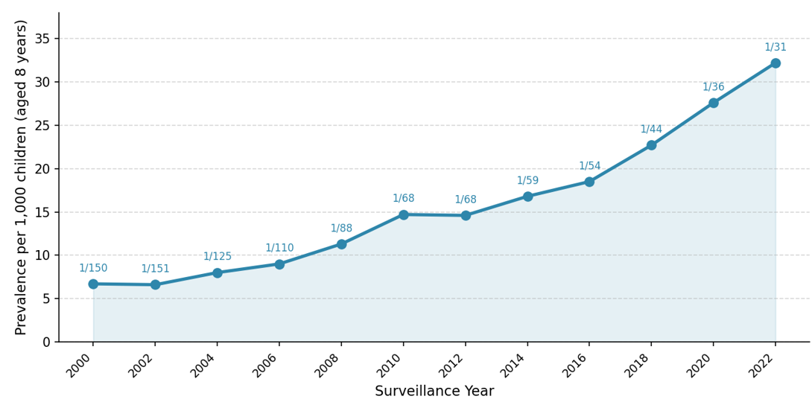
Note. Data source: CDC Autism and Developmental Disabilities Monitoring (ADDM) Network surveillance reports, 2000–2025. The 2022 data point (1 in 31) is from the most recent ADDM report released in 2025.

Figure 1: Trends in ASD Prevalence Among 8-Year-Old Children in the United States, 2000–2022 (CDC ADDM Network) Values above each data point indicate the corresponding "1 in N" prevalence ratio.

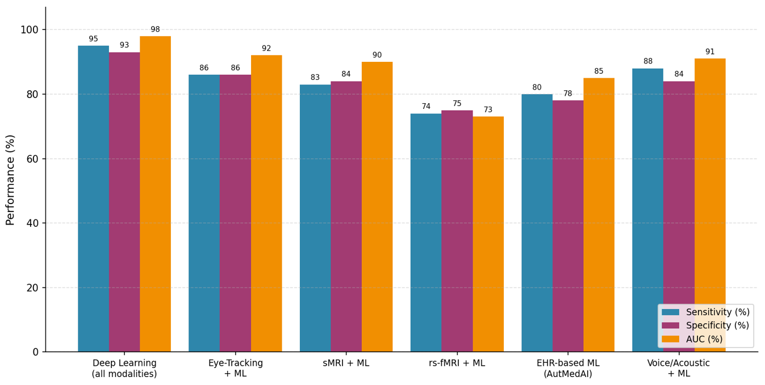
Note. Sources: BMC Psychiatry 2024 (deep learning); ScienceDirect 2025 (eye-tracking); JMIR 2020 (MRI); Jiao et al. 2022 (rs-fMRI); Rajagopalan 2024 (EHR); Leboeuf et al. 2025 (voice/acoustic). Note that voice/acoustic estimates reflect controlled conditions; real-world performance is likely lower. AUC for rs-fMRI and voice/acoustic modalities was not available from pooled analyses and is not displayed.
Figure 2: Diagnostic Performance of AI-Based ASD Detection Across Data Modalities Pooled estimates from published meta-analyses. Bars represent sensitivity, specificity, and AUC (expressed as percentages for comparability).

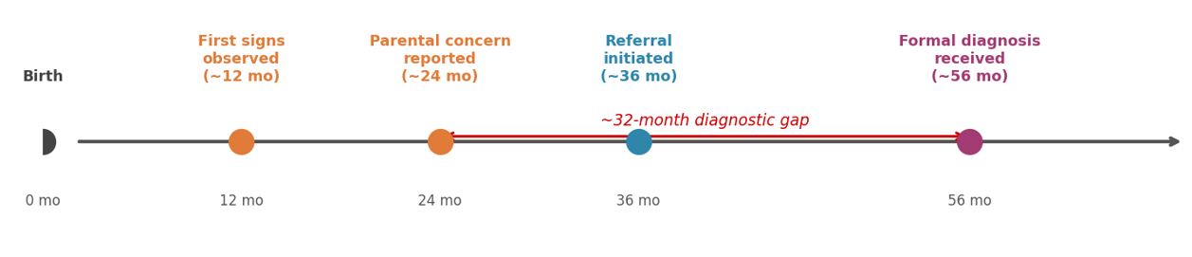
Note. Timeline is based on pooled data from multiple sources. Mean age of first parental concern: ~23.64 months; mean age of formal diagnosis: ~55.97 months (Rødgaard et al. 2021, as cited in narrative literature). US estimates suggest diagnosis at 4–5 years in most states; children from minority or low-income backgrounds experience additional delays of 12–18 months.

Figure 3: Typical Diagnostic Delay Pathway in ASD: From Parental Concern to Formal Diagnosis The red bidirectional arrow illustrates the approximate 32-month gap between first parental concern and diagnosis in high-income countries.

Challenge Domain | Description | Proposed Mitigation
Dataset size & homogeneity | Most models trained on small, predominantly White, HIC samples; ABIDE is convenience-sampled | Federated learning; multisite consortia; mandatory demographic reporting
Algorithmic bias | Female, BAME, and LMIC presentations systematically under-represented; AI may replicate gender diagnostic gap | Stratified sampling; external bias audits; participatory design with autistic communities
Cross-site generalisability | Performance degrades markedly when models tested at unseen sites (known as "domain shift") | Harmonised acquisition protocols; domain adaptation techniques
Interpretability ("Black Box") | Deep learning outputs lack clinician-readable rationale; undermines trust and adoption | SHAP values, LIME, attention visualisation; regulatory requirement for explainability
Privacy & consent | Biometric data from children (video, EEG, fMRI) are highly sensitive; storage governance lacking | GDPR/HIPAA compliance; data minimisation; proxy consent frameworks
Over-reliance risk | AI tools positioned as standalone diagnosis rather than decision support | Regulatory guidance; mandatory human oversight clause in deployment
Regulatory pathway | Most tools lack FDA/CE clearance; clinical liability undefined | FDA Breakthrough Device pathway; ISO 13485; post-market surveillance plans
Note. BAME = Black, Asian, and Minority Ethnic; GDPR = General Data Protection Regulation; HIPAA = Health Insurance Portability and Accountability Act; SHAP = SHapley Additive exPlanations; LIME = Local Interpretable Model-agnostic Explanations; FDA = Food and Drug Administration.

Table 4: Principal Challenges to Clinical Translation of AI-Based ASD Diagnostic Tools and Proposed Mitigations.

2. Background: Conventional Diagnostic Challenges
ASD diagnosis presents unique challenges that are not fully addressed by existing clinical tools. The heterogeneity of the condition means that two individuals with ASD may present with markedly different symptom profiles, complicating the identification of universal biomarkers. Moreover, many ASD features overlap with those of other neurodevelopmental conditions, including attention deficit hyperactivity disorder (ADHD), language disorders, and intellectual disability, necessitating careful differential diagnosis [4].

Clinician availability represents a practical bottleneck. The demand for specialist assessment significantly exceeds supply in most health systems, resulting in waiting lists that delay diagnosis and, by extension, the initiation of evidence-based behavioural and educational interventions. The economic cost of delayed diagnosis is substantial: a systematic review estimated the lifetime societal cost of ASD at over one million US dollars per individual in the United States and over 1.4 million British pounds in the United Kingdom, much of which is attributable to reduced productivity and increased support needs that early intervention might partially mitigate [5].

These challenges have motivated the search for objective, scalable, and cost-effective diagnostic adjuncts. AI-based approaches represent a particularly promising avenue, given their demonstrated capacity to process high-dimensional biological and behavioural data at speed and scale [4].

3. Machine Learning Approaches to ASD Diagnosis

3.1 Classical machine learning methods
The earliest AI applications to ASD diagnosis employed classical supervised learning algorithms applied to structured behavioural and clinical datasets. Support vector machines (SVMs), random forests, k-nearest neighbour classifiers, and logistic regression models have been trained on questionnaire responses, developmental milestones, and demographic variables to distinguish individuals with ASD from neurotypical controls [6]. Rasul et al. [6] conducted a systematic evaluation of multiple machine learning algorithms for ASD detection and demonstrated that ensemble methods, particularly random forests, achieved robust classification performance, while also highlighting the significant influence of feature selection on model accuracy [6].

A landmark study from the Karolinska Institutet, published in JAMA Network Open in 2024, developed the AutMedAI model using a minimal set of medical and background variables drawn from routine healthcare records. Among approximately 12,000 individuals, AutMedAI correctly identified approximately 80% of children with ASD using features including age of first smile, age of first short sentence, and other routinely collected developmental data [7] (Table 3). The authors noted that the model’s reliance on a minimal, clinically accessible feature set made it particularly suitable for integration into primary care settings, where specialist assessment capacity is limited.

The use of electronic health record (EHR) data for ASD prediction has gained increasing attention. Algorithms applied to longitudinal EHR data can identify patterns of healthcare utilisation, developmental concerns, and comorbid diagnoses that collectively signal elevated ASD risk well before formal diagnosis [8]. These approaches are appealing for population-level screening, as EHR data are already collected as part of routine care.

3.2 Deep learning architectures
Deep learning methods, particularly convolutional neural networks (CNNs) and recurrent neural networks (RNNs), have demonstrated superior performance in tasks involving high-dimensional unstructured data such as images, audio, and time-series signals. In ASD research, deep learning has been applied to neuroimaging data, eye-tracking sequences, home videos, and acoustic recordings with considerable success [9].

A systematic review and meta-analysis published in BMC Psychiatry in 2024 examined the performance of deep learning models across multiple ASD diagnostic datasets and found consistently high classification accuracy, with many models achieving area under the curve (AUC) values above 0.90 [10] (Table 2 and Figure 2). The authors identified resting-state functional MRI (rs-fMRI) and eye-tracking as the modalities yielding the highest diagnostic performance, though they cautioned that methodological heterogeneity across studies limited direct comparison.

Transformer-based architectures, initially developed for natural language processing, have more recently been adapted for multimodal ASD classification. A multi-task Transformer framework incorporating attention mechanisms to weight the relative contribution of different input features has shown promise for simultaneously identifying ASD and estimating symptom severity [11].

4. Neuroimaging-Based Approaches

4.1 Functional MRI
Resting-state functional MRI (rs-fMRI) has emerged as one of the most extensively studied neuroimaging modalities for AI-assisted ASD diagnosis. The technique captures spontaneous fluctuations in blood-oxygen-level-dependent (BOLD) signals during resting conditions, providing a non-invasive measure of intrinsic functional connectivity across brain networks. In ASD, altered functional connectivity has been consistently observed, particularly within the default mode network and social brain regions including the superior temporal sulcus and amygdala [12].

The Autism Brain Imaging Data Exchange (ABIDE) consortium, which has aggregated rs-fMRI data from over 1,000 individuals with ASD and a comparable number of neurotypical controls across multiple sites, has served as the primary benchmarking dataset for neuroimaging-based AI models [12]. Deep learning models applied to ABIDE data have achieved classification accuracies ranging from 67% to over 80%, with multimodal approaches incorporating both functional and structural connectivity features generally outperforming single-modality models [9] (Table 2).

Feng and Xu applied a CNN to rs-fMRI data in a paediatric cohort and demonstrated accurate ASD identification in children, underscoring the feasibility of automated neuroimaging analysis in the population of greatest clinical interest [13]. The same research group noted that motion artefacts, a particular challenge in paediatric neuroimaging, represented a significant source of variability that required careful correction.

A proposed deep multimodal model that learns joint representations from two types of functional connectivity data derived from fMRI scans achieved a classification accuracy of 74% and a recall of 95%, with an F1 score of 0.805, outperforming single-modality approaches on the ABIDE dataset [14] (Table 3). The authors argued that incorporating multiple functional imaging modalities provided a more comprehensive representation of neural activity and reduced the risk of overfitting to noise present in any single data type.

4.2 EEG and other neuroimaging modalities
Electroencephalography (EEG) offers complementary advantages to fMRI, including high temporal resolution, portability, and relatively low cost. ML and deep learning models applied to EEG signals in ASD have examined features including spectral power, functional connectivity, and event-related potentials. A comprehensive review of neuroimaging modalities for ASD diagnosis concluded that EEG-based classifiers offered a promising balance of diagnostic accuracy and clinical feasibility, particularly for applications in settings where MRI is unavailable [15].

Structural MRI, magnetoencephalography (MEG), and functional near-infrared spectroscopy (fNIRS) have each been explored as input modalities for ASD classification algorithms, though the evidence base for these approaches remains less mature than for rs-fMRI and EEG. A systematic review of AI applications to ASD neuroimaging published in Frontiers in Molecular Neuroscience noted that studies combining multiple neuroimaging modalities consistently outperformed those relying on a single modality, reinforcing the importance of multimodal integration [15].

5. Eye-Tracking Based Approaches
Atypical visual social attention is among the most reliably identified early markers of ASD, manifesting as reduced fixation on faces and social scenes, diminished attention to the eye region, and altered gaze patterns during social interaction [16]. Eye-tracking technology offers an objective, quantifiable measure of these patterns, and has been extensively combined with AI to develop automated ASD screening tools.

A review of eye-tracking biomarkers for ASD published in Research in Autism Spectrum Disorders evaluated machine learning and deep learning approaches across multiple studies and concluded that eye-tracking data yielded high classification accuracy, with models trained on scan-path sequences and fixation density maps performing particularly well [16] (Table 2 and Figure 2). Algorithms trained on gaze patterns during social stimuli were found to generalise better across age groups than those trained on non-social stimuli.

Deep learning models, including hybrid CNN-RNN architectures designed to capture both spatial and temporal features of gaze sequences, have demonstrated improved performance over classical ML approaches for eye-tracking-based ASD classification [17]. Alsharif et al. [18] reported significant improvements in ASD identification accuracy using deep learning models applied to an intelligent eye-tracking system, with results suggesting that automated eye-tracking could serve as a feasible adjunct to clinical assessment in resource-limited environments [18].

A study published in JAMA in 2023 directly compared eye-tracking-based social visual engagement measurement with expert clinical diagnosis and found strong correspondence between AI-derived gaze metrics and clinical ASD classification [19] (Table 3). This study represented one of the most rigorous evaluations of eye-tracking technology against the diagnostic gold standard, providing important evidence for clinical validity.

Despite these promising results, limitations in eye-tracking-based approaches include sensitivity to calibration quality, variability in stimulus paradigms across studies, and reduced performance in younger infants in whom reliable gaze data are more difficult to obtain. The development of standardised stimulus batteries and robust calibration protocols will be necessary for clinical deployment.

6. Acoustic, Speech, and Multimodal Approaches

6.1 voice and speech analysis
Speech and language atypicalities are core diagnostic features of ASD, including reduced joint attention, atypical prosody, and delayed language acquisition. AI-based analysis of acoustic features including pitch, rhythm, timbre, and spectral characteristics has been explored as a non-invasive screening tool, particularly in infants and toddlers where behavioural assessment is challenging.

A scoping review analysing 158 studies on AI-based ASD detection using voice and behavioural data found that modern ML and deep learning techniques demonstrated highly promising diagnostic performance in controlled environments, with reported accuracies of up to 99% [20] (Table 2). Voice biomarkers, conversational dynamics, and linguistic analysis were among the most informative modalities. However, the review identified critical challenges impeding clinical translation, including pervasive dataset heterogeneity, gender bias in training samples, and small overall sample sizes [20].

Infant cry analysis has emerged as a particularly early window into neurodevelopmental status. A systematic review and meta-analysis examining AI-based cry analysis for ASD screening demonstrated the feasibility of detecting acoustic signatures associated with ASD in the first months of life, well before the onset of reliably observable behavioural symptoms [21].

6.2 Multimodal integration
The convergent evidence from multiple modalities suggests that multimodal AI frameworks, integrating neuroimaging, eye-tracking, acoustic, and clinical data, offer the greatest diagnostic accuracy and clinical utility. A comprehensive review of AI-enabled technologies for ASD published in 2025 examined diagnostic accuracy, clinical feasibility, scalability, and implementation hurdles across modalities including eye-tracking, acoustic analysis, video-based behavioural screening, neuroimaging, molecular and genetic assays, EHR-based prediction, and home-based digital applications [22]. The review found that multimodal integration significantly enhanced predictive power relative to any single modality (Table 2 and Figure 2), and that several AI-based tools had received Food and Drug Administration (FDA) clearance, signalling momentum for wider clinical deployment [22].

Home video analysis represents a particularly scalable multimodal approach. Algorithms trained on brief smartphone-recorded videos of child behaviour can extract gaze direction, facial expression, motor patterns, and social responsiveness simultaneously, enabling low-cost screening in home and community settings. Initial studies have reported sensitivities exceeding 80% for ASD detection in toddlers using this approach, though further validation in diverse populations is required [22].

7. Challenges, Limitations, and Ethical Considerations

7.1 Data quality and generalisability
Despite impressive performance metrics reported in individual studies, the generalisability of AI-based ASD diagnostic tools remains a significant concern (Table 4). Most existing models have been trained on relatively small, demographically homogeneous datasets, predominantly drawn from high-income countries with well-resourced diagnostic services [23]. The ABIDE dataset, while influential, reflects a convenience sample of individuals with existing ASD diagnoses and may not represent the full phenotypic spectrum of the condition.

Dataset heterogeneity poses additional challenges. Variations in data acquisition protocols, scanner hardware, stimulus paradigms, and diagnostic criteria across contributing sites introduce systematic noise that can impair model performance [24]. Cross-site validation studies have consistently demonstrated performance degradation when models trained at one institution are applied to data from another, underscoring the need for harmonised data collection standards and multi-site training approaches.

7.2 Bias and equity
Algorithmic bias represents a critical risk in AI-based ASD diagnosis (Table 4). Training data that underrepresents certain demographic groups, including females, individuals from racial and ethnic minority backgrounds, and those from LMICs, can yield models that perform poorly for these populations [23]. ASD in females is systematically underdiagnosed due to phenotypic differences from the predominantly male ASD presentation on which most research has been based, and AI models trained on biased datasets risk perpetuating this diagnostic disparity [25].

Prior studies examining AI models trained on neurotypical data have found that such systems may misclassify autistic communication patterns as atypical or pathological when compared against neurotypical norms, raising concerns about the imposition of neuronormative standards in AI-assisted assessment [26]. These findings highlight the importance of involving autistic individuals and advocacy organisations in the co-design and evaluation of AI diagnostic tools.

7.3 Interpretability and the "Black Box" problem
Many high-performing deep learning models lack transparency in their decision-making processes, a characteristic described as the "black box" problem (Table 4). In clinical settings, where diagnostic decisions carry significant consequences for individuals and families, the inability to explain how a model arrived at a particular classification undermines clinician trust and limits acceptance [27]. Explainable AI (XAI) methods, including SHAP (SHapley Additive exPlanations) values, LIME (Local Interpretable Model-agnostic Explanations), and attention visualisation, offer partial solutions by providing post-hoc interpretations of model outputs [27]. However, the faithful translation of these explanations into clinically meaningful insights remains an active area of research.

7.4 Ethical and privacy considerations
The collection and processing of sensitive biometric data from children with ASD raises significant ethical and privacy concerns (Table 4). Behavioural video data, eye-tracking streams, EEG recordings, and neuroimaging data can reveal identities, emotional states, and cognitive characteristics; their secondary use and storage require robust governance frameworks [25]. Obtaining informed consent from parents and guardians, ensuring data minimisation, and implementing appropriate access controls are minimum requirements that are not yet uniformly applied across the field.

The deployment of AI diagnostic tools in clinical settings also raises concerns about over-reliance on algorithmic outputs and the potential displacement of human clinical judgement. Current evidence does not support the use of AI tools as standalone diagnostic instruments; rather, they should function as decision-support adjuncts that assist, rather than replace, qualified clinical assessors [24].

8. Future Directions
Several priority areas for future research emerge from this review. First, the development of large-scale, demographically diverse, and multisite training datasets is essential for improving the generalisability and equity of AI-based ASD diagnostic models. Federated learning approaches, which enable model training across multiple institutions without centralising sensitive patient data, offer a technically feasible mechanism for achieving this goal while preserving data privacy [29].

Second, the standardisation of data acquisition protocols, stimulus paradigms, and outcome definitions across research groups would facilitate direct comparison of competing models and accelerate the accumulation of evidence. International consortia modelled on ABIDE have demonstrated the value of this approach for neuroimaging data; analogous consortia for eye-tracking, EEG, and video datasets are needed.

Third, the integration of AI tools into routine clinical workflows will require engagement with regulatory bodies and the development of clear frameworks for clinical validation, post-market surveillance, and liability. The growing number of FDA-cleared AI-based diagnostic devices for ASD [22] signals that this regulatory pathway is navigable, but broader guidance is needed.

Finally, participatory design approaches that meaningfully involve autistic individuals, families, and advocacy organisations in the development and evaluation of AI tools are essential for ensuring that these technologies serve the needs and preferences of the communities they are intended to benefit.

9. Conclusion
Artificial intelligence holds substantial promise for transforming the early diagnosis of Autism Spectrum Disorder. Across a range of data modalities, including neuroimaging, eye-tracking, acoustic analysis, and clinical records, AI and machine learning approaches have demonstrated high diagnostic accuracy and the capacity to detect ASD-related features at earlier stages than conventional clinical assessment alone. The AutMedAI model, multimodal deep learning frameworks, and eye-tracking classifiers represent particularly noteworthy recent advances.

Nevertheless, the path from research to clinical implementation requires careful navigation of significant challenges related to data diversity, algorithmic bias, model interpretability, and ethical governance. The responsible integration of AI into ASD diagnostic pathways will necessitate rigorous multi-site validation, equitable dataset curation, transparent algorithmic design, and meaningful clinician-AI collaboration. With these safeguards in place, AI has the potential to substantially reduce diagnostic delays, extend the reach of specialist assessment to underserved populations, and ultimately improve outcomes for individuals with ASD and their families.

References
- American Psychiatric Association. Diagnostic and Statistical Manual of Mental Disorders: DSM-5-TR. 5th ed., text revision. Washington, DC: American Psychiatric Association (2022).
- World Health Organization. Autism Spectrum Disorders. Geneva: World Health Organization (2023).
- Maenner MJ, Warren Z, Williams AR, et al. Prevalence and characteristics of autism spectrum disorder among children aged 8 years—Autism and Developmental Disabilities Monitoring Network, 11 sites, United States, 2020. MMWR Surveillance Summaries 72 (2023): 1-14.
- Joudar SS, Albahri A, Hamid RA. Triage and priority-based healthcare diagnosis using artificial intelligence for autism spectrum disorder and gene contribution: A systematic review. Computers in Biology and Medicine 146 (2022): 105553.
- Buescher AV, Cidav Z, Knapp M, et al. Costs of autism spectrum disorders in the United Kingdom and the United States. JAMA Pediatrics 168 (2014): 721-728.
- Rasul RA, Saha P, Bala D, et al. An evaluation of machine learning approaches for early diagnosis of autism spectrum disorder. Healthcare Analytics 5 (2024): 100293.
- Rajagopalan SS, Zhang Y, Yahia A, et al. Machine learning prediction of autism spectrum disorder from a minimal set of medical and background information. JAMA Network Open 7 (2024): e2429229.
- Amit G, Bilu Y, Sudry T, et al. Early prediction of autistic spectrum disorder using developmental surveillance data. JAMA Network Open 7 (2024): e2351046.
- Elbattah M, Ibrahim OAS, Dequen G. Editorial: Improving autism spectrum disorder diagnosis using machine learning techniques. Frontiers in Neuroinformatics 18 (2024): 1529839.
- Wei Q, Dong W, Yu D, et al. Early identification of autism spectrum disorder based on machine learning with eye-tracking data. Journal of Affective Disorders 358 (2024): 326-334.
- Elbattah M, Dequen G, et al. Multi-task transformer for autism spectrum disorder assessment. Proceedings of HEALTHINF (2022).
- Liu M, Li B, Hu D. Autism spectrum disorder studies using fMRI data and machine learning: A review. Frontiers in Neuroscience 15 (2021): 697870.
- Feng M, Xu J. Detection of ASD children through deep-learning application of fMRI. Children 10 (2023): 1654.
- Dvornek NC, Li X, Zhuang J, et al. Deep multimodal learning for the diagnosis of autism spectrum disorder. Journal of Personalized Medicine 11 (2021): 756.
- Moridian P, Ghassemi N, Jafari M, et al. Automatic autism spectrum disorder detection using artificial intelligence methods with MRI neuroimaging: A review. Frontiers in Molecular Neuroscience 15 (2022): 999605.
- Jeyarani RA, Senthilkumar R. Eye tracking biomarkers for autism spectrum disorder detection using machine learning and deep learning techniques: Review. Research in Autism Spectrum Disorders 108 (2023): 102228.
- Cheekaty S, Muneeswari G. Enhanced multilevel autism classification for children using eye-tracking and hybrid CNN-RNN deep learning models. Neural Computing and Applications (2024).
- Alsharif N, Al-Adhaileh MH, Al-Yaari M, et al. Utilizing deep learning models in an intelligent eye-tracking system for autism spectrum disorder diagnosis. Frontiers in Medicine 11 (2024): 1436646.
- Briend F, David C, Silleresi S, et al. Eye-tracking-based measurement of social visual engagement compared with expert clinical diagnosis of autism. JAMA 330 (2023): 402-414.
- Leboeuf A, et al. A scoping review of AI-based approaches for detecting autism traits using voice and behavioral data. Bioengineering 12 (2025): 1136.
- Pusil S, Laguna A, Chino B, et al. Early identification of autism using cry analysis: A systematic review and meta-analysis of retrospective and prospective studies. Journal of Autism and Developmental Disorders (2025).
- Imoh PO, Adeniyi M, Ayoola VB, et al. AI-enabled technologies and biomarker analysis for the early identification of autism and related neurodevelopmental disorders. Children 12 (2025): 1670.
- Keerthana Sai K, et al. A scoping review of AI-based approaches for detecting autism traits using voice and behavioral data. BMC Psychiatry (2025).
- Al-Rawi M, et al. The role of artificial intelligence for early diagnostic tools of autism spectrum disorder: A systematic review. Discover Mental Health (2025).
- Natraj N, et al. Artificial intelligence in early detection of autism spectrum disorder for preschool ages: A systematic literature review. medRxiv (2025).
- Shishido E, Ogawa S, Miyata S, et al. Application of eye trackers for understanding mental disorders: Cases for schizophrenia and autism spectrum disorder. Neuropsychopharmacology Reports 39 (2019): 72-77.
- Ganie AA, Malik MB. Explainable AI in early autism detection: A literature review of interpretable machine learning approaches. Discover Mental Health (2025).
- Sabegh AM, Samadzadehaghdam N, Seyedarabi H, et al. Automatic detection of autism spectrum disorder based on fMRI images using a novel convolutional neural network. Research on Biomedical Engineering 39 (2023): 1-7.
- Khodatars M, Shoeibi A, Sadeghi D, et al. Deep learning for neuroimaging-based diagnosis and rehabilitation of autism spectrum disorder: A review. Computers in Biology and Medicine 139 (2021): 104949.


This article is an open-access article distributed under the terms and conditions.
Creative Commons Attribution (CC-BY) license 4.0

