

Research Article

Effectiveness of AI-Based Chatbots for Mental Health Support: A Systematic Review and Meta-Analysis

Uche Timothy¹, Puneeth Reddy Chada², Shabnam Abdulaziz Memon³, Selvy Ketanbhai Patel⁴, Sneha Ashok⁵, Ghazala S. Virk⁶, Arvind Dhanabalan⁷, Archna Patel⁸, Muhammad Sohail S. Mirza^{9*}

¹Livewell Southwest CIC, Plymouth, UK.
²Emilio Aguinaldo College-School of Medicine, Manila City, Philippines.
³C.U. Shah Medical College, Surendranagar, Gujarat, India.
⁴Dr. MK Shah Medical College and Research Centre. Gujarat University, Gujarat, India
⁵Pondicherry Institute of Medical Sciences, Pondicherry, UT of Puducherry, India
⁶Avalon University School of Medicine, Willemstad, Curacao.
⁷Allsaints University School of Medicine • Roseau, DMA
⁸Marshall University Joan C. Edwards School of Medicine, Huntington, West Virginia
⁹Shandong University School of Medicine, Jinan, China.

*Corresponding Author: Muhammad Sohail S. Mirza, MBBS. Shandong University School of Medicine, Jinan, China.

Received: 31 May 2026; Accepted: 09 June 2026; Published: 25 June 2026

Citation: Uche Timothy, Puneeth Reddy Chada, Shabnam Abdulaziz Memon, Selvy Ketanbhai Patel, Sneha Ashok, Ghazala S. Virk, Arvind Dhanabalan, Archna Patel, Muhammad Sohail S. Mirza. Effectiveness of AI-Based Chatbots for Mental Health Support: A Systematic Review and Meta-Analysis. Journal of Psychiatry and Psychiatric Disorders 10 (2026): 110-118.

Abstract
AI-based chatbots are increasingly integrated into digital mental health interventions, valued for their scalability, accessibility, and immediate psychological support. This systematic review and meta-analysis quantitatively assessed their efficacy in mitigating depression and anxiety symptoms. Adhering to PRISMA 2020 guidelines, relevant randomized controlled trials (RCTs) on AI chatbot mental health interventions were identified through comprehensive database searches up to 2025. A random-effects model calculated standardized mean differences (SMDs) and 95% confidence intervals (CIs); heterogeneity was assessed via the I² statistic, and robust sensitivity analyses were performed. Five RCTs, totaling 676 participants, were included for synthesis. Results indicated AI-based chatbots significantly reduced depression symptoms (SMD = -0.51, p < 0.0001) with low heterogeneity (I² = 5.6%). Anxiety symptoms also decreased significantly (SMD = -0.31, p = 0.0057) with no heterogeneity (I² = 0.0%). Sensitivity analyses confirmed result stability. Overall, AI-powered chatbots appear beneficial for alleviating depression and anxiety, supporting conversational AI's potential in mental health care. However, further large, multi-center RCTs with long-term follow-up are essential to strengthen this evidence.

Keywords: Artificial intelligence; Chatbots; Mental health; Depression; Anxiety; Digital health; Systematic review; Meta-analysis.

- Introduction
One of the largest causes of disability globally, and one of the highest contributors to the global burden of disease, is mental health disorders [1,2]. Depression and anxiety disorders impact hundreds of millions of people, causing decreased social functioning, lowered productivity, greater healthcare utilization, and higher suicide rates [3]. The World Health Organization (WHO) estimates that depression is a major cause of disability adjusted life years all over the world, and anxiety disorders are one of the most common psychiatric disorders in developed and developing nations [1]. In addition to psychological distress, social isolation, and mental health needs that were largely unmet, the coronavirus disease 2019 (COVID-19) pandemic further increased psychological distress, social isolation, and unmet mental health needs, especially among university students and adolescents [4]. Although there has been great progress in awareness for mental disorders, a significant treatment gap remains due to the lack of trained clinicians, financial constraints, waiting times, geographical barriers, and social stigma surrounding seeking psychological assistance [5]. As a result, a lot of people with mental anguish go without treatment or don't get adequate treatment. Given these issues, digital mental health interventions have been developed as a potential solution regarding accessibility and scalability of mental healthcare [6]. Artificial intelligence (AI)-powered chatbots and conversational agents have been a popular feature in the world of digital mental health tools. Conversational AI systems use NLP, machine learning, and algorithms to have lifelike conversations, deliver psychoeducation, reach out to emotional support, provide cognitive behavioral therapy (CBT) exercises, mindfulness training, monitor mood, and offer coping skills [7,8]. Chatbot interventions can be delivered through smartphone and web applications, 24-hours a day, which is better than traditional therapy, whilst also increasing reach and accessibility, whilst lowering cost and stigma [9]. Several conversational systems have been created based on these AI techniques to help with mental health-related issues, such as Woebot, Tess, Wysa, XiaoE, and Emohaa [10-14]. These interventions are increasingly implemented in educational institutions, primary care settings, and digital wellness platforms. Importantly, research-based psychological frameworks are the foundation of many studies of chatbot interventions, especially those based on CBT, which have shown efficacy in treating depression and anxiety disorders [15]. The conversational abilities of AI systems, exemplified by greater adaptability, flexibility, and context-awareness, have recently gained increased momentum, benefiting from advances in generative AI and large language models [16]. That's why conversational agents are seen as extendable supplements to the conventional mental health service. But there are some concerns about their clinical effectiveness, safety, ethical concerns, protection of privacy, algorithmic bias, and the long-term therapeutic effect [17]. There have been a few systematic reviews conducted on digital mental health interventions and conversational agents [18-21]. The growing number of studies on AI-based chatbot interventions, however, requires a new quantitative synthesis of studies focusing on RCT studies with usable outcome measures. Thus, the present systematic review and meta-analysis aimed to assess how effective an AI-based chatbot is for decreasing the severity of depression and anxiety symptoms.

- Materials and Methods
Mental health disorders constitute a major global public health challenge, contributing substantially to disability, reduced quality of life, and increased healthcare burden. Depression and anxiety disorders are among the most prevalent mental illnesses worldwide and are associated with impaired psychosocial functioning, reduced productivity, and increased risk of suicide. Despite advances in mental health services, access to psychological care remains limited because of shortages of trained clinicians, social stigma, financial constraints, and geographic barriers.

Digital mental health interventions have emerged as promising alternatives to traditional face-to-face therapy. Among these technologies, AI-based chatbots and conversational agents have gained significant attention. Chatbots can simulate human-like interactions using natural language processing and machine learning techniques to deliver psychological support, cognitive behavioral therapy (CBT)-based guidance, mood tracking, psychoeducation, and emotional assistance.
Recent years have witnessed increasing implementation of chatbot platforms such as Tess, Wysa, Woebot, XiaoE, and Emohaa. These systems are designed to provide scalable, low-cost, and accessible mental health support through smartphones and web-based applications. Several randomized controlled trials have evaluated the effectiveness of these interventions in improving depression and anxiety symptoms.

Although previous systematic reviews have explored conversational agents in mental health care, the rapid expansion of AI technologies and newly published trials necessitate an updated quantitative synthesis focusing specifically on AI-based chatbot interventions. Therefore, the present systematic review and meta-analysis aimed to evaluate the effectiveness of AI-based chatbots for improving depression and anxiety outcomes.

  - Study Design
This systematic review and meta-analysis were conducted according to the PRISMA 2020 guidelines.

Table 1: PICO Framework
Component | Description
Population | Individuals receiving mental health support
Intervention | AI-based chatbot or conversational agent
Comparator | Standard care, waitlist, bibliotherapy, or control intervention
Outcomes | Depression and anxiety symptoms
Study Design | Randomized controlled trials

Table 1 describes the PICO Framework for this study.

Search Strategy
Electronic databases, including PubMed, Scopus, Web of Science, PsycINFO, and Google Scholar, were searched for eligible studies published until 2025.

Boolean Search Strategy
(“artificial intelligence” OR AI OR chatbot* OR “conversational agent” OR” virtual agent”) AND (“mental health” OR depression OR anxiety OR stress) AND (randomised OR randomised OR trial OR RCT).

Table 2: Inclusion and Exclusion Criteria
Inclusion Criteria | Exclusion Criteria
Randomized controlled trials | Reviews and meta-analyses
AI-based chatbot interventions | Protocol papers
Human participants | Non-randomized studies
Depression or anxiety outcomes reported | Studies without extractable quantitative data
Mean and standard deviation are extractable. | Conference abstracts only
English-language studies | Non-AI digital interventions
Published peer-reviewed articles | Studies lacking postintervention data

Inclusion and exclusion criteria for this study are shown in Table 2

  - Study Selection
Studies were evaluated for eligibility after searching and screening the databases, according to the pre-established inclusion and exclusion criteria. Articles that failed to include mean and standard deviation data post-intervention, reported as a protocol paper or abstract paper, or were review papers were excluded. Randomized controlled trials that were suitable for quantification were included in the final meta-analysis. The included trials were differentiated by the mental health outcomes assessed (depression and/or anxiety) and AI-based Chatbot interventions. The AI-based Chatbot interventions included in the analyses were with respect to depression and/or anxiety outcomes (as measured by validated mental health scales). Included studies were based on a variety of populations and settings, such as university students, young adults, adolescents, adults with chronic diseases, and adults seeking mental health services. There were four types of chatbot interventions: AI-based self-help chatbots, Tess, XiaoE, and Wysa, and conversational agents based on CBT. The comparator conditions were different and could be bibliotherapy, information control, mobile control application, usual support, standard control condition, and nurse hotline support. This feeling may be strengthened by the overall findings from the pooled analysis, which revealed statistically significant reductions in depression and anxiety outcomes for AI-based chatbot interventions. Most studies found that chatbot interventions consistently supported this direction. The pooled effects were relatively stable with regard to variation across the study samples, platforms, and control conditions, as concentration was low for depression and zero for anxiety. The pooled effects were not very different for each study sample about variation across study platform and control conditions, as there was little to no variation across platform or control conditions for depression, and a zero for anxiety. Results are reported for outcomes of depression and anxiety separately. The impacts of small-study effects were graphically assessed using funnel plots, with investigation of the trim-and-fill analysis; the small-study effects were evaluated using forest plots, while the impacts of study-level effects on the heterogeneity were evaluated by leave-one-out, and Baujat plots were conducted to evaluate the robustness of the pooled findings.

  - Data Extraction
The following data were extracted from each included study:
- Author and year
- Country
- Sample size
- Population characteristics
- Chatbot platform
- Comparator
- Outcome measures
- Mean and standard deviation values
- Follow-up duration

  - Risk of Bias Assessment
Risk of bias was assessed using the Cochrane Risk of Bias 2 (RoB 2) tool for randomized controlled trials.

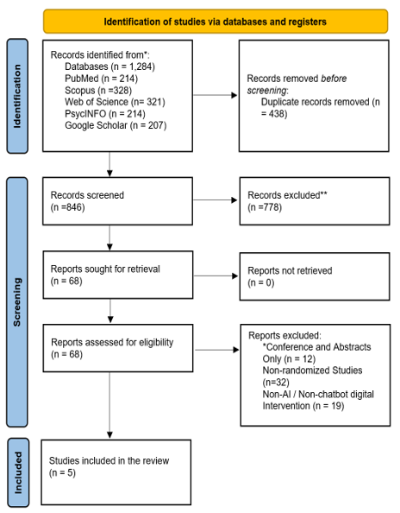
Figure 1: PRISMA Flowchart

The (Figure 1) PRISMA flowchart illustrates how studies were chosen for this systematic review and meta-analysis. We identified initial records by searching various electronic databases, including PubMed, Scopus, Web of Science, PsycINFO, and Google Scholar, along with other relevant sources. After removing duplicate records, we screened titles and abstracts against our predefined eligibility criteria. Studies classified as reviews, protocols, conference abstracts, or non-randomized were excluded. We also removed studies that did not involve AI digital interventions or lacked extractable quantitative post-intervention data. Subsequently, full-text articles underwent eligibility assessment. Only randomized controlled trials evaluating AI-based chatbot interventions for depression or anxiety outcomes were ultimately selected. In the end, five randomized controlled trials, involving a total of 676 participants, met all inclusion criteria and were incorporated into the quantitative meta-analysis.

Table 3: Characteristics of included studies
Study | Country | Population | Mean Age | Chatbot Platform | Comparator | Intervention Duration | Outcomes | Sample Size
Liu et al., 2022 [11] | China | University students with depressive symptoms | 20.4 years | AI self-help chatbot | Bibliotherapy | 2 weeks | PHQ-9, GAD-7 | 83
He et al., 2022 [12] | China | Young adults with depressive symptoms | 22.1 years | XiaoE | Mobile control application | 4 weeks | PHQ-9 | 84
Nicol et al., 2022 [13] | United States | College students with anxiety symptoms | 21.3 years | Tess | Information control | 2 weeks | GAD-7 | 50
MacNeill et al., 2024 [30] | Canada | Adults with chronic disease | 41.7 years | Wysa | Control condition | 4 weeks | PHQ-9, GAD-7, PSS-10 | 68
Chen et al., 2025 [29] | China | Adults seeking mental health support | 33.6 years | AI chatbot | Nurse hotline | 4 weeks | PHQ-9, GAD-7 | 103

Five randomized controlled trials from China, the US, and Canada were analyzed as shown in Table 3. These studies involved diverse populations (ages 20-42) with conditions like depression or anxiety. Chatbots (e.g., Tess, Wysa) were compared to various controls, including bibliotherapy or nurse hotlines. Interventions, lasting 2-4 weeks, used validated tools (e.g., PHQ-9) for outcome assessment. With 50-103 participants, these represent small but clinically relevant RCTs of AI chatbot mental health interventions.

  - Statistical Analysis
Meta-analysis was conducted using RStudio with the “meta” and “metafor” packages. Standardized mean differences (SMDs) with 95% confidence intervals were calculated using a random-effects model with restricted maximum likelihood estimation.

Heterogeneity was assessed using:
- Cochran’s Q test
- Tau² statistic
- I² statistic

Additional analyses included:
- Funnel plots
- Trim-and-fill analysis
- Baujat plots
Leave-one-out sensitivity analysis

- Results
  - Depression Outcomes
The following data were submitted for inclusion in the meta-analysis of depression: five studies. Self-report scales for depression symptoms were primarily used to evaluate outcomes (the most utilized was the PHQ-9), and some studies employed similar completed depression symptom scales. Standardized mean difference (SMD) was the pooled effect measure due to the fact that the trials in the pooled sample employed different measures to provide effect measures.

The results of the random-effects meta-analysis revealed that AI-based chatbot interventions were effective in reducing depressive symptoms to a statistically significant degree compared to the control. Results showed a moderate effect on the pooled effect estimate SMD = -0.51 (95% CI: -0.75 to -0.28), with a moderate effect being in favor of chatbot interventions. The pooled effect was significant (p < 0.0001), indicating that the participants in the chatbot interventions showed a greater decrease in depression symptoms than the participants in the comparator groups.

The level of heterogeneity between included depression studies was low (I² = 5.6%), indicating that the effects of the treatments were not very different between studies. This low degree of heterogeneity, plus the high number of studies, reduces the concerns regarding exaggeration of the overall result, as this is affected by limited variability between the studies. Results indicated that most of the studies supported chatbot interventions, with a varying magnitude of benefits within each study in the forest plot.

Clinically, the pooled SMD of -0.51 indicates the potential of meaningfully improving patients' symptom management for those with depressive symptoms through the use of AI-based chatbots, particularly when the interventions involve CBT, psychoeducation, mood monitoring, and guided self-help. But because the length of time for most studies included is brief, it is not necessarily considered as clinical remission results, but rather short-term effectiveness.

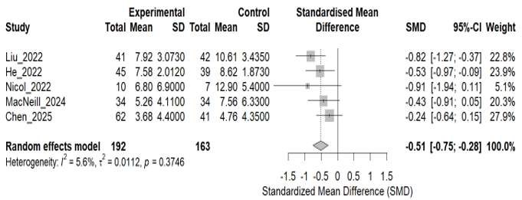
Figure 2: Forest of Depression Outcomes

In the forest plot (Figure 2), most of the included studies reported positive effects of the interventions with AI chatbots on depressive symptoms. The pooled summary was statistically significant, with the confidence interval not overlapping the no-effect line, indicating potential effectiveness of the chatbot-based interventions in reducing acute depression symptoms.

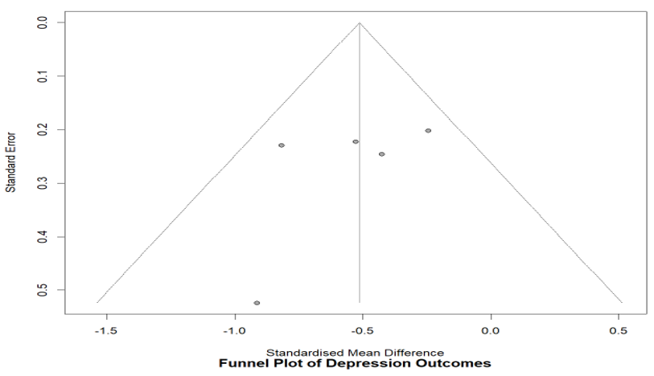
Figure 3: Funnel Plot of Depression Outcomes

Visual inspection of the funnel plot (Figure 3) demonstrated a relatively symmetrical distribution with minimal evidence of publication bias.
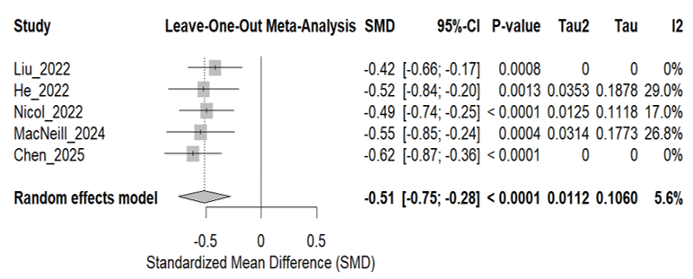
Figure 4: Leave- One- Out Sensitivity Analysis for Depression

Sensitivity analysis (Figure 4) demonstrated that omission of any individual study did not substantially alter the pooled effect estimate.
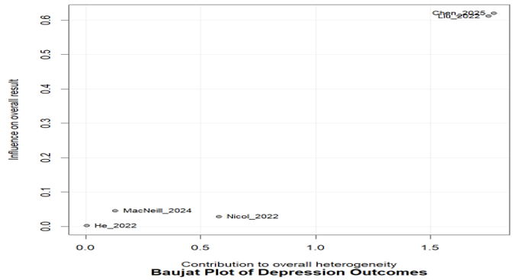
Figure 5: Baujat Plot of Depression Outcomes

The Baujat plot in Figure 5 shows that Liu et al. and Chen et al. contributed most to heterogeneity and overall influence.

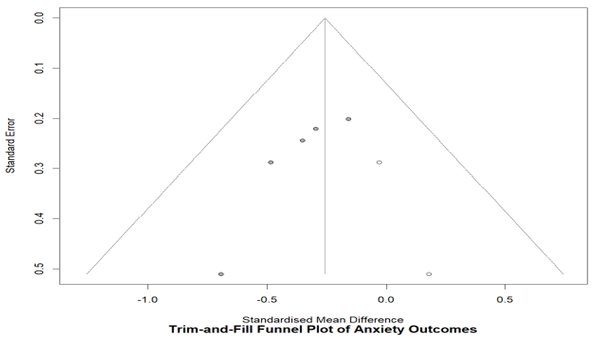
Figure 6: Trim and Fill Funnel Plot for Depression

Trim-and-fill (Figure 6) analysis did not substantially alter the pooled effect estimate.

  - Anxiety Outcomes
Five studies contributed data to the anxiety meta-analysis.
The pooled effect demonstrated a significant reduction in anxiety symptoms:
SMD = -0.31, 95% CI [-0.54, -0.09], p = 0.0057.
No substantial heterogeneity was observed:
I² = 0.0%.

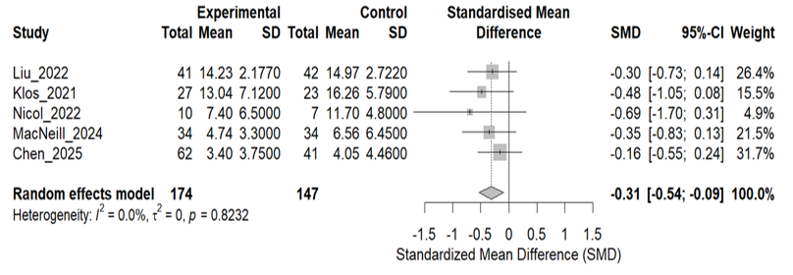
Figure 7: Forest Plot of Anxiety Outcomes

The forest plot (Figure 7) demonstrated consistent beneficial effects of chatbot interventions across studies.

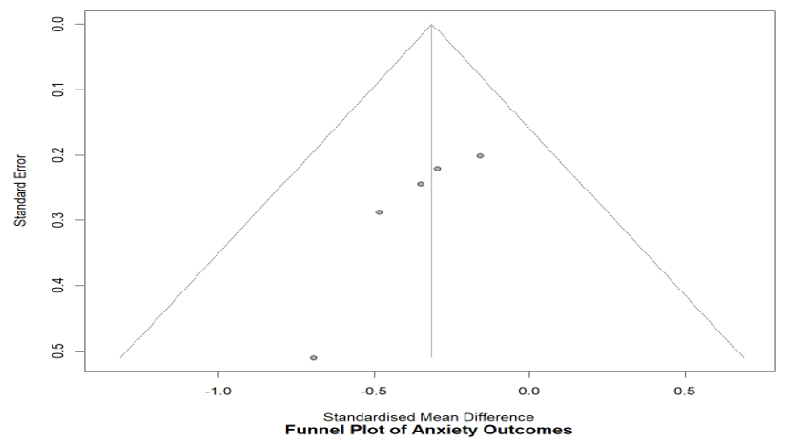
Figure 8: Funnel Plot of Anxiety Outcomes

The funnel plot (Figure 8) appeared relatively symmetrical with limited evidence of small-study effects.

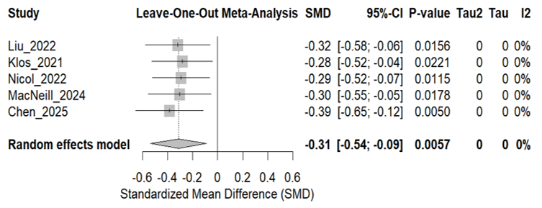
Figure 9: Forest Plots of Leave One Out Sensitivity Analysis For Anxiety

Figure 9 shows Sequential omission of studies did not materially affect the pooled anxiety estimate.

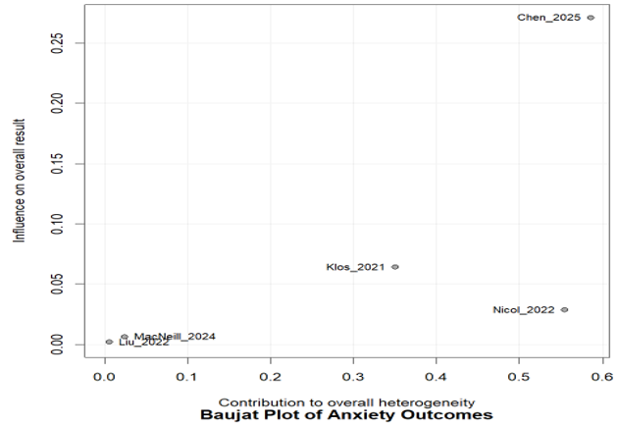
Figure 10: Bajaut Plot of Anxiety Outcomes

Figure 10 shows that Chen et al. appeared to exert the largest influence on the pooled anxiety effect.

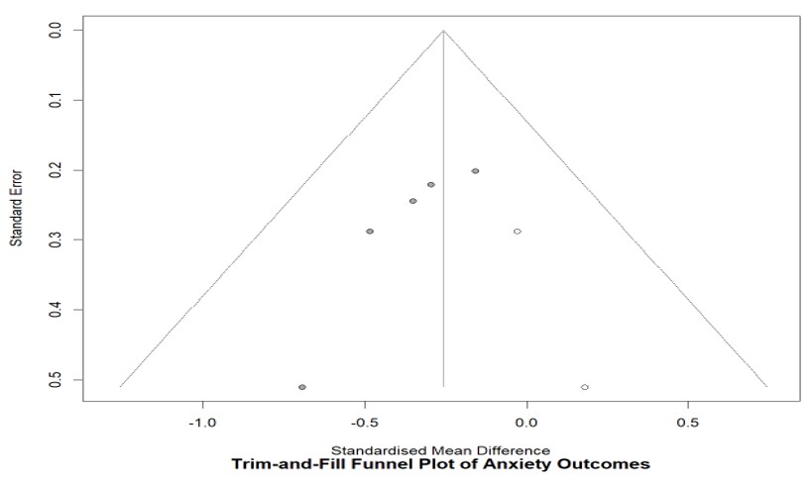
Figure 11: Trim-and-Fill Funnel Plot for Anxiety

Trim-and-fill analysis (Figure 11) suggested minimal publication bias.

Discussion
This systematic review and meta-analysis showed significant benefits for depression and anxiety outcomes with AI-based chatbot interventions compared to controls. The pooled depression effect size (SMD = -0.51) showed a moderate beneficial effect of the program, while the pooled anxiety effect size (SMD = -0.31) indicated a smaller but statistically significant effect. The results highlight the growing role of conversational AI systems in mental health care delivery in the digital domain. AI-powered chatbots can be effective for various reasons. One of the major benefits of conversational agents is that they allow individuals to access mental health services on demand, 24 hours a day. This would be especially meaningful to those who do not have access to mental health service providers or who face stigma or transportation issues [21]. Second, a substantial number of interventions included were based on the CBT approach, which has proven effective for depression and anxiety disorders [14,22]. Third, the anonymity and ease that come with a chatbot-guided intervention could foster users' engagement and openness about their emotional issues [23]. In the present study, the pooled effect of the depression was larger than the pooled effect of the anxiety. This variation is driven by the possibility that interventions using chatbots focus more on cognitive behavioral therapy (CBT) based mood management strategies, while those for anxiety disorders may need more than a standard therapeutic program. However, a significant reduction in symptoms was found with both pooled analyses. The point to note is that the level of heterogeneity was low in both analyses. There was little heterogeneity in the outcomes related to depression (I² = 5.6%) and no significant heterogeneity in the anxiety outcomes (I² = 0.0%). The results indicate that the effect of the interventions is fairly stable despite some differences in the platforms used for the chatbots, the characteristics of the users, and the different conditions that were found for the different comparisons. Examining funnel plots visually showed relatively symmetrical distributions, and trim and fill analyses showed no obvious signs of publication bias. In addition, leave-one-out sensitivity analyses were conducted that showed that the overall results were not significantly affected by the exclusion of a single study. The conclusions remained consistent across the studies, but Baujat plots suggested that some studies, in particular 'Liu et al' and 'Chen et al', contributed more to the shoulders of the dip in heterogeneity and pooled influence. The results of the present study are similar to previous systematic reviews about digital mental health interventions and conversational agents, which indicated comparable benefits and lack of side effects regardless of the platforms used [17-20,24]. Conversational agents have been shown to have positive impacts on mental health support, and chatbots are reported to be scalable and easily accessible [18,25]. Likewise, Vaidyam et al. highlighted the increasing relevance of AI applications in psychiatry and digital mental healthcare [26]. The implications of the clinical implementation and public health aspects of AI-based chatbot interventions are notable. Firstly, conversational agents could be a solution for mental health service shortages, especially in low-resource areas. Secondly, chatbots could offer the first psychological help to people averse to classic treatment. Secondly, chatbots could give early psychological support to people unwilling to get classic treatment. Third, these systems can also be used as complementary in addition to traditional psychotherapy and psychiatric care. Although the results were promising, some caveats need to be noted. First, the total number of RCTs included was fairly low, as many studies that we were interested in did not have means and SDs post the intervention identified for extraction. Secondly, interventions were often of brief duration, and the follow-up periods were brief, restricting conclusions about the long-term effects and sustained engagement in the intervention. Third, most literature included university students or people who were skilled with computers, so the findings may not apply to older people and the less technologically advanced. Fourth, the features of the chatbot designs were found to differ significantly across studies in terms of the therapeutic content, channels of conversation, and personalization. Further, evidence bases may not keep up with the current pace of change of generative AI technologies. While significant progress has been made in deepening the conversational abilities and personalization features of LLM systems, questions about hallucination, misinformation, privacy, and ethical safety continue to be pertinent safety concerns [27-29]. Moving forward, there is a need for more comprehensive studies of the safety, transparency, fairness, and clinical governance of AI.

Future Research
- Large multicenter randomized controlled trials
- Long-term follow-up and sustained engagement
- Diverse and underserved populations
- Standardized mental health outcome measures
- Ethical and privacy considerations
- Integration of generative AI and personalized psychotherapy support

Overall, the present findings support the growing role of AI-based chatbots as scalable and accessible tools for mental health support. Although these systems are unlikely to replace clinicians, they may represent valuable adjuncts to conventional mental health services.

Limitations
This meta-analysis has several limitations. The number of included studies was limited because several potentially relevant studies lacked extractable postintervention mean and standard deviation values. Additionally, variability in chatbot design, intervention duration, and outcome scales may influence pooled estimates. Publication bias could not be entirely excluded because of the relatively small number of included studies.

Conclusions
AI-driven chatbot interventions have shown considerable effectiveness in reducing symptoms of depression and anxiety. These findings suggest that conversational AI systems could serve as scalable and accessible tools for mental health support. While the observed effects were modest to moderate, AI chatbots may still offer an important complement to conventional psychological services. Further high-quality randomized controlled trials, involving larger sample sizes and extended follow-up, are warranted to solidify these findings.

References
- World Health Organization. Depression and Other Common Mental Disorders: Global Health Estimates. Geneva: WHO (2017).
- GBD 2019 Mental Disorders Collaborators. Global burden of mental disorders and implications for prevention and treatment. Lancet Psychiatry 9 (2022): 137-150.
- American Psychiatric Association. Diagnostic and Statistical Manual of Mental Disorders. 5th ed. Washington, DC: APA (2013).
- Patel V, Saxena S, Lund C, et al. The Lancet Commission on global mental health and sustainable development. Lancet 392 (2018): 1553-1598.
- Torous J, Bucci S, Bell IH, et al. The growing field of digital psychiatry. World Psychiatry 20 (2021): 318-335.
- Miner AS, Laranjo L, Kocaballi AB. Chatbots in the fight against mental health challenges. NPJ Digit Med 3 (2020): 65.
- Laranjo L, Dunn AG, Tong HL, et al. Conversational agents in healthcare: a systematic review. J Am Med Inform Assoc 25 (2018): 1248-1258.
- Inkster B, Sarda S, Subramanian V. An empathy-driven conversational AI agent for mental healthcare. Internet Interv 12 (2018): 80-86.
- Fitzpatrick KK, Darcy A, Vierhile M. Delivering cognitive behavior therapy to young adults using a fully automated conversational agent (Woebot): randomized controlled trial. JMIR Ment Health 4 (2017): e19.
- Fulmer R, Joerin A, Gentile B, et al. Using psychological artificial intelligence (Tess) to relieve symptoms of depression and anxiety: randomized controlled trial. JMIR Ment Health 5 (2018): e64.
- Liu D, Dineva T, Keenan A, et al. AI chatbot interventions for self-help depression support among university students: randomized controlled trial. Front Digit Health 2 (2022): 576361.
- He Y, Yang L, Huang J, et al. Effectiveness of a conversational agent intervention in reducing depressive symptoms among young adults. Front Digit Health 5 (2022): 1133987.
- Nicol G, Wang R, Graham S, et al. Chatbot-Delivered Cognitive Behavioral Therapy in Adolescents with Depression and Anxiety During the COVID-19 Pandemic: Feasibility and Acceptability Study. JMIR Form Res 6 (2022): e40242.
- Butler AC, Chapman JE, Forman EM, et al. The empirical status of cognitive-behavioral therapy: a review of meta-analyses. Clin Psychol Rev 26 (2006): 17-31.
- Sohn SY, et al. Conversational artificial intelligence interventions for mental health disorders: systematic review and future directions. NPJ Digit Med (2025).
- Bendig E, Erb B, Schulze-Thuesing L, Baumeister H. The next generation: chatbots in clinical psychology and psychotherapy. Internet Interv 16 (2019): 93-104.
- Abd-Alrazaq A, Alajlani M, Alalwan AA, et al. An overview of conversational agents in healthcare. J Med Internet Res 22 (2020): e16021.
- Gaffney H, Mansell W, Edwards R, et al. Conversational agents in mental health care: a systematic review. Front Psychiatry 10 (2019): 64.
- Page MJ, McKenzie JE, Bossuyt PM, et al. The PRISMA 2020 statement. BMJ 372 (2021): n71.
- Sterne JAC, Savović J, Page MJ, et al. RoB 2: revised tool for assessing risk of bias in randomized trials. BMJ 366 (2019): l4898.
- Clement S, Schauman O, Graham T, et al. What is the impact of mental health-related stigma on help-seeking? Psychol Med 45 (2015): 11-27.
- Cuijpers P, Karyotaki E, Reijnders M, et al. Meta-analyses and mega-analyses of the effectiveness of digital health interventions. World Psychiatry 18 (2019): 245-258.
- Provoost S, Lau HM, Ruwaard J, et al. Embodied conversational agents in clinical psychology. Internet Interv 10 (2017): 1-7.
- Vaidyam AN, Wisniewski H, Halamka JD, et al. Chatbots and conversational agents in mental health. Psychiatr Serv 70 (2019): 981-983.
- Inkster B, et al. Digital mental health and AI interventions. Internet Interv 12 (2018): 80-86.
- Torous J, Roberts LW. The ethical use of mobile health technology in psychiatry. J Nerv Ment Dis 205 (2017): 4-8.
- Harrer M, Cuijpers P, Furukawa TA, et al. Doing Meta-Analysis With R: A Hands-On Guide. Boca Raton: Chapman and Hall/CRC (2021).
- Balduzzi S, Rücker G, Schwarzer G. How to perform a meta-analysis with R. Evid Based Ment Health 22 (2019): 153-160.
- Miner AS, Shah N, Bullock KD, et al. Key considerations for AI in mental health care. NPJ Digit Med 2 (2019): 1-6.
- MacNeill H, et al. Mental health chatbot intervention among adults with chronic disease: randomized controlled trial. JMIR Form Res 8 (2024): e50025.


This article is an open-access article distributed under the terms and conditions of the
Creative Commons Attribution (CC-BY) license 4.0

