

Case Report

Hemorrhagic Intramuscular Schwannoma Mimicking Myxoid Neoplasm in the Anterior Deltoid of a Patient with Cholangiocarcinoma: A Case Report

Rishabh Agrawal*, Diego A L Garcia
University of Florida, Department of Radiology, Gainesville, FL, USA

*Corresponding Author: Rishabh Agrawal, University of Florida, Department of Radiology, Gainesville, FL, USA

Received: 04 March 2026; Accepted: 10 March 2026; Published: 18 March 2026

Citation: Rishabh Agrawal, Diego A L Garcia. Hemorrhagic Intramuscular Schwannoma Mimicking Myxoid Neoplasm in the Anterior Deltoid of a Patient with Cholangiocarcinoma: A Case Report. Journal of Radiology and Clinical Imaging 9 (2026): XX-XX.

Abstract
Background: Peripheral nerve sheath tumors (PNSTs) often present diagnostic challenges when complicated by hemorrhage or cystic degeneration, which can obscure classic imaging features. In oncologic patients, these atypical presentations may mimic metastases or myxoid neoplasms.
Case Presentation: A 58-year-old woman with a history of cholangiocarcinoma presented with a painful mass in the right shoulder. MRI revealed a 5.1 cm intramuscular lesion in the anterior deltoid with thick peripheral enhancement, central T2 hyperintensity, and a "fat-cap sign." Although imaging initially favored intramuscular myxoma or necrotic metastasis, biopsy confirmed a schwannoma with prominent intralesional hemorrhage.
Conclusion: Hemorrhagic schwannomas should be considered in the differential diagnosis of intramuscular masses with peripheral enhancement. Recognition of internal tubular structures and encapsulated growth patterns is key, though classic signs must be interpreted with caution in oncologic settings.

Keywords: Deltoid; Hemorrhagic degeneration; MRI; Oncology; Peripheral nerve sheath tumors; Schwannoma
1. Introduction
Schwannomas are typically benign, encapsulated soft tissue masses with predictable MRI signals, such as T1 isointensity and T2 hyperintensity. However, degenerative changes—including cystic/myxoid degeneration and intralesional hemorrhage—can mask classic diagnostic signs like the "target sign" or "split-fat sign." In the context of a patient with known malignancy, such as cholangiocarcinoma, a new soft tissue mass frequently raises concern for rare skeletal muscle metastasis or treatment-related changes. This case highlights the role of MRI in distinguishing between necrotic metastases, myxoid sarcomas, and benign but atypical schwannomas.

2. Case Presentation & Imaging Findings
A 58-year-old female presented with a painful, enlarging mass in the anterior right shoulder. Physical examination revealed a firm, mobile, and tender mass without neurologic deficits.

MRI Evaluation:
- Location and Morphology: A well-defined, lobulated 5.1 cm mass was centered within the anterior deltoid muscle.
- Signal and Enhancement: The lesion was isointense on T1 and heterogeneously hyperintense on T2/STIR (Figure 1). Post-contrast sequences demonstrated thick peripheral enhancement with a non-enhancing central component, suggesting cystic or hemorrhagic degeneration (Figure 2).
- Vascular/Neural Features: Tubular low-signal structures were noted along the margins, likely representing intratumoral vessels. A thin rim of fat (the "fat-cap sign") suggested encapsulation within the muscle (Figure 1).
- Advanced Imaging: PET/CT showed intense peripheral FDG uptake (SUVmax of 5.20), mirroring the enhancement pattern seen on MRI and further complicating the exclusion of malignancy (Figure 3).

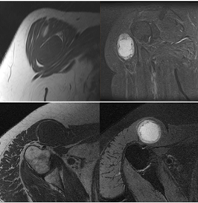

Figure 1: Sagittal T1-weighted (top left), Coronal T2-weighted fat-suppressed (top right), Axial T1-weighted (bottom left), Axial PD-weighted fat-suppressed (bottom right) demonstrate a well-defined intramuscular lesion surrounded by a thin, circumferential fat rim (“fat cap” sign). Note: The fat-cap sign suggests encapsulation but requires correlation to exclude low-grade malignancy

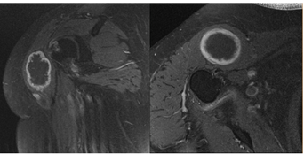

Figure 2: Coronal (left) and Axial (right) T1-weighted fat-suppressed post-contrast images demonstrate a well-circumscribed intramuscular centrally T1 hypointense with thick, irregular peripheral enhancement.

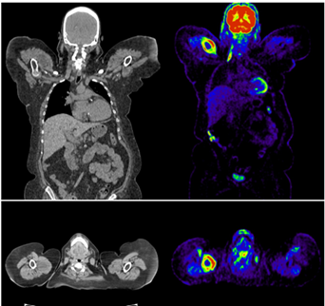

Figure 3: Coronal (top) and axial (bottom) PET/CT images demonstrate peripheral FDG uptake corresponding to the enhancing rim of the lesion, with no central metabolic activity.

3. Histopathology & Discussion
Ultrasound-guided biopsy revealed spindle cell proliferation with alternating Antoni A (hypercellular) and Antoni B (myxoid) areas. Presence of S100 protein positivity and hemosiderin-laden macrophages confirmed a schwannoma with recent hemorrhage. No epithelial malignancy was found, ruling out metastatic cholangiocarcinoma.

4. Differential Diagnosis:
Schwannomas demonstrate variable MRI characteristics depending on their internal composition. In this case, the peripheral enhancement pattern reflects the viable cellular component surrounding a hemorrhagic core.
It is important to emphasize that the "fat-cap sign" (or split-fat sign)—while a classic indicator of a peripheral nerve sheath tumor—is not strictly pathognomonic for benignity. While it suggests a slow-growing, encapsulated lesion that displaces rather than infiltrates adjacent fat, certain low-grade malignancies or even metastases with expansive growth patterns can occasionally mimic this appearance.

- Intramuscular Myxoma: Often shows central T2 hyperintensity and peripheral enhancement but typically lacks the internal vascular/tubular structures seen in this case.
- Soft Tissue Metastasis: While rare for cholangiocarcinoma, these are usually more infiltrative and lack a well-defined fat plane.
- Myxoid Sarcoma: Usually presents with more aggressive features, such as ill-defined margins and extensive perilesional edema.

5. Conclusion
This case demonstrates that peripheral enhancement in an intramuscular lesion is not pathognomonic for myxoid neoplasms or necrotic metastases. While the "fat-cap sign" is a useful diagnostic clue, it must be interpreted with caution in oncologic patients as it does not definitively exclude low-grade malignancy. Schwannomas with hemorrhagic degeneration should remain a key consideration in the differential diagnosis of well-circumscribed intramuscular masses.

References
- Kransdorf MJ, Murphey MD. Imaging of Soft Tissue Tumors. Lippincott Williams & Wilkins; 3rd edtn (2013).
- Beaman FD, Kransdorf MJ, Menke DM. Schwannoma: radiologic-pathologic correlation. Radiographics 24 (2004): 1477-1481.
- Pilavaki M, Chourmouzi D, Kiziridou A, et al. Imaging of peripheral nerve sheath tumors with pathologic correlation: pictorial review. Eur J Radiol 52 (2004): 229-239.
- Murphey MD, McRae GA, Fanburg-Smith JC, et al. Imaging of soft-tissue myxoma with emphasis on CT and MR imaging. Radiology 225 (2002): 215-224.


This article is an open access article distributed under the terms and conditions of the
Creative Commons Attribution (CC-BY) license 4.0

