

Case Report

Moyamoya Vasculopathy with Atypical Cogan’s Syndrome: A Case Report

Amy Phu¹, Erica Chao¹, Ranjana Sood², David R. Chen², Devendra K. Agrawal¹*,
¹Department of Translational Research, College of Osteopathic Medicine of the Pacific, Western University of Health Sciences, Pomona, California 91766 USA
²El Camino Health, Mountain View, California 94040 USA

*Corresponding Author: Devendra K Agrawal, Department of Translational Research, College of Osteopathic Medicine of the Pacific, Western University of Health Sciences, Pomona, California 91766 USA

Received: 29 May 2026; Accepted: 08 June 2026; Published: 06 July 2026

Citation: Amy Phu, Erica Chao, Ranjana Sood, David R. Chen, Devendra K. Agrawal. Moyamoya Vasculopathy with Atypical Cogan’s Syndrome: A Case Report. Archives of Clinical and Medical Case Reports 10 (2026): 323-328.

Abstract
Cogan’s syndrome (CS) is a rare autoimmune disorder involving audio-vestibular and ocular inflammation. While systemic vasculitis is a known complication, its association with Moyamoya-type cerebrovascular remodeling has not been previously documented. A 19-year-old Asian woman was diagnosed with atypical CS following a presentation of hyperpyrexia, unintentional weight loss, and severe bilateral sensorineural hearing loss. After five years of appropriate immunosuppressive treatment, she developed subacute headaches, hypertension, and left hemiparesis and paresthesia. Despite normal inflammatory markers, neuroimaging revealed right-sided internal carotid artery occlusion and extensive collateralization characteristic of Moyamoya syndrome. Genetic testing showed a variant of uncertain significance in SLC37A4. The patient underwent a right extracranial-intracranial (STA-MCA) bypass, resulting in complete resolution of neurological symptoms. The late emergence of Moyamoya suggests that chronic autoimmune-mediated vascular injury may trigger progressive steno-occlusive disease. Clinicians should consider Moyamoya syndrome as a differential for new neurological symptoms in CS patients, even when systemic inflammation appears controlled. To our knowledge, this is the first reported case of concurrent Cogan’s syndrome and Moyamoya vasculopathy at time of writing this article.

Keywords: Audio-vestibular dysfunction; Circle of Willis stenosis; Cogan’s Syndrome; Moyamoya disease; Moyamoya syndrome; Ocular inflammation; Vasculitis

1. Introduction
Cogan’s Syndrome (CS) is an extremely rare multisystem autoimmune disorder presenting with non-syphilitic keratitis and audio-vestibular symptoms. Its clinical manifestations include vertigo, tinnitus, deafness, and reduced vision [1]. Typical CS presents interstitial keratitis and hearing loss, while atypical CS is characterized by inflammatory ocular symptoms alongside audio-vestibular symptoms and systemic inflammation vasculitis in approximately 70% of patients [1-3]. Neurological manifestations associated in patients with CS include hemiparesis or hemiplegia due to cerebral vascular events, and aphasia secondary to transient ischemic events [4,5].
Conversely, Moyamoya disease and syndrome are rare and chronic cerebrovascular conditions characterized by stenoses and occlusion of the terminal portion of the internal carotid artery and its main branches, leading to formation of an abnormal collateral vascular network at the base of the brain [6,7]. When a patient meets the diagnostic criteria for Moyamoya disease but also has a preexisting condition, such as autoimmune disease and genetic disorders, it is classified as Moyamoya syndrome [6]. Clinical manifestations include transient ischemic attacks, strokes, and other nonspecific neurological manifestations such as headache, neurocognitive impairment, and movement disorders [6]. At time of writing, no prior cases of Moyamoya vasculopathy in patients with Cogan’s syndrome have been reported in the literature.

2. Methods
A retrospective review of the patient’s medical records, including laboratory results and imaging studies was conducted, encompassing data from May 2017 through January 2026. To provide clinical context, a literature search was conducted in PubMed and Google Scholar using keywords “Moyamoya, Cogan’s syndrome, infliximab, methotrexate, hearing loss, vasculitis. “Fifty articles were initially reviewed with 23 articles selected for inclusion with dates of publication ranging from years 1959 to 2025. The patient’s consent was received for their medical records to be used for publication. This case report was deemed not human subject research by the Institutional Review Board of Western University of Health Sciences, Pomona, California, USA.

3. Case Presentation
The patient is a 19-year-old Asian woman presenting to the internal medicine clinic with a three-month history of daily intermittent fevers (102-104°F) and chills, drenching night sweats, loss of appetite, significant weight loss, nonproductive cough, and acute hearing loss. The patient also reported mild pain in her metacarpophalangeal joints (MCP) and ankles and knees bilaterally. The patient presented with a fatigued appearance; blood pressure readings were elevated at 143/71 mmHg, and persistent tachycardia was noted due to resting heart rate of 118 beats per minute Audiometric evaluation revealed bilateral severe sensorineural hearing loss (SNHL) (Figure 1). Laboratory tests showed significantly elevated inflammatory markers, with an erythrocyte sedimentation rate (ESR) of 88 mm/h and a C-Reactive protein (CRP) of 47.3 mg/L. Lactate dehydrogenase (LDH) was mildly elevated at 291 U/L. Transthoracic echocardiogram and chest X-ray were unremarkable. Exhaustive outpatient infectious disease workup including blood and urine cultures, and ANCA, ANA, CMV, HSV, Cocci, Brucella, and Coxiella serologies were all negative. Whole body 18-Fluorodeoxyglucose-positron emission tomography (FDG-PET) was performed to rule out lymphoma in consideration of the elevated ESR and presenting constitutional symptoms of weight loss, nonproductive cough, and fever. Cranial Magnetic Resonance imaging (MRI), including the internal auditory canal, was unremarkable. The patient was subsequently referred to and evaluated in a rheumatology clinic, where a differential diagnosis of Cogan’s syndrome was proposed. Given the patient’s severe hearing loss and systemic symptoms warranting high acuity care, the patient was admitted to the medical/surgical unit for multispecialty evaluation. The inpatient physical exam by otology and ophthalmology was unremarkable. Neurological examination revealed inability to hear fingers rub bilaterally but was otherwise unremarkable. Lupus analyzer and anti-hsp70 antibody (anti-inner ear antigen antibodies) were negative. CBC with differentials showed mild anemia. The comprehensive metabolic panel was unremarkable. Procalcitonin was elevated (0.25 ng/mL). The diagnosis of Cogan’s syndrome was established after exclusion of potential infectious, neurological, and malignant etiologies, as well as in consideration of the clinical presentation and elevated inflammatory markers.

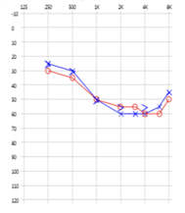

Figure 1: Audiogram 4/5/17 (at initial onset). Pure tone threshold: Right ear: mild to moderately severe SNHL 250-6000 Hz rising to moderate hearing loss at 8000 Hz; Left ear: normal hearing sensitivity at 250 Hz with a mild to moderately severe SNHL 250-6000 Hz rising to moderate hearing loss at 8000 Hz. SRT (in dB): 40 R, 45 L; WRS (in %): 88 R, 76 L; Tympanogram: Type A AU.

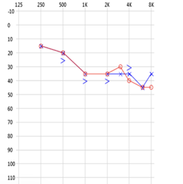

Figure 2: Audiogram 6/5/17 (after methylprednisolone treatment). Pure tone threshold: Bilateral mild to moderate SNHL above 0.5 kHz. There has been an overall improvement of 5 to 20 dB. Speech threshold down to 30 dB HL. Tympanogram: Type As AU.

The patient was treated with intravenous 1 mg/kg Solu-Medrol. Significant clinical improvement followed, with complete resolution of fever and dry cough within 24 hours of Solu-Medrol (methylprednisolone) administration. Despite significant improvement in hearing loss, the patient continued to have mild SNHL (Figure 2). Given the lack of ocular symptoms at onset and presence of systemic involvement, this case would be classified as an atypical presentation of Cogan’s syndrome. Serum inflammatory markers, CBC, and LDH eventually returned to normal ranges with outpatient prednisone treatment at a starting dosage of 60 mg/day. The patient was gradually tapered off oral prednisone over the course of approximately 6 months and maintained on a regimen of methotrexate 20mg once a week for continued immunosuppression. The patient’s hearing remained stable, and no disease flares occurred with this therapeutic regimen. Approximately five years later in 2022, the patient experienced a second episode of acute decline in hearing. Due to suspicion of hearing loss secondary to recurrence of Cogan’s syndrome, ESR, CRP, complete blood counts, and comprehensive metabolic panels were ordered. However, all laboratory tests were found to be within normal limits. SNHL was the sole presenting symptom during this episode, with no systemic symptoms (Figure 3). Despite unremarkable inflammatory markers and laboratory test results, the patient was begun on 40 mg/day oral prednisone and infliximab under the assumption the hearing loss was due to an underlying inflammatory process.
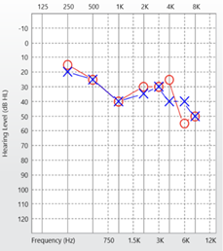
Figure 3: Audiogram 1/3/24 (worsening SNHL initially noted in 2022, unchanged after treatment with prednisone, infliximab therapy, and craniotomy for Moyamoya vasculopathy). Pure tone threshold: Normal hearing sensitivity 250-500Hz sloping mild to moderate sensorineural hearing loss 1000-8000Hz; SRT (in dB): 35 AU; WRS (in %): 100 AU; Tympanogram: Type As AU.

The patient experienced no improvement in hearing despite concurrent prednisone, infliximab, and methotrexate therapy. Prednisone was gradually tapered and discontinued, while the patient continued receiving infliximab therapy every 8 weeks in addition to weekly 20mg methotrexate. After about 6 months on this immunosuppressive regimen, the patient presented again to rheumatology clinic for routine follow-up with 2 months of subacute onset of hypertension, nausea, vomiting, and unilateral right sided headaches, fatigue and neuropsychiatric disturbances with progression to intermittent left upper extremity paresthesia and weakness, and postural tremor of the fourth and fifth digits of the left hand. Admission to the emergency department and subsequent MRI and CT head imaging studies demonstrated a focal occlusion of the right M1 middle cerebral artery (MCA) with extensive Moyamoya vessels; thus, a diagnosis of Moyamoya disease was established. The patient was discharged home on daily aspirin 81 mg and 40 mg. Despite weeks of aspirin and statin therapy, the patient’s symptoms continued to progress, warranting an urgent visit to rheumatology clinic, where orthostatic tachycardia and hypertension (BP 165/95 mmHg) was noted during the physical exam. The patient was admitted to neurology inpatient service for further multispecialty assessment given the progressive neurological symptoms and abnormal vital signs. Inpatient evaluation revealed ophthalmological findings of a singular cotton wool spot in the left eye, mild bilateral cataracts and keratoconjunctivitis sicca. The otolaryngological physical exam was unremarkable. MR chest, abdomen, pelvis angiography with and without IV contrast findings revealed no evidence of large vessel vasculitis. MRI brain with and without intravenous contrast and Diamox showed chronic right anterior superficial and deep border zone infarcts, right anterior circulation steno-occlusive disease of the right carotid terminus and MCA with collateralization compatible with Moyamoya vasculopathy and right MCA territory hypoperfusion without augmentation after Diamox administration. CT of the brain revealed peripheral right frontal wedge-shaped area of chronic appearing infarction and areas of border zone injury in the right hemispheric white matter. Intracranial CT angiogram revealed critical stenosis/occlusion of the right supraclinoid internal carotid artery (ICA), segmental occlusion of the proximal right M1, with distal reconstitution via collateral vessels, proximal stenosis and diffuse small caliber A1 consistent with Moyamoya vasculopathy.

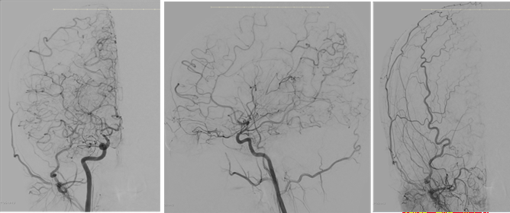

Figure 4: Preoperative diagnostic cerebral angiogram (left and middle image: right internal carotid artery (ICA), right image: right external carotid artery (ECA).

Diagnostic cerebral angiogram showed unilateral right side Moyamoya disease with severe steno-occlusive disease of the right ICA terminus involving the origin of the A1 segment of the right anterior cerebral artery with concurrent occlusion of the right MCA at its origin and extensive right hemispheric cortical collateral vessels (Figure 4). The Invitae comprehensive neuropathies panel analyzed genes that are associated with hereditary neuropathies including aortopathy comprehensive panel, autoinflammatory and autoimmunity syndromes panel, and hereditary Moyamoya disease panel. The findings revealed a heterozygous variant (c.703G>T [p.Val235Leu]) of uncertain significance in gene SLC37A4. Serum results for ESR, C-reactive protein, antineutrophil cytoplasmic antibodies, rheumatoid factor, anti-cyclic citrullinated peptide, double-stranded DNA, IgG and IgM anticardiolipin antibodies, lupus inhibitor, dilute Russell’s viper venom time and cryoglobulins were all negative or normal. Lumbar puncture was performed to exclude primary CNS vasculitis, the results of which were unremarkable. Cerebrospinal fluid, blood, and urine cultures were unremarkable except for mild leukocytosis and elevated Hb of 16.4. The patient underwent unilateral right extracranial-intracranial bypass with the right superficial temporal artery (STA) to the right MCA. The STA was placed on the cortical surface to induce an indirect bypass, as well as a direct one. The surgery was without complications, and the patient experienced complete resolution of nausea, vomiting, headache, hypertension, and neuropsychiatric disturbances. The bilateral sensorineural hearing loss, postural tremor of the 4th and 5th digits of the left upper extremity, and mild left upper extremity weakness persisted. This patient continues to be on an immunosuppressive regimen of 20mg oral methotrexate weekly and bimonthly infliximab infusions with no further fluctuations in hearing. Due to the poor prognosis of Cogan’s syndrome as noted in the medical literature, aggressive continued immunosuppressive therapy to prevent disease progression and recurrence of systemic vasculitis will be continued indefinitely. The patient continues to have routine follow-up with rheumatology, audiology and neurology. Annual MRI and

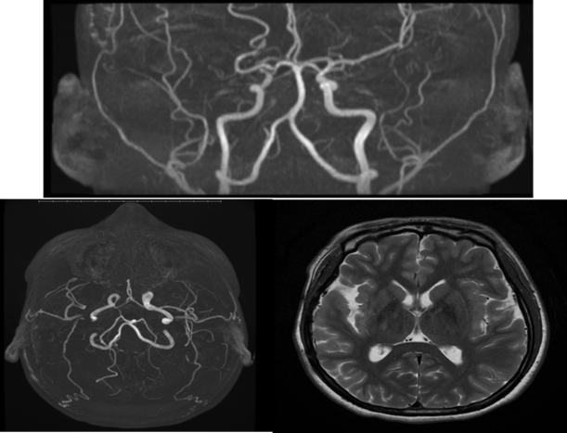

Figure 5: Postoperative MRI/MRA brain with diamox, axial T2. Stable collateralized severe steno-occlusive disease involving the right carotid terminus with leptomeningeal collaterals compatible with moyamoya vasculopathy, augmentation in all vascular territories after administration of Diamox.

MRA of the head and neck is performed to monitor for development of vasculopathy on the left hemisphere of the brain (Figure 5). Additionally, digital subtraction angiograms were performed one, five, then ten years post-surgery to ensure bypass patency (Figure 6).
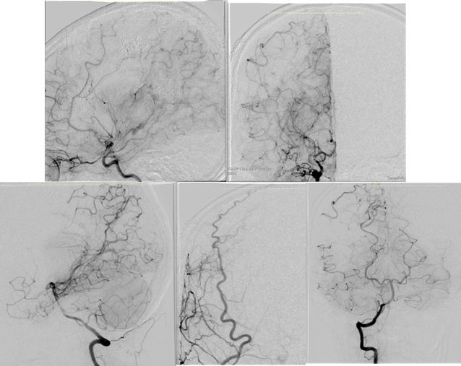

Figure 6: Postoperative cerebral angiogram showing patent right superficial temporal to middle cerebral artery bypass that supplies approximately 25% of the right MCA territory, with additional indirect supply that arises from the right middle meningeal artery.

4. Discussion
The year 2022 episode of acute hearing loss in this patient presents a diagnostic challenge since it occurred in the context of both established CS and subsequently diagnosed Moyamoya syndrome. Hearing loss associated with Moyamoya disease is rare but well-documented in the literature [8-10]. The mechanism of hearing loss in Moyamoya disease can occur through several pathways: microvascular ischemia affecting the inner ear, central deafness from bilateral temporal lobe infarction, or ischemia of the labyrinthine artery. In this case, the 2022 hearing deterioration occurred with normal inflammatory markers, distinguishing it from the initial 2017 presentation of CS. This raises the possibility that microvascular ischemia or temporal subcortical hemorrhage causing damage related to evolving Moyamoya vasculopathy may have contributed to the progressive hearing loss [11,12]. The cochlea is supplied by the labyrinthine artery, an end artery without collateral circulation, thus making it particularly vulnerable to ischemic injury. Studies have demonstrated that patients with cardiovascular risk factors and vascular disease have higher rates of sudden SNHL, with the presumed mechanism being circulatory disturbance and cochlear infarction [10-12]. However, considering the unilaterality of the patient’s moyamoya syndrome and relatively symmetric SNHL, it is unclear if this is likely to be a major contributing factor to the acute episode of SNHL in 2022.
The atypical presentation of CS without initial ocular involvement highlights the diagnostic challenge and the need for high clinical suspicion in young patients with unexplained systemic inflammation and hearing loss [14,15]. Additionally, the development of Moyamoya syndrome five years after the initial CS diagnosis raises important questions about the relationship between autoimmune vasculitis and cerebrovascular disease. Recent evidence suggests that Moyamoya may have an immune-related component, with autoimmune conditions reported in association with Moyamoya vasculopathy. Studies have shown increased prevalence of autoimmune diseases, particularly thyroid disease and type 1 diabetes, in Moyamoya patients compared to the general population [6,16,17]. This case highlights the critical importance of early and aggressive immunosuppressive therapy in CS. While this patient achieved initial disease control with corticosteroids and methotrexate, the addition of infliximab has been shown in multiple studies to be particularly effective for audio-vestibular symptoms in steroid-refractory cases [18,19]. The literature suggests that infliximab is the only significant predictor of audio-vestibular improvement in CS, with response rates of 80% compared to 35-39% with steroids or conventional DMARDs alone [19]. Early initiation of biologic therapy may prevent irreversible hearing loss and should be considered in patients with progressive audio-vestibular symptoms despite conventional immunosuppression. The heterozygous SLC37A4 variant (c.703G>T [p.Val235Leu]) identified in this patient is classified as a variant of uncertain significance. SLC37A4 encodes glucose-6-phosphate translocase (G6PT), and biallelic pathogenic variants in this gene cause glycogen storage disease type Ib (GSD1b), an autosomal recessive disorder characterized by hepatomegaly, hypoglycemia, neutropenia, and inflammatory bowel disease [20-22]. A specific heterozygous variant in SLC37A4 (c.1267C>T, p.Arg423Trp) has recently been identified as causing a dominantly inherited congenital disorder of glycosylation (CDG) characterized by liver dysfunction and coagulopathy [20,23]. This dominant-negative variant causes mislocalization of the mutant protein, altered Golgi morphology, and abnormal N-glycosylation patterns [20]. However, the p.Val235Leu variant identified in this patient has not been previously reported in association with either GSD1b or CDG, and its clinical significance remains uncertain.

Since this patient is heterozygous for the SLC37A4 variant and does not exhibit the classic features of GSD1b (hepatomegaly, hypoglycemia, or neutropenia) in addition to the absence of coagulopathy characteristic of SLC37A4-CDG, this variant is likely a benign polymorphism or a variant of uncertain significance without direct pathogenic relevance to either CS or Moyamoya disease. Further studies are necessary to determine if this specific variant has any biological effect on G6PT function.

5. Conclusion
This case represents a unique presentation of atypical CS complicated by the subsequent development of unilateral Moyamoya syndrome. In the year 2022 hearing deterioration likely represents a multifactorial process with potential involvement of both ongoing autoimmune inner ear disease and emerging cerebrovascular insufficiency from Moyamoya vasculopathy. The association between these two rare conditions in a single patient supports the growing recognition of immune-mediated mechanisms in Moyamoya disease pathogenesis and highlights the need for comprehensive long-term monitoring of patients with systemic vasculitis. The SLC37A4 variant identified appears to be incidental and unrelated to the patient's clinical phenotype. This case emphasizes the importance of early aggressive immunosuppression in CS, the potential benefit of biologic agents such as infliximab for audio-vestibular symptoms, and the need for vigilant neurological surveillance in patients with autoimmune vasculitis to detect evolving cerebrovascular complications.

Declaration
This case report is presented in an anonymous manner. All authors have reviewed the case report, the findings, and the interpretation, and approved it for submission to publish in the journal. Permission was granted by the attending rheumatologist and neurologist to use the patient’s medical history, angiograms and MRI/MRA images in this case report.

Author Contributions
All authors contributed to analyzing the patient case as well as the authoring and editing of the manuscript.

Funding
The research work of DKA is supported by the R25AI179582 grant from the National Institutes of Health, USA. The contents of this research article are solely the responsibility of the authors and do not necessarily represent the official views of the National Institutes of Health.

Competing interests
All authors have read the manuscript and declare no conflict of interest. No writing assistance was utilized in the production of this manuscript.

Consent for publication
All authors have read the manuscript and consented for publication.

References
- D'Aguanno V, Ralli M, de Vincentiis M, Greco A. Optimal management of Cogan's syndrome: a multidisciplinary approach. J Multidiscip Healthc 11 (2017): 1-11.
- Cogan DG. Syndrome of nonsyphilitic interstitial keratitis and vestibuloauditory symptoms. Arch Ophthalmol 33 (1945): 144-149.
- Kessel A, Vadasz Z, Toubi E. Cogan syndrome--pathogenesis, clinical variants and treatment approaches. Autoimmun Rev 13 (2014): 351-354.
- Bicknell JM, Holland JV. Neurologic manifestations of Cogan syndrome. Neurology 28 (1978):278-281.
- Chynn EW, Jakobiec FA. Cogan’s syndrome: ophthalmic, audiovestibular, and systemic manifestations and therapy. Int Ophthalmol Clin 36 (1996): 61-72.
- Gonzalez NR, Amin-Hanjani S, Bang OY, et al. American Heart Association Stroke Council; Council on Cardiovascular and Stroke Nursing; and Council on Clinical Cardiology. Adult Moyamoya Disease and Syndrome: Current Perspectives and Future Directions: A Scientific Statement From the American Heart Association/American Stroke Association. Stroke 54 (2023): e465-e479.
- Liu Z, Wang Y, Li C, et al. Moyamoya Disease: Epidemiology, Clinical Characteristics, Diagnosis, Physiopathology, and Treatment. Cerebrovasc Dis (2025): 1-15.
- Tseng LS, Luo SD. Unilateral sudden hearing loss as the first presenting symptom of moyamoya disease. J Laryngol Otol 127 (2013): 196-199.
- Setzen G, Cacace AT, Eames F, et al. Central deafness in a young child with Moyamoya disease: paternal linkage in a Caucasian family: two case reports and a review of the literature. Int J Pediatr Otorhinolaryngol 48 (1999): 53-76.
- Tabuchi S. Auditory dysfunction in patients with cerebrovascular disease. ScientificWorldJournal (2014): 261824.
- Silva J, Sousa M, Mestre S, et al. Cortical deafness of following bilateral temporal lobe stroke. J Stroke Cerebrovasc Dis 29 (2020): 104827.
- Tsuzuki N, Wasano K, Oishi N, et al. Severe sudden sensorineural hearing loss related to risk of stroke and atherosclerosis. Sci Rep 11 (2021): 20204.
- Schreiber BE, Agrup C, Haskard DO, et al. Sudden sensorineural hearing loss. Lancet 375 (2010): 1203-1211.
- Belfeki N, Ghriss N, Kammoun S, et al. A comprehensive review. Eur J Intern Med 138 (2025): 35-43.
- Pagnini I, Zannin ME, Vittadello F, et al. Clinical features and outcome of Cogan syndrome. J Pediatr 160 (2012): 303-307.e1.
- Asselman C, Hemelsoet D, Eggermont D, et al. Moyamoya disease emerging as an immune-related angiopathy. Trends Mol Med 28 (2022): 939-950.
- Bower RS, Mallory GW, Nwojo M, et al. Moyamoya disease in a primarily white, midwestern US population: increased prevalence of autoimmune disease. Stroke 44 (2013): 1997-1999.
- Tayer-Shifman OE, Ilan O, Tovi H, et al. Cogan's syndrome--clinical guidelines and novel therapeutic approaches. Clin Rev Allergy Immunol 47 (2014): 65-72.
- Durtette C, Hachulla E, Resche-Rigon M, et al. Cogan syndrome: Characteristics, outcome and treatment in a French nationwide retrospective study and literature review. Autoimmun Rev 16 (2017): 1219-1223.
- Ng BG, Sosicka P, Fenaille F, et al. A mutation in SLC37A4 causes a dominantly inherited congenital disorder of glycosylation characterized by liver dysfunction. Am J Hum Genet 108 (2021): 1040-1052.
- Xia Y, Sun Y, Du T, et al. Genetic Variants and Clinical Features of Patients With Glycogen Storage Disease Type Ib. JAMA Netw Open 8 (2025): e2461888.
- Kishnani PS, Austin SL, Abdenur Je, et al. American College of Medical Genetics and Genomics. Diagnosis and management of glycogen storage disease type I: a practice guideline of the American College of Medical Genetics and Genomics. Genet Med 16 (2014): e1.
- Raynor A, Haouari W, Ng BG, et al. SLC37A4-CDG: New biochemical insights for an emerging congenital disorder of glycosylation with major coagulopathy. Clin Chim Acta 521 (2021): 104-106.


This article is an open access article distributed under the terms and conditions of the
Creative Commons Attribution (CC-BY) license 4.0

