

Case Report

Not All that Bleeds is a GIST: A Case of Gastric Glomus Tumor

Molina Estavillo LH, García Flores JE, De León-Rosas DA, Treviño-Ayala M*, Ibarra Cruz G, Guzmán De La Garza DE, Campos Cruz CP

Department of General Surgery, Universidad de Monterrey, Hospital Christus Muguerza Alta Especialidad, Monterrey Nuevo León, México

*Corresponding Author: Treviño-Ayala M, Department of General Surgery, Universidad de Monterrey, Hospital Christus Muguerza Alta Especialidad, Monterrey Nuevo León, México

Received: 11 July 2025; Accepted: 18 August 2025; Published: 25 August 2026

Citation: Molina Estavillo LH, García Flores JE, De León-Rosas DA, Treviño-Ayala M*, Ibarra Cruz G, Guzmán De La Garza DE, Campos Cruz CP. Not All that Bleeds is a GIST: A Case of Gastric Glomus Tumor. Journal of Surgery and Research 9 (2026): 265-268.

Abstract
Introduction: Gastric glomus tumors (GGTs) are rare mesenchymal neoplasms that often mimic more common submucosal tumors such as GISTs or neuroendocrine tumors. Their diagnosis is challenging and relies on histopathology and immunohistochemistry.
Case Presentation: We report the case of a 34-year-old female with a history of long-standing asthma who presented with melena, asthenia, and anemia (Hb 5.5 g/dL). Imaging and endoscopy revealed a 4 cm submucosal, hypervascular mass in the gastric antrum. EUS-guided biopsy suggested a glomus tumor. She underwent laparoscopic distal gastrectomy. Histopathological analysis confirmed a glomus tumor, positive for smooth muscle actin and negative for chromogranin A, synaptophysin, DOG1, and INSM1. Postoperative recovery was uneventful.
Discussion: GGTs originate from modified smooth muscle cells of the glomus body and typically present with nonspecific symptoms such as GI bleeding. Immunohistochemistry is essential for diagnosis. Surgical resection is curative in most cases.
Conclusion: Gastric glomus tumors, although rare, should be considered in the differential diagnosis of subepithelial gastric masses with GI bleeding. Surgical resection offers an excellent prognosis in benign cases.

Keywords: Glomus tumor; Gastric neoplasm; Submucosal mass; Upper GI bleeding; Laparoscopic gastrectomy
Introduction and Importance
Gastric glomus tumors (GGTs) are rare mesenchymal neoplasms arising from modified smooth muscle cells of the glomus body, a specialized arteriovenous structure primarily involved in thermoregulation. While glomus tumors typically occur in the distal extremities, especially in subungual regions, their occurrence in visceral organs is uncommon. Within the gastrointestinal tract, the stomach is the most frequent site, particularly the antrum, yet GGTs represent less than 1% of all gastrointestinal soft tissue tumors [1,2].
Clinically, GGTs often present with nonspecific symptoms such as epigastric discomfort, gastrointestinal bleeding, or anemia. Owing to their submucosal location and vascular nature, they are frequently misdiagnosed as gastrointestinal stromal tumors (GISTs) or neuroendocrine tumors (NETs) based on endoscopic or imaging findings [3,4]. Radiologic modalities such as contrast-enhanced computed tomography (CT) and endoscopic ultrasound (EUS) may help in identifying a well-circumscribed, hypervascular lesion; however, definitive diagnosis relies on histopathological examination and immunohistochemistry [1,5].
Accurate diagnosis is essential because the therapeutic approach and prognosis differ significantly from those of GISTs and NETs. Surgical resection remains the mainstay of treatment and is typically curative in benign cases [2,5]. Here, we present a case of a young woman with upper gastrointestinal bleeding secondary to a gastric glomus tumor, highlighting the diagnostic challenges and surgical management of this rare entity.

Objective
The purpose of this report is to report a rare case of upper gastrointestinal bleeding caused by a gastric glomus tumor in a young female patient, emphasizing the diagnostic challenges, the importance of immunohistochemistry for accurate differentiation from other subepithelial gastric tumors, and the effectiveness of laparoscopic distal gastrectomy as a safe and curative treatment approach.

Case Presentation
A 34-year-old female with a history of long-standing asthma under medical treatment presented with a 3-week history of melena occurring in more than five episodes, associated with asthenia, adynamia, chills, low-grade fever, nausea without vomiting, and exertional dyspnea. She also reported diffuse colicky abdominal pain exacerbated by defecation and relieved by rest. Initial blood work performed externally revealed a hemoglobin of 5.5 g/dL, prompting hospital admission.
On admission, vital signs were: heart rate 115 bpm, respiratory rate 24 bpm, blood pressure 96/68 mmHg, temperature 36.2°C, BMI 32.03. Physical examination showed pallor of the oral mucosa and stable cardiopulmonary and abdominal findings without peritoneal signs.
Laboratory tests confirmed normocytic, normochromic anemia. She received a total of 5 packed red blood cell transfusions during her hospitalization. A contrast-enhanced abdominal CT scan revealed a well-circumscribed, hypervascular, nodular lesion measuring 30×28×24 mm located in the gastric antrum, suggestive of a submucosal origin, with heterogeneous enhancement and central necrosis (Figure 1).
Upper GI endoscopy showed digested blood remnants and multiple fundic-appearing polyps. A lobulated mass of approximately 40 mm was observed in the posterior wall of the antrum, with ulcerated areas and an adherent clot. Epinephrine was injected for hemostasis (Figure 2). Endoscopic ultrasound (EUS) revealed a 4 cm hyperechoic, heterogeneous lesion arising from the muscularis propria, with internal vascularity. Fine needle aspiration (FNA) and cell block analysis were performed (Figure 3).
Cytological examination of the aspirate revealed a neoplasm composed of small round blue cells. Immunohistochemistry showed strong diffuse positivity for smooth muscle actin (SMA), focal weak positivity for synaptophysin, and negative staining for DOG1, INSM1, and chromogranin A. The Ki-67 index was 3%. These findings confirmed the diagnosis of a gastric glomus tumor [1-3] (Figure 4).
A laparoscopic distal gastrectomy was performed with subtotal resection of the stomach, beginning 4 cm proximal to the pylorus and extending to the angle of His. The specimen was extracted through a left flank incision. Staple line hemostasis was reinforced with serosal suturing, and intraoperative leak test with methylene blue was negative. The patient was transferred stable to recovery and had an uneventful postoperative course (Figure 5).

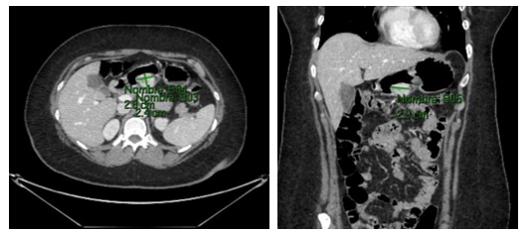

Figure 1: Contrast-enhanced abdominal CT scan.

Well-defined, hypervascular nodular lesion with circumscribed margins located in the gastric antrum, likely of submucosal origin. The lesion measures 30 × 28 × 24 mm and demonstrates heterogeneous enhancement after intravenous contrast administration, with areas of internal necrosis.

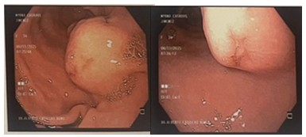
Figure 2: Upper Endoscopy

Toward the posterior aspect of the antrum, a lobulated tumor measuring approximately 40 mm in diameter is observed, presenting multiple surface ulcerations, including one in the distal region with an adherent clot.

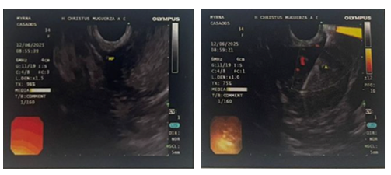
Figure 3: Endoscopic Ultrasound

Review of the gastric antrum reveals a 4 cm subepithelial lesion, hyperechogenic and heterogeneous, originating from the muscularis propria and showing vascularization.

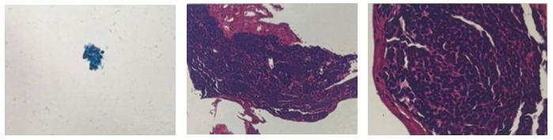

Figure 4: Biopsy

Gastric antrum lesion resulting from fine needle aspiration biopsy → small round blue cell neoplasm with an immunophenotype compatible with a glomus tumor.

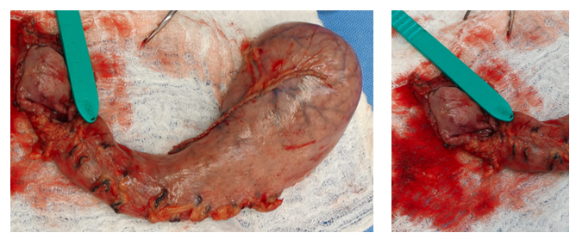

Figure 5: Surgical Piece

Gastric antrum lesion sampled by fine needle aspiration biopsy → small round blue cell neoplasm with an immunophenotype compatible with a glomus tumor.

Clinical Discussion
Gastric glomus tumors (GGTs) are exceptionally rare and often misdiagnosed due to their overlap in clinical and radiologic features with more common submucosal gastric tumors such as gastrointestinal stromal tumors (GISTs) and neuroendocrine tumors (NETs) [1-3]. Most GGTs present as well-defined, hypervascular lesions in the gastric antrum, and commonly manifest with gastrointestinal bleeding, epigastric pain, or anemia, as in our patient [2,4].
Radiological evaluation via contrast-enhanced CT typically demonstrates a small, round or oval submucosal mass with homogeneous or heterogeneous enhancement, and occasional central necrosis [3]. Endoscopic ultrasound (EUS) can delineate origin from the muscularis propria and help guide fine needle aspiration (FNA), although cytologic diagnosis remains challenging due to overlapping features with NETs or GISTs [2].
Definitive diagnosis relies on histopathologic and immunohistochemical analysis. Histologically, GGTs are composed of small, uniform, round cells arranged around blood vessels. Immunoprofiling is critical to distinguish glomus tumors from mimickers. GGTs typically stain positively for smooth muscle actin (SMA) and vimentin, and are negative for CD117, DOG1 (which are positive in GISTs), as well as chromogranin A and synaptophysin (positive in NETs) [1,4-6]. In our case, the tumor was strongly positive for SMA, but negative for DOG1, chromogranin A, and INSM1, confirming the diagnosis of a glomus tumor.
Most GGTs are considered benign; however, a minority may display malignant potential. According to Folpe’s criteria, features associated with malignancy include a size >2 cm, deep location, moderate-to-high nuclear grade, and a mitotic rate ≥5 per 50 high-power fields [5]. Our patient’s tumor was >3 cm in size and deeply located but had a low Ki-67 index (3%) and no atypia or mitotic activity, suggesting a benign course. Surgical resection with negative margins remains the mainstay of treatment and is curative in most cases [4,6]. Laparoscopic distal gastrectomy, as performed in our patient, is effective and associated with favorable postoperative outcomes.

Methods
This case has been reported in accordance with the SCARE 2023 Guidelines for surgical case reports [7].

Conclusion
Gastric glomus tumors are rare mesenchymal neoplasms that may present with upper gastrointestinal bleeding and mimic more common tumors such as GISTs or NETs. Accurate diagnosis requires a high index of suspicion and relies on histopathological and immunohistochemical confirmation. Laparoscopic resection is a safe and effective treatment in symptomatic cases. Awareness of this rare entity is important to avoid misdiagnosis and ensure appropriate surgical management.

Conflict of interest disclosure
None of the authors have any conflicts of interest to disclose

Funding source
Not applicable

Ethics statement
- “Institutional review board approval was not required for a single-patient case report in our hospital Christus Muguerza Alta Especialidad, Monterrey, México, and the report was prepared in accordance with institutional ethical guidelines.”
- “This case report was not required to be registered on a research registry.”
- “No experiments have been carried out on humans or animals for this research.”

Acknowledgement
The authors acknowledge all the staff of Hospital Christus Muguerza Alta Especialidad.

References
- Miettinen M, Paal E, Lasota J, et al. Gastrointestinal glomus tumors: a clinicopathologic, immunohistochemical, and molecular genetic study of 32 cases. Am J Surg Pathol 26 (2002): 301-311.
- Wang Z, Huang X, Liu C, et al. Gastric glomus tumor: a rare case and review of the literature. Int J Clin Exp Pathol 7 (2014): 8855-8860.
- Cheng Y, Shao J, Yuan L, et al. Gastric glomus tumor with a rare presentation: a case report and literature review. Ann Med Surg (Lond) 85 (2024): 105008.
- Park SH, Han JH, An JY, et al. Gastric glomus tumor: analysis of 10 cases and review of the literature. J Gastric Cancer 15 (2015): 142-147.
- Folpe AL, Fanburg-Smith JC, Miettinen M, et al. Atypical and malignant glomus tumors: analysis of 52 cases, with a proposal for the classification of glomus tumors. Am J Surg Pathol 25 (2001): 1-12.
- Zhang S, Zhao G, Liu J, et al. Gastric glomus tumor: a case report and literature review. Oncol Lett 8 (2014): 877-879.
- Agha RA, Franchi T, Sohrabi C, et al. For the SCARE Group. The SCARE 2023 Guideline: Updating Consensus Surgical Case Report (SCARE) Guidelines. Int J Surg 110 (2023): 988-994.


This article is an open access article distributed under the terms and conditions of the Creative Commons Attribution (CC-BY) license 4.0

