

Case Report

Primary Bone Lymphoma of the Tibia Mimicking Stress Injury: The Classic Imaging Paradox Between Conventional Imaging and MRI

Kevin Pierre, Rishabh Agrawal, Kalyani N Ballur, Diego A L Garcia*

Department of Radiology, University of Florida, Gainesville, FL, USA.

*Corresponding Author: Diego A L Garcia, University of Florida, Department of Radiology, Gainesville, FL, USA

Received: 17 March 2026; Accepted: 23 March 2026; Published: 31 March 2026

Citation: Kevin Pierre, Rishabh Agrawal, Kalyani N Ballur, Diego A L Garcia. Primary Bone Lymphoma of the Tibia Mimicking Stress Injury: The Classic Imaging Paradox Between Conventional Imaging and MRI. Journal of Radiology and Clinical Imaging 9 (2026): 33-37.

Abstract
Primary bone lymphoma (PBL) is an uncommon malignant neoplasm that frequently presents nonspecific symptoms and subtle findings on conventional imaging, which may delay diagnosis. A characteristic image feature of PBL is the discrepancy between minimal abnormalities on radiographs or computed tomography (CT) and extensive marrow involvement on magnetic resonance imaging (MRI).

We report the case of a 25-year-old male presenting with progressive anterior tibial pain after recreational soccer activity. Initial clinical suspicion was a tibial stress injury. Radiographs and CT demonstrated only subtle intramedullary sclerosis without cortical destruction or periosteal reaction. In contrast, MRI revealed extensive marrow infiltration involving the proximal tibial epiphysis, metaphysis, and diaphysis. Image-guided biopsy confirmed diffuse large B-cell lymphoma This case highlights the classic imaging paradox of primary bone lymphoma and emphasizes the crucial role of MRI when clinical symptoms appear disproportionate to findings on radiography or CT. Early recognition of this imaging pattern can expedite biopsy and diagnosis, preventing delays in treatment.

Keywords: Primary bone lymphoma; Tibia; Stress injury; MRI; Imaging paradox; Diffuse large B-cell lymphoma.

1. Introduction
Primary bone lymphoma (PBL) is a rare malignant tumor defined as lymphoma arising within bone without evidence of systemic disease at the time of diagnosis or within the initial staging period. It accounts for approximately 3–5% of primary bone tumors and less than 1% of all non-Hodgkin lymphomas [1-4]. Diffuse large B-cell lymphoma (DLBCL) represents the most common histologic subtype, comprising nearly 70–80% of cases [5-7]. PBL typically affects adults in the fourth to sixth decades of life, although younger individuals may also be affected [8-10]. Patients most often present with localized bone pain, which may precede diagnosis by several months. Systemic “B-symptoms,” including fever, night sweats, and weight loss, are uncommon in isolated skeletal disease [11-13]. One of the most distinctive imaging features of PBL is the discordance between subtle findings on radiographs or CT and extensive marrow involvement on MRI. This phenomenon reflects the infiltrative biological behavior of lymphoma cells within the medullary cavity and has been described as the imaging paradox of primary bone lymphoma [14-18]. Because of this discrepancy, early imaging studies may appear deceptively benign, leading to misinterpretation as stress injury, osteomyelitis, or other benign musculoskeletal conditions, particularly in physically active patients [19-21]. We present a case of primary bone lymphoma of the tibia in a young athlete initially suspected to have a tibial stress injury. The case illustrates the classic imaging paradox between conventional imaging modalities and MRI and underscores the importance of advanced imaging when clinical symptoms are disproportionate to initial imaging findings.

2. Case Presentation
A 25-year-old previously healthy man presented with progressive pain localized to the anterior aspect of the right tibia. The pain began shortly after a recreational soccer match. The patient did not recall a specific traumatic event but described persistent focal discomfort that gradually worsened over several weeks. Initially, the pain was activity-related but subsequently became constant, limiting the patient’s ability to run and participate in sports. There was no history of systemic symptoms such as fever, night sweats, or weight loss. Physical examination revealed localized tenderness over the proximal tibial shaft without swelling, erythema, or palpable mass. Given the clinical presentation and the location of symptoms, the initial diagnostic consideration was a tibial stress reaction or early stress fracture, a common injury in physically active individuals and athletes [22-24].

Because of persistent symptoms despite conservative management, imaging evaluation was pursued.

3. Imaging Findings
3.1 Radiography
Plain radiographs of the tibia and fibula were obtained as the initial imaging study (Figure 1). The radiographs demonstrated subtle and nonspecific findings consisting of faint, ill-defined intramedullary sclerosis within the proximal tibia. No fracture line, cortical disruption, periosteal reaction, or soft-tissue abnormality was identified.
Given that early stress injuries may demonstrate minimal or absent radiographic abnormalities, these findings remained compatible with a possible stress-related injury.

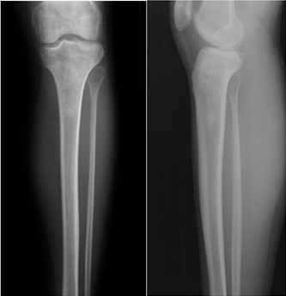

Figure 1: Anteroposterior and lateral radiographs of the tibia demonstrate faint ill-defined intramedullary sclerosis within the proximal tibial metaphysis and diaphysis without cortical disruption, periosteal reaction, or visible fracture line.

3.2 Computed Tomography
Computed tomography (CT) of the tibia was subsequently performed to better evaluate cortical integrity (Figure 2).

CT demonstrated mild ill-defined medullary sclerosis involving the proximal tibial metaphysis and diaphysis. Cortical bone remained largely preserved, and no aggressive bone destruction, periosteal reaction, or fracture line was identified.

Although the findings remained nonspecific, the absence of a fracture line and the presence of ill-defined marrow alteration raised concern for a marrow-replacing process, prompting further evaluation with MRI.

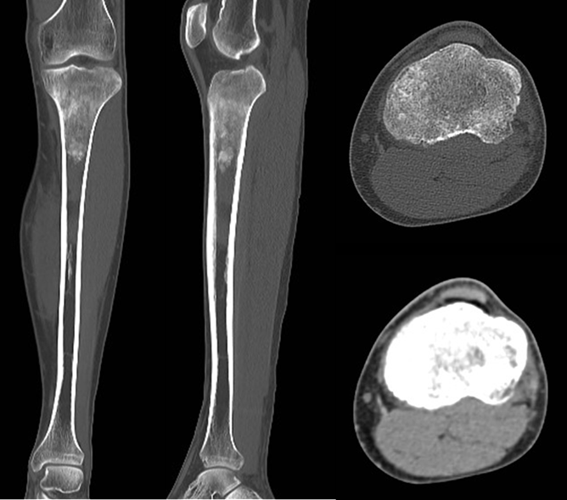
Figure 2: Coronal, sagittal, and axial reformatted CT images of the tibia show subtle, ill-defined medullary sclerosis involving the proximal tibial metaphysis with preservation of cortical bone and absence of periosteal reaction or extraosseous soft-tissue component.

3.3 Magnetic Resonance Imaging
MRI of the tibia demonstrated findings that were markedly disproportionate to those observed on radiography and CT (Figures 3 and 4).

A large region of the tibia showed diffuse replacement of normal fatty marrow signal extending from the proximal tibial epiphysis through metaphysis and along the diaphysis. The involved marrow appeared hypointense on T1-weighted images and mildly hyperintense on fluid-sensitive sequences. Despite extensive intramedullary involvement, cortical integrity remained relatively preserved and no significant extraosseous soft-tissue component was identified. These findings revealed a substantially greater extent of disease than suggested by radiography or CT, illustrating the classic imaging paradox associated with primary bone lymphoma.

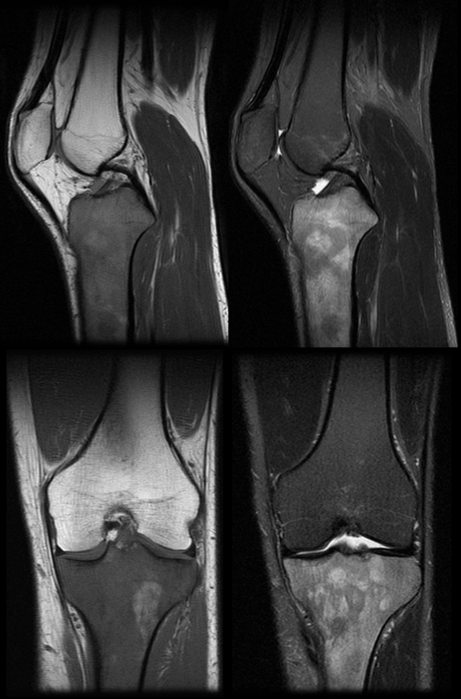

Figure 3: MRI of the tibia demonstrates diffuse marrow infiltration involving the proximal tibial epiphysis, metaphysis, and diaphysis. The lesion appears hypointense relative to normal marrow on T1-weighted sequences and hyperintense on fluid-sensitive sequences, consistent with extensive marrow replacement.

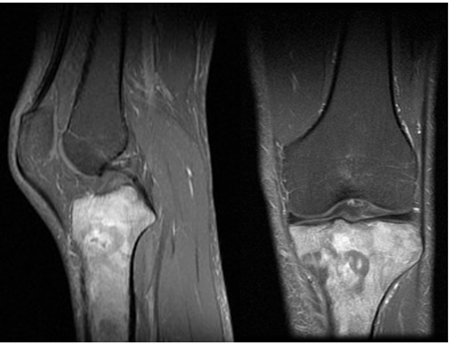

Figure 4: Post-contrast fat-suppressed T1-weighted MRI images demonstrate diffuse, mildly heterogeneous enhancement within the infiltrated marrow of the proximal tibia, without evidence of cortical destruction or extraosseous soft-tissue extension.

3.4 Histopathology
Image-guided percutaneous core needle biopsy of the tibial lesion was performed. Histopathologic examination demonstrated diffuse infiltration of the bone marrow by large atypical lymphoid cells with irregular nuclear contours and prominent nucleoli. Immunohistochemical analysis showed tumor cells positive for CD20 and CD79a, with a Ki-67 proliferation index of approximately 80%, consistent with diffuse large B-cell lymphoma (DLBCL). Subsequent staging evaluation, including PET-CT, demonstrated no additional sites of disease, confirming the diagnosis of primary bone lymphoma.

4. Discussion
Primary bone lymphoma demonstrates distinctive biological and imaging characteristics that differentiate it from most primary bone malignancies. Unlike aggressive bone sarcomas, which often produce early cortical destruction and soft-tissue mass formation, lymphoma tends to infiltrate the medullary cavity while preserving cortical architecture [25-28]. Tumor cells spread along the marrow space and through the Haversian and Volkmann vascular channels, allowing longitudinal propagation along bone without extensive cortical destruction [29-31]. This infiltrative growth pattern explains the classic imaging paradox observed in primary bone lymphoma: extensive marrow disease with minimal abnormalities on radiographs or CT [14-18].

Radiographic findings may range from normal appearance to subtle medullary sclerosis, permeative bone destruction, or mixed lytic-sclerotic lesions [32-34]. However, early disease often demonstrates only minimal abnormalities, which may delay diagnosis.

MRI is the most sensitive imaging modality for detecting bone marrow infiltration [35-38]. Typical MRI features include diffuse low signal intensity on T1-weighted images, hyperintense signal on fluid-sensitive sequences, and longitudinal marrow involvement.

Another characteristic feature is the relative preservation of cortical bone despite extensive marrow replacement [39-41].
In the present case, radiographs and CT demonstrated only subtle medullary sclerosis, whereas MRI revealed extensive marrow infiltration extending from the proximal tibial epiphysis through the diaphysis. The dramatic discrepancy between imaging modalities exemplifies the classic imaging presentation of primary bone lymphoma.

5. Differential Diagnosis
In a young adult presenting with tibial pain, the differential diagnosis may include:
- Tibial stress reaction or stress fracture
- Osteomyelitis
- Ewing sarcoma
- Leukemic infiltration
- Metastatic disease
- Osteosarcoma
- Langerhans cell histiocytosis

Stress injuries are particularly common in athletes and frequently present with normal radiographs early in the disease course. However, stress fractures typically demonstrate a focal cortical or periosteal abnormality on MRI rather than diffuse longitudinal marrow infiltration.

The combination of extensive marrow replacement on MRI with minimal abnormalities on radiography or CT should raise a strong suspicion for primary bone lymphoma.

6. Clinical Implications
Early recognition of this imaging pattern is clinically important because primary bone lymphoma is a potentially curable malignancy with favorable outcomes when treated promptly with systemic therapy. Diagnostic delay may occur when clinicians rely primarily on radiography or CT findings. MRI plays a critical role in identifying marrow infiltration and defining the true extent of disease.

7. Teaching Point
Extensive marrow infiltration on MRI with only subtle abnormalities on radiography or CT represents a classic imaging presentation of primary bone lymphoma and should prompt early biopsy.

8. Conclusion
Primary bone lymphoma may mimic benign stress-related injuries in young physically active individuals presenting with tibial pain. The key diagnostic clue is the discrepancy between minimal abnormalities on radiography or CT and extensive marrow involvement on MRI. Recognition of this imaging paradox is essential for timely biopsy and accurate diagnosis.

Reference
- Freeman C, Berg JW, Cutler SJ. Occurrence and prognosis of extranodal lymphomas. Cancer 29 (1972): 252-260.
- Jawad MU, Schneiderbauer MM, Min ES, et al. Primary lymphoma of bone in adult patients. Cancer 116 (2010): 871-879.
- Ramadan KM, Shenkier T, Sehn LH, et al. A clinicopathological retrospective study of 131 patients with primary bone lymphoma. Ann Oncol 18 (2007): 129-135.
- Messina C, Christie D, Zucca E, et al. Primary and secondary bone lymphomas. Cancer Treat Rev 41 (2015): 235-246.
- Bhagavathi S, Fu K. Primary bone lymphoma. Arch Pathol Lab Med 133 (2009): 1868-1871.
- Cai L, Stauder MC, Zhang YJ, et al. The role of radiotherapy in primary bone lymphoma. Radiother Oncol 104 (2012): 297-302.
- Beal K, Allen L, Yahalom J. Primary bone lymphoma: treatment results and prognostic factors. Cancer 106 (2006): 2652-2656.
- Held G, Zeynalova S, Murawski N, et al. Role of radiotherapy in primary bone lymphoma: results of the RICOVER-60 trial. J Clin Oncol 31 (2013): 4115-4122.
- Ostrowski ML, Unni KK, Banks PM, et al. Malignant lymphoma of bone. Cancer 58 (1986): 2646-2655.
- Mulligan ME, McRae GA, Murphey MD. Imaging features of primary lymphoma of bone. AJR Am J Roentgenol 173 (1997): 1691-1697.
- Anderson MW, Temple HT, Dussault RG, et al. Compartmental anatomy of the musculoskeletal system: radiologic considerations. Radiology 199 (1996): 553-560.
- Desai SS, Jambhekar NA. Primary lymphoma of bone: a review of 40 cases. Indian J Orthop 44 (2010): 302-307.
- Puri A, Gulia A, Agarwal MG, et al. Primary lymphoma of bone: prognostic factors and outcomes. Clin Orthop Relat Res 468 (2010): 2952-2959.
- Krishnan A, Shirkhoda A, Tehranzadeh J, et al. Primary bone lymphoma: radiographic-MR imaging correlation. Radiographics 23 (2003): 1371-1383.
- Murphey MD, Fairbairn KJ, Parman LM, et al. Musculoskeletal lymphoma: radiologic-pathologic correlation. Radiographics 14 (1994): 1253-1280.
- Surov A, Holzhausen HJ, Ruschke K, et al. Primary and secondary bone lymphoma: prevalence, clinical signs and radiological features. Skeletal Radiol 39 (2010): 609-617.
- O'Donnell P, Saifuddin A. The imaging of lymphoma of bone. Clin Radiol 59 (2004): 1001-1012.
- Heyning FH, Hogendoorn PC, Kramer MH, et al. Primary non-Hodgkin lymphoma of bone: a clinicopathological investigation of 60 cases. Leukemia 13 (1999): 2094-2098.
- Vanel D, Henry-Amar M, Picci P, et al. Primary lymphoma of bone: radiologic aspects. Skeletal Radiol 16 (1987): 181-187.
- Liu PT, Valadez SD, Chivers FS, et al. Anatomically based guidelines for core needle biopsy of bone tumors. AJR Am J Roentgenol 188 (2007): 563-570.
- Davies AM, Sundaram M, James SL. Imaging of Bone Tumors and Tumor-Like Lesions: Techniques and Applications. Berlin: Springer; (2009).
- Fredericson M, Jennings F, Beaulieu C, et al. Stress fractures in athletes. Top Magn Reson Imaging 17 (2006): 309-325.
- Bennell KL, Brukner PD. Epidemiology and site specificity of stress fractures. Sports Med 28 (1999): 91-122.
- Nattiv A, Goolsby MA, Matheson G, et al. Stress fracture risk factors, incidence, and distribution: a 3-year prospective study. Clin Sports Med 32 (2013): 167-184.
- Baur-Melnyk A, Buhmann S, Durr HR, et al. Role of MRI for the diagnosis and prognosis of multiple myeloma. Eur J Radiol 55 (2008): 56-63.
- Adams HJ, Kwee TC, Vermoolen MA, et al. Whole-body MRI vs PET/CT in staging lymphoma: systematic review and meta-analysis. Haematologica 99 (2014): e23-e25.
- Adams HJ, Kwee TC. Prognostic value of interim FDG-PET in lymphoma: systematic review. Eur J Nucl Med Mol Imaging 41 (2014): 1811-1823.
- Glotzbecker MP, Kersun LS, Choi JK, et al. Primary bone lymphoma in children. J Pediatr Orthop 26 (2006): 501-505.
- Tao R, Allen PK, Rodriguez A, et al. Benefit of consolidative radiation therapy for primary bone lymphoma. Cancer 121 (2015): 679-687.
- Swerdlow SH, Campo E, Harris NL, et al. WHO Classification of Tumours of Haematopoietic and Lymphoid Tissues. Revised 4th ed. Lyon: IARC; (2017).
- Parker F, et al. Primary bone lymphoma: imaging findings. Skeletal Radiol 47 (2018): 1521-1530.
- Mulligan ME, et al. Imaging of lymphoma of bone. Radiology 222 (2002): 325-332.
- Mulligan ME, et al. CT and MRI features of skeletal lymphoma. AJR Am J Roentgenol 180 (2003): 1691-1697.
- Griffith JF, et al. Imaging of musculoskeletal lymphoma. Radiographics 27 (2007): 485-497.
- Vanhoenacker FM, et al. Imaging of primary bone tumors. Eur J Radiol 81 (2012): 1364-1374.
- Hermann G, et al. Imaging of lymphoma in bone. Skeletal Radiol 34 (2005): 47-58.
- Tins BJ, et al. MR imaging of bone marrow disorders. Clin Radiol 62 (2007): 1121-1133.
- Davies AM, et al. MR imaging of bone tumors. Skeletal Radiol 37 (2008): 107-121.
- Kransdorf MJ, et al. Imaging of soft tissue tumors. Radiology 179 (1991): 297-302.
- Kransdorf MJ, et al. Radiologic evaluation of musculoskeletal tumors. Radiographics 20 (2000): 1587-1602.
- Greenspan A. Orthopedic Imaging: A Practical Approach. 6th ed. Philadelphia: Lippincott Williams & Wilkins; (2015).
- Baur-Melnyk A, et al. Imaging of multiple myeloma. Radiology 277 (2015): 633-647.
- Surov A, et al. Imaging findings of lymphoma of bone. Clin Imaging 36 (2012): 531-538.
- Messina C, et al. Imaging of lymphoma of bone. Oncologist 19 (2014): e1-e10.
- Wu H, et al. Imaging features of primary bone lymphoma. Skeletal Radiol 49 (2020): 1423-1433.


This article is an open access article distributed under the terms and conditions of the
Creative Commons Attribution (CC-BY) license 4.0

