

Case Report

Revisiting Mycetoma: Predominant Intraosseous Dot-in-Circle Pattern on MRI in a Chronic Foot Infection

Sylvia Arce, Kevin Pierre, Diego A L Garcia*
University of Florida, Department of Radiology, Gainesville, Florida, USA.

*Corresponding Author: Diego A L Garcia, University of Florida, Department of Radiology, Gainesville, FL, USA

Received: 10 April 2026; Accepted: 15 April 2026; Published: 17 April 2026

Citation: Sylvia Arce, Kevin Pierre, Diego A L Garcia. Revisiting Mycetoma: Predominant Intraosseous Dot-in-Circle Pattern on MRI in a Chronic Foot Infection. Journal of Radiology and Clinical Imaging 9 (2026): 38-41.

Abstract
Mycetoma is a chronic granulomatous infection that predominantly affects individuals in rural environments and is often associated with delayed diagnosis and progressive tissue destruction. Magnetic resonance imaging (MRI) plays a central role in early recognition, particularly through the identification of the characteristic “dot-in-circle” sign.

We report the case of a 36-year-old male agricultural worker presenting with chronic foot pain and swelling. MRI demonstrated extensive disease with a striking predominance of intraosseous involvement, including multiple tarsal bones, characterized by numerous intraosseous “dot-in-circle” lesions, in addition to soft tissue infiltration and sinus tract formation. Microbiological analysis confirmed mycetoma.

This case highlights an atypical imaging pattern of mycetoma with predominant intraosseous expression, which may mimic multifocal osteomyelitis or neoplastic processes. Recognition of this presentation expands the known imaging spectrum of mycetoma and reinforces the importance of MRI in early diagnosis and disease characterization.

Keywords: Mycetoma; Dot-in-circle; MRI; Infection; Intraosseous

1. Introduction
Mycetoma is a chronic, progressively destructive infection involving the skin, subcutaneous tissues, and frequently the underlying bone [1-4]. It is caused by filamentous bacteria (actinomycetoma) or true fungi (eumycetoma), both of which share overlapping clinical and imaging features [3,5]. The disease is endemic in tropical and subtropical regions and disproportionately affects rural populations with repeated exposure to contaminated soil [1,2].

Clinically, mycetoma is characterized by a triad of tumefaction, draining sinuses, and granular discharge; however, early stages are often nonspecific, contributing to delayed diagnosis [5,6]. MRI has emerged as the most sensitive imaging modality for early detection and for assessing disease extent [7-10].

The “dot-in-circle” sign is considered highly specific for mycetoma and reflects granulomatous lesions containing central microbial grains surrounded by inflammatory tissue [8,10]. Classically, mycetoma demonstrates predominant soft tissue involvement with secondary osseous extension.

In this report, we describe an unusual presentation characterized by predominant intraosseous involvement with multiple intraosseous dot-in-circle lesions, expanding the known imaging spectrum of the disease.

2. Case Presentation
A 36-year-old male agricultural worker from a rural region presented with an eight-month history of progressive right foot pain and swelling. Symptoms began insidiously with mild discomfort during ambulation, followed by gradual enlargement of the foot. The patient reported frequent barefoot walking during agricultural activities and denied any history of trauma.

Over time, swelling worsened and was associated with intermittent discharge through small cutaneous openings. No systemic symptoms such as fever or weight loss were reported. Due to limited access to healthcare, evaluation was delayed until functional impairment became significant.

Physical examination demonstrated diffuse enlargement of the right foot with firm subcutaneous thickening and multiple draining sinus tracts. Mild tenderness was present without significant erythema or warmth.

3. MRI Findings
MRI of the right foot demonstrated extensive involvement of both soft tissues and multiple tarsal bones.

Soft tissue findings included numerous rounded and coalescent lesions with high signal intensity on T2-weighted and STIR sequences and low-to-intermediate signal on T1-weighted images. Multiple sinus tracts extending to the skin surface were identified.
A hallmark feature was the presence of multiple small central hypointense foci within hyperintense spherical lesions, consistent with the classic “dot-in-circle” sign [8,10,12].

Notably, these target-like lesions were predominantly located within the osseous structures, involving the calcaneus, navicular, cuboid, and cuneiform bones. These intraosseous lesions demonstrated marrow replacement, with low T1 and high signal on fluid-sensitive sequences, as well as patchy post-contrast enhancement [17,32].

This pattern of multifocal intraosseous dot-in-circle lesions is atypical, as mycetoma more commonly demonstrates dominant soft tissue involvement with secondary bone extension.

Cortical irregularity and early bone destruction were present, supporting progressive osseous invasion [17,32]. No large abscess collections were identified.

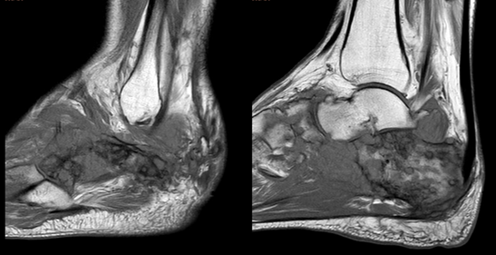

Figure 1: Sagittal T1-weighted MR images of the foot demonstrate multiple areas of abnormal low signal intensity involving the calcaneus, tarsal bones, and fourth metatarsal base, corresponding to marrow infiltration. Associated soft tissue thickening is also noted, reflecting the extent of the underlying infectious process.

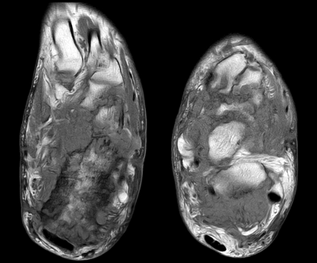

Figure 2: Axial T1-weighted MR image demonstrates extensive low-signal marrow replacement involving the calcaneus, consistent with osseous infiltration. There is also associated involvement of the surrounding soft tissues, which appear thickened and infiltrated, reflecting extension of the infectious process beyond the bone.

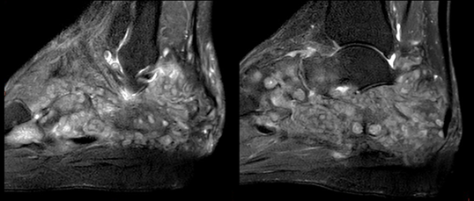

Figure 3: Sagittal fat-suppressed T2-weighted MR image demonstrates intermediate to hyperintense lesions again involving the calcaneus, tarsal bones, and fourth metatarsal, with multiple well-defined rounded foci containing central low-signal intensity, consistent with the “dot-in-circle” sign. Notably, these target-like lesions are more prominently distributed within the osseous structures than in the surrounding soft tissues, highlighting an atypical pattern of predominant intraosseous involvement.

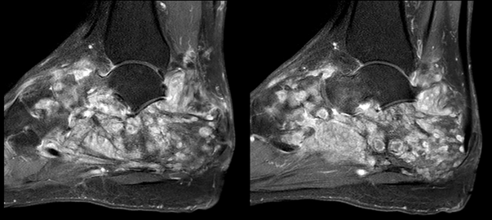

Figure 4: Sagittal fat-suppressed post-contrast T1-weighted MR image demonstrates multiple target-like lesions with predominantly peripheral enhancement, corresponding to the “dot-in-circle” appearance. There is also extensive surrounding marrow enhancement within the involved bones, consistent with reactive osteitis and active inflammatory infiltration.

4. Microbiological Correlation
Samples obtained from draining sinus tracts revealed granules composed of filamentous organisms on direct microscopy. Culture confirmed the diagnosis of mycetoma [21,31]. Although species-level differentiation between actinomycetoma and eumycetoma was not available at the time of reporting, the microbiological findings supported the imaging diagnosis.

5. Discussion
This case highlights an atypical imaging presentation of mycetoma characterized by predominant intraosseous involvement with multiple intraosseous dot-in-circle lesions.

MRI plays a central role in the diagnosis and staging of mycetoma, with the dot-in-circle sign considered highly specific [8,10,22]. This sign reflects compact microbial grains surrounded by inflammatory granulomatous tissue and fibrous septa.
Classically, mycetoma is described as a soft tissue–predominant disease, with bone involvement occurring in more advanced stages through contiguous spread [17,32]. In contrast, the present case demonstrates a striking predominance of intraosseous disease, with multiple tarsal bones extensively involved and containing numerous target-like lesions.

This atypical pattern has important diagnostic implications. Predominant intraosseous involvement may mimic chronic multifocal osteomyelitis, tuberculous infection, or primary and secondary bone neoplasms [33,39]. However, the identification of intraosseous dot-in-circle lesions provides a critical diagnostic clue favoring mycetoma.

The pathophysiology underlying this pattern may relate to early medullary invasion or rapid contiguous spread through adjacent structures, although this remains incompletely understood.

Recognition of this imaging variant is essential, particularly in endemic or high-risk populations, as delayed diagnosis may lead to extensive destruction and increased need for surgical intervention [30,35].

6. Conclusion
Mycetoma should be considered in patients presenting with chronic foot infection and characteristic MRI findings.
This case expands the known imaging spectrum by demonstrating a predominant intraosseous dot-in-circle pattern, which may mimic other pathologies. Awareness of this presentation is critical for accurate diagnosis and appropriate management.

Reference
- Fahal AH. Mycetoma: a global medical and socio-economic dilemma. PLoS Negl Trop Dis 11 (2017): e0005509.
- van de Sande WWJ. Global burden of human mycetoma: a systematic review and meta-analysis. Lancet Infect Dis 13 (2013): 493-503.
- Zijlstra EE, van de Sande WWJ, Welsh O, et al. Mycetoma: a unique neglected tropical disease. Lancet Infect Dis 16 (2016): 100-112.
- Welsh O, Vera-Cabrera L, Salinas-Carmona MC. Mycetoma. Clin Dermatol 25 (2007): 195-202.
- Relhan V, Mahajan K, Agarwal P, et al. Mycetoma: an update. Indian J Dermatol 62 (2017): 332-340.
- Fahal AH, Suliman SH, Hay R. Mycetoma: the spectrum of clinical presentation. Trans R Soc Trop Med Hyg 109 (2015): 3-4.
- Sarris I, Berendt AR, Athanasous N, et al. MRI of mycetoma of the foot: two cases demonstrating the dot-in-circle sign. Clin Radiol 58 (2003): 831-834.
- Cherian RS, Betty M, Manipadam MT, et al. The “dot-in-circle” sign—a characteristic MRI finding in mycetoma foot. Radiology 252 (2009): 662-666.
- El Shamy ME, Fahal AH, Shakir MY, et al. New MRI grading system for the diagnosis and management of mycetoma. Skeletal Radiol 41 (2012): 671-679.
- Suleiman SH, Wadaella ES, Fahal AH. The “dot-in-circle” sign of mycetoma on MRI. AJR Am J Roentgenol 199 (2012): 564-569.
- Prasad PV, Kumar A, Khandelwal N. Imaging spectrum in mycetoma: a pictorial review. J Med Imaging Radiat Oncol 54 (2010): 214-249.
- Jain V, Makwana GE, Bahri N, et al. The “dot-in-circle” sign on MRI in mycetoma: a characteristic finding. Indian J Radiol Imaging 22 (2012): 297-300.
- Lichon V, Khachemoune A. Mycetoma: a review. Am J Clin Dermatol 7 (2006): 315-321.
- McGinnis MR. Mycetoma. Dermatol Clin 14 (1996): 97-104.
- Fahal AH, Mahgoub ES, El Hassan AM, et al. Mycetoma in the Sudan: an update from the Mycetoma Research Centre. Curr Opin Infect Dis 27 (2014): 151-157.
- Bonifaz A, Tirado-Sánchez A, Calderón L, et al. Mycetoma: experience of 482 cases in a single center in Mexico. PLoS Negl Trop Dis 8 (2014): e3102.
- Abd El Bagi ME. New radiographic classification of bone involvement in pedal mycetoma. Skeletal Radiol. 2003;32 (2003): 343-351.
- Sen A, Pillay RS, Awad ME, et al. Correlation of ultrasound and MRI findings in mycetoma. Skeletal Radiol 40 (2011): 451-457.
- El Sanousi SM, Fahal AH. Imaging of mycetoma. Trans R Soc Trop Med Hyg 85 (1991): 409-410.
- Fahal AH, Suliman SH. Clinical presentation of mycetoma. East Mediterr Health J 1 (1994): 45-50.
- Ahmed AA, van de Sande WWJ, Fahal AH. Mycetoma laboratory diagnosis: review article. PLoS Negl Trop Dis 9 (2015): e0003827.
- Suleiman SH, Fahal AH. Imaging features of mycetoma. Clin Radiol 68 (2013): e423-432.
- Fahal AH. Mycetoma pathogenesis. Lancet Infect Dis 15 (2015): 1003-1004.
- Mahgoub ES. Mycetoma in Sudan. Trans R Soc Trop Med Hyg 67 (1973): 1-9.
- Abbott PH. Mycetoma in the Sudan. Lancet 271 (1956): 667-668.
- Fahal AH. Mycetoma: a thorn in the flesh. Trans R Soc Trop Med Hyg 98 (2004): 3-11.
- Emery D, Denning DW. The global distribution of actinomycetoma and eumycetoma. PLoS Negl Trop Dis 14 (2020): e0008397.
- van de Sande WWJ, Fahal AH, Goodfellow M, Mahgoub ES, Welsh O, Zijlstra EE. Merits and pitfalls of currently used diagnostic tools in mycetoma. Lancet Infect Dis 14 (2014): e1-e10.
- World Health Organization. Mycetoma. Geneva: WHO (2020).
- Fahal AH, Rahman IA, El-Hassan AM, et al. Mycetoma in Sudan: treatment and outcome. PLoS Negl Trop Dis 9 (2015): e0003739.
- Ahmed SA, van de Sande WWJ, Stevens DA, et al. Advances in the diagnosis of mycetoma. J Fungi (Basel) 6 (2020): 291.
- Bakhiet SM, Fahal AH, van de Sande WWJ. Bone involvement in mycetoma. PLoS Negl Trop Dis 13 (2019): e0007353.
- Suleiman SH, Wadaella ES, Fahal AH. MRI differentiation between eumycetoma and actinomycetoma. Eur J Radiol 83 (2014): e252-257.
- Elagab EA, Fahal AH. Mycetoma: clinical spectrum. Trans R Soc Trop Med Hyg 93 (1999): 265-268.
- Fahal AH, Suliman SH, Hay R. Surgical management of mycetoma. PLoS Negl Trop Dis 8 (2014): e2753.
- Zijlstra EE, van de Sande WWJ. Mycetoma: a long journey from neglect. Curr Opin Infect Dis 27 (2014):151-157.
- Ahmed AO, van Leeuwen W, Fahal A, et al. Mycetoma caused by Madurella mycetomatis: molecular identification. J Clin Microbiol 41 (2003): 5440-5444.
- De Backer AI, Mortelé KJ, Vanschoubroeck IJ, et al. Imaging of musculoskeletal infections. Eur Radiol 16 (2006): 658-671.
- Krishnamoorthy S, Gopalakrishnan S, Kumar N. MRI features of mycetoma. Skeletal Radiol 44 (2015): 515-522.
- Garg B, Sharma V, Kotwal PP. Imaging-pathology correlation in mycetoma. Clin Radiol 72 (2017): 509-517.


This article is an open access article distributed under the terms and conditions of the
Creative Commons Attribution (CC-BY) license 4.0

