

Review Article

Role of Early Versus Late Corticosteroid Treatment in Pediatric Asthma Exacerbations - A Systematic Review and Meta-analysis

Ghazala S. Virk¹, Imdad Ullah^{2*}, Kaushikkumar Shantilal Barot³, Rawan Abdalla⁴, Munazzah Mehvish Kalyankar⁵, Riyazuddin Mohd⁶, Syeda Rahma Suroor⁷, Abdul Eizad Asif⁸, Mars Christian Aragon Sta Ines⁹

¹Avalon University School of Medicine, Willemstad, Curaçao
²Khyber Medical College, Peshawar, Pakistan
³Shantabaa Medical College and General Hospital, Amreli, Gujarat, India.
⁴Al Neelain University, Khartoum, Sudan.
⁵JIIUs Indian Institute of Medical Science and Research, Jalna, Maharashtra, India.
⁶Deccan College of Medical Sciences, Hyderabad, Telangana, India.
⁷Deccan College of Medical Sciences, Hyderabad, Telangana, India.
⁸Shalamar Hospital, Lahore, Pakistan.
⁹Stepping Hill Hospital, Stockport, United Kingdom.

*Corresponding Author: Imdad Ullah, Khyber Medical College, Peshawar, Pakistan.

Received: 21 July 2026; Accepted: 11 August 2026; Published: 18 August 2026

Citation: Ghazala S. Virk, Imdad Ullah, Kaushikkumar Shantilal Barot, Rawan Abdalla, Munazzah Mehvish Kalyankar, Riyazuddin Mohd6, Syeda Rahma Suroor, Abdul Eizad Asif, Mars Christian Aragon Sta Ines. Role of Early Versus Late Corticosteroid Treatment in Pediatric Asthma Exacerbations - A Systematic Review and Meta-analysis. Journal of Pediatrics, Perinatology and Child Health 10 (2026): 165-177.

Abstract
Asthma attacks in children are one of the most frequent emergency department (ED) cases, and it is usually necessary to provide timely care to avoid the aggravation of the symptoms. One of the major treatments is corticosteroids, and whether to give them at an early or a late stage is controversial. It is a systematic review study aimed at determining if early administration of corticosteroids (before 60 minutes of arrival at the ED) or delayed administration of corticosteroids (after 60 minutes) can improve clinical outcomes in childhood asthma exacerbations. A comprehensive search on PubMed, Web of Science, and Google Scholar was conducted using the PRISMA rules. The inclusion criteria were studies meeting PICOS criteria and retrospective and prospective cohort studies. Meta-Essentials was used to conduct a meta-analysis to extract the effect sizes, standard errors, and correlation coefficients. The primary outcomes were length of stay (LOS) in the ED, admission to the hospital, and time of administration of corticosteroids. The analysis was done with ten studies having a total of 10,811 pediatric patients. The combined effect size was 0.79 (95% CI -0.35 to 1.93), which showed moderate benefits of early use of corticosteroids. Nonetheless, high levels of heterogeneity were found (I² = 93.10%), which indicated inconsistency in the study designs and patient populations. In studies that had structured care protocols, the subgroup analysis showed higher effects. Based on the findings, it can be concluded that early intervention with corticosteroids can be effective in improving the short-term outcome of pediatric asthma exacerbations, although the studies should be further developed in order to streamline protocols and determine long-term outcomes.

Keywords: Pediatric asthma; Corticosteroid administration; Early treatment; Emergency room; Meta-analysis

1. Introduction
Asthma is a chronic respiratory disease that is most common in children, with more than 300 million children being affected by the illness worldwide, with a huge percentage being below the age of 18 [1]. Acute exacerbations of symptoms, emergency department (ED) visits, and hospital admissions due to pediatric asthma are among the most common causes in the world [2]. Even with the use of inhaled corticosteroid (ICS) as a maintenance therapy, most children have frequent exacerbations that require systemic corticosteroid (SCS) intervention [3]. Corticosteroid early administration was considered one of the pillars of asthma management, because it is capable of almost immediately reducing airway inflammation and reducing the risk of relapse. Nevertheless, the optimal time of administration of corticosteroids, at the start of an exacerbation, early or late, is a clinical grey area [4].

Prednisolone and dexamethasone are familiar systemic corticosteroids that have been shown to reduce hospital stay, improve lung function, and decrease the occurrence of relapses in patients at the time of exacerbation [5]. Recent discoveries point out that the time of corticosteroid administration is of utmost importance. A retrospective multicenter study identified that delays of more than one hour in the administration of SCS in children with asthma were related to extended hospitalization and prolonged oxygen therapy [6]. Equally, corticosteroid administration in the prehospital setting under the emergency medical service (EMS) has demonstrated that hospital admission is decreased and the early recovery rates are increased in children who are taken to hospital due to asthma exacerbation [7]. These results highlight the fact that corticosteroid early initiation can have a considerable impact on clinical outcomes [8].

Recent randomized controlled trials have contributed to evidence on the benefits of early interventions. In a 240 child cohort with acute asthma, Ahmad et al. (2025) compared nebulized and systemic corticosteroids and found that, within 48 hours, symptoms were resolved more quickly and the clinical outcome was improved more by systemic corticosteroids [9]. Similarly, research has shown that systemic corticosteroids have the potential to slow the progression of asthma attacks caused by the virus and reduce or eliminate hospitalization when used at the first stage of the exacerbation [10].

On the contrary, untimely corticosteroid or delayed intervention leads to lower lung function and a longer duration of symptom recovery [11]. The results of both emergency department and EMS settings show that late initiation of corticosteroids does not have any significant effect in terms of hospitalization as compared to immediate treatment [5]. Further, delayed use has been observed to be associated with the necessity to use further bronchodilator therapy and prolonged use of supplemental oxygen [12].

In spite of such findings, the issue of corticosteroid prescribing variability has been a problem. Research has shown that there are vast discrepancies in corticosteroid timing, dosage, and formulation across healthcare providers, specifically, between primary and specialty pediatric care [13]. Such a discrepancy can result in the ineffectiveness of treatment, and standardized early intervention guidelines should be seen as an important solution [14]. There is also uncertainty over the side effects that may arise with repeated courses of early systemic therapy with corticosteroids despite its widespread recommendation, including transient immunosuppression and hyperglycemia [15].

Since cases of asthma exacerbation are common, and corticosteroids have been shown to have anti-inflammatory effects, it is important to learn how best corticosteroids should be administered in children [16]. Timely introduction of corticosteroids may enhance short-term results, decrease hospitalization, and avoid severe respiratory distress. Nonetheless, the degree of utility and the risks that might be involved with early and delayed therapy are yet to be fully measured [17].
Thus, the purpose of the systematic review and meta-analysis is to integrate existing evidence (2010-2026) on the subject of early and late corticosteroid usage in the management of asthma attacks in children. In particular, it will compare differences in clinical outcomes, such as the time required to resolve the symptoms, hospital admissions, oxygen therapy duration, and the rate of relapse.

2. Methods
2.1 Data Sources and search strategy
An extensive literature search was conducted to find literature that investigated the impact of early corticosteroid use versus late corticosteroid use regarding exacerbation of asthma in children. The databases PubMed, Google Scholar, and Web of Science were searched systematically to find the appropriate research papers released between 2010 and 2026. The search was based on the PRISMA 2020 guidelines, which guarantee transparency and reproducibility and a systematic study identification and selection approach. To identify all the potentially relevant research, a combination of keywords and Medical Subject Headings (MeSH) was employed. The following keyword searches were used: pediatric asthma, childhood asthma, exacerbation of asthma, acute asthma, inhaled corticosteroids, systemic corticosteroids, early corticosteroid treatment, delayed corticosteroid treatment, timing of corticosteroid (Table 1).

The Boolean operators that were used to combine these terms were the AND and OR operators to enhance the sensitivity and precision of the search. Several combinations were used to make sure that the studies, in which there may be early or late corticosteroid use, were included in the emergency, hospital, or prehospital setting. Only the studies in which human participants were under 18 years old and were published in English were taken into consideration (Table 2).

Database | Search Terms Used | Filters Used | Truncations / Syntax
PubMed | (("pediatric asthma" OR "childhood asthma")) AND (("asthma exacerbation" OR "acute asthma attack")) AND (("early corticosteroid" OR "delayed corticosteroid" OR "systemic corticosteroid")) AND (("treatment timing" OR "early intervention")) | Publication years: 2010–2026; Humans; English language; Age: Child (0–18 years) | MeSH terms used: Asthma; Corticosteroids; Boolean operators (AND/OR); quotation marks for phrase searching
Web of Science | "pediatric asthma" OR "childhood asthma" AND "early corticosteroid treatment" OR "delayed corticosteroid administration" AND "acute exacerbation" OR "emergency management" | Years: 2010–2026; Document type: Article or Review; English only | Quotation marks (" ") for exact phrases; Boolean (AND/OR); truncation with *
Google Scholar | "early corticosteroid therapy in pediatric asthma exacerbation" OR "timing of systemic corticosteroid in acute asthma" | Custom range: 2010–2026; English only | Quotation marks for phrase searches; Manual screening of the first 200 hits

Table 1: Search strategy in databases.

PICOS Element | Criteria for Inclusion | Criteria for Exclusion
Population (P) | Children and adolescents aged 0–18 years diagnosed with asthma exacerbations (mild, moderate, or severe) by clinical or diagnostic criteria. | Studies in mixed adult populations without subgroup analysis of the pediatric population, or non-human studies.
Intervention (I) | Early corticosteroid administration, defined as administration of systemic or inhaled corticosteroids within 1–2 hours of emergency presentation or within 24 hours of symptom onset. | Maintenance corticosteroid therapy, chronic asthma control programs, or preventive use of inhaled steroids not in the context of acute exacerbation.
Comparison (C) | Late corticosteroid administration, defined as initiation of corticosteroid therapy at or after 2 hours of presentation or beyond 24 hours of symptom onset. | Studies without a comparable group (i.e., no distinction between early and late treatment).
Outcomes (O) | Primary: Length of time to resolution of symptoms, hospital admission rate, length of stay in hospital, need for oxygen therapy, readmission rate, or rate of relapse. Secondary: Adverse drug reactions, failure of treatment, and mortality (if reported). | Papers that did not provide appropriate clinical outcomes, or considered biochemical, genomic, or non-clinical outcomes.
Study Design (S) | Randomized controlled trials (RCTs), prospective or retrospective cohort studies, observational studies comparing early and late corticosteroid initiation. | Case reports, reviews, letters, conference abstracts, or studies with inadequate data for comparing outcomes.

Table 2: Inclusion Criteria and Exclusion Criteria Based on PICOS Framework.

2.2 Data Extraction
Two independent reviewers extracted the data into a predefined standardized data collection form to perform data extraction for this systematic review and meta-analysis in order to produce data that was accurate and consistent. Key bibliographic and methodological information was obtained, such as the name of the first author of the studies, year of publication, and study design, from every eligible study. The data on the subject population were obtained, including the variables of the sample size, age group, gender balance, asthma severity, and the diagnostic criteria according to which exacerbations were defined. Information about the intervention was also systematically collected, such as the kind of corticosteroid used (e.g., prednisolone, dexamethasone, or methylprednisolone), route of administration (oral, intravenous, or inhaled), when the corticosteroid was started (early vs. late), and dosage or length of treatment. The primary extracted results were the clinical improvement measures, time to resolve symptoms, the length of hospital stay, the need for oxygen therapy, and the rate of admission or readmission to the hospital. Secondary outcomes were adverse events, rates of treatment failure, and mortality (when reported). There were instances where the two reviewers disagreed on the data extracted; these were resolved by way of discussion and reaching an agreement. The data that was still in conflict was subject to a third senior reviewer to support fairness and reliability of the final data set.

2.3 Quality Assessment
Systematic evaluation of the methodological quality and risk of bias of all studies that were included was done through validated tools. In case of non-randomized and observational studies, the quality of the studies was determined using the Newcastle-Ottawa Scale (NOS). The three key areas that were investigated using this tool were participant selection, exposure and control group comparability, and outcome evaluations. Scores of the studies were rated on a nine-point scale, and studies scoring seven or above were classed as high quality and scores below five as low quality [18].

To investigate the presence of publication bias, visual inspection of funnel plots was conducted to examine the presence of asymmetry when an outcome had at least ten studies. Also, the regression test conducted by Egger was used to statistically identify small-study effects. In case potential bias had been detected, pooled estimates were adjusted by the trim-and-fill approach, which offered a more balanced view of the aggregate evidence [19,20].

2.4 Statistical Analysis
This systematic review and meta-analysis was statistically analyzed using the Meta-Essential software. The pooling of the data of eligible studies was carried out through a random-effects model since variations were anticipated among the study populations, type of corticosteroid, time of administration, and outcome measures. The model has been selected as it is used to address both within-study and between-study variability, which gives a more reliable and conservative estimation of overall effects. To obtain continuous measures, including the length of stay in a hospital and the time to symptom resolution, the results were reported in the form of mean differences (MD) or standardized mean differences (SMD) with a 95 percent confidence interval (CI). In the case of dichotomous outcomes, i.e., hospital admission, relapse rates, and adverse events, the risk ratios (RR) were used to summarize the findings with the help of the 95% CIs. The I² statistic was used to assess the degree of heterogeneity among included studies, with 25, 50, and 75 percent heterogeneity levels taken as low, moderate, and high levels of heterogeneity, respectively. In the case of heterogeneity greater than 50, subgroup analysis and sensitivity tests were also conducted to determine the possible sources of variation. Subgroup analyses were conducted depending on the applicable factors, that included route of corticosteroid administration (oral vs. intravenous vs. inhaled), timing of the start of treatment (prehospital vs. in-hospital vs. moderate/severe asthma), and the level of asthma severity (mild, moderate, and severe). Moreover, differences in age group and study design were also evaluated in order to detect whether effects of treatment were affected by these factors. All pooled analyses were taken as statistically significant when their p-value was less than 0.05.

3. Results
3.1 Study selection
In this systematic review and meta-analysis, 1,657 studies were identified at the beginning of the research after a search in various databases and other sources. Having eliminated the duplication of records, as well as apparently irrelevant articles, there were 1,357 studies left to screen for eligibility. Out of these, 853 studies were excluded due to their lack of interest in pediatric asthma exacerbations or timeliness of corticosteroid administration. All 504 studies were then read through to be potentially eligible to be included. After this, 494 studies were excluded due to lack of direct comparison of early and late corticosteroid treatment, lack of outcome data, and lack of complete methodology. Finally, 10 studies were eligible and incorporated into the meta-analysis, comparing the early with the late use of corticosteroids in the treatment of the exacerbation of asthma in children (Figure 1).

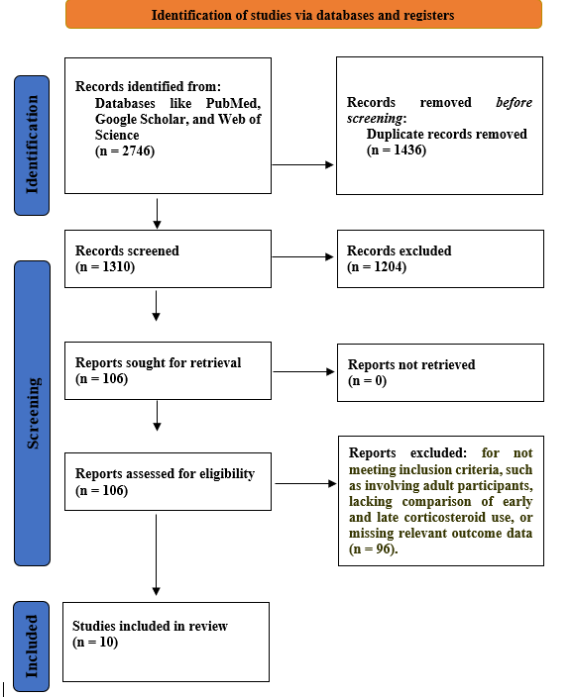

Figure 1: PRISMA Flowchart.
3.2 Characteristics of the included studies
This systematic review involved 10 studies published in the last 12 to 24 years, which consisted of retrospective cohort studies, prospective cohort studies, quality improvement (QI) initiatives, and multicenter observational trials (Table 3). The trials were on pediatric patients aged between 2 and 21 years and having moderate to severe asthma attacks. The number of participants was between 205 and 3,192, with 10,811 being the number of observations used in the studies. Interventions included early corticosteroid administration within the first 60 minutes of ED arrival; the drugs used included oral prednisolone, dexamethasone, and inhaled corticosteroids, and the comparison and control groups were delayed corticosteroid treatment (after 60 minutes) and no treatment. Outcome measures were diverse but shared many similarities, such as length of stay (LOS) in the EDs, hospital admissions, speed at which corticosteroid was administered, and asthma severity. The treatment periods were between one intervention (that is, a single corticosteroid administration) and continuing treatment procedures and sessions in the ED. Although the majority of studies have reported the positive effect of initial corticosteroid on the treatment outcomes, including reduced ED LOS and lower hospitalization rates, a variety of studies demonstrated inconsistent responses, specifically with respect to admission rates or ED readmission rates.

Author | Study Design | Population (Age Group) | Intervention (I) | Comparison (C) | Outcomes (O) | Key Findings
Davis et al. [21] | Retrospective cohort study | 882 children aged 2–18 years with acute asthma exacerbations presenting to a pediatric ED | Early corticosteroid administration within 60 minutes of triage using oral prednisolone or dexamethasone | Corticosteroid administration after 60 minutes | Primary: Length of stay (LOS) in ED. Secondary: Asthma severity (MPIS), hospital admission, albuterol or corticosteroid treatment, discharge rate | Children treated within 60 minutes had a 25-minute reduction in ED LOS compared with those treated later (p < 0.0001). No significant difference in hospital admission rates.
Bekmezian et al. [22] | Retrospective cohort study | 817 children ≤21 years with moderate to severe asthma exacerbations presenting to a general academic ED | Systemic corticosteroid administration within 60 minutes of ED arrival | Corticosteroid administration after 60 minutes | Primary: Steroid administration time, hospital LOS, ED disposition (admission or discharge). Secondary: ED crowding, factors affecting treatment delays | Median steroid administration time was 108 minutes. Younger age, ED crowding, and severe symptoms such as tachypnea and hypoxia were associated with treatment delays.
Bekmezian et al. [23] | Prospective cohort study with pre- and post-intervention design | 1249 children ≤21 years presenting to a U.S. academic ED with moderate to severe asthma exacerbations | Clinical pathway with early corticosteroid administration within 1 hour, bronchodilators, and NIH asthma guidelines | Pre-pathway period (2006–2011) vs. post-pathway period (2011–2013) | Primary: Proportion receiving corticosteroids within 1 hour, hospital admissions. Secondary: ED LOS, use of chest X-rays, bronchodilator administration | Post-pathway implementation increased corticosteroid use within 1 hour from 18% to 45%, reduced hospital admission from 21% to 13%, and decreased chest X-ray utilization.
Sneller et al. [24] | Prospective quality improvement initiative with Plan-Do-Study-Act cycles | 1775 children aged 1–18 years presenting with acute asthma exacerbations to pediatric EDs | Nurse-initiated oral dexamethasone administration within 60 minutes of ED arrival | Pre-implementation practice | Primary: Percentage receiving steroids within 60 minutes. Secondary: ED LOS, admission rate, ED return rate | Timely steroid administration increased from 59.3% to 84.3%. Mean time to steroid administration decreased from 71.4 minutes to 48.1 minutes. Admission rates decreased by 4.8%, and ED LOS slightly improved for discharged patients.
Desai et al. [25] | Multisite quality improvement pre- and post-study | 881 ED visits and 138 hospital admissions among children aged 2–17 years with asthma | Pediatric asthma pathway emphasizing systemic corticosteroid administration within 60 minutes, clinician education, and electronic order sets | Pre-pathway vs. post-pathway period | Timely corticosteroid administration, ED and hospital LOS, chest X-ray use, antibiotic use, readmission rate | Implementation increased timely corticosteroid administration and improved overall care efficiency, including reduced diagnostic imaging and better adherence to pathway protocols.
Alakeel et al. [26] | Retrospective cohort study | 586 children aged 1–18 years with severe persistent asthma exacerbations | Combination therapy with long-acting beta-agonist and inhaled corticosteroid (Symbicort or Seretide) | Inhaled corticosteroid monotherapy | Primary: Frequency and severity of exacerbations within the previous 4 weeks. Secondary: Oxygen saturation, hospital admission, comorbidities, treatment adherence | Combination therapy reduced exacerbation frequency to 67% compared with 98.5% in the monotherapy group. Moderate to severe exacerbations were lower with combination therapy (84.5% vs. 95.6%).
Kelly et al. [27] | Retrospective cohort study | 252 children aged 2–17 years presenting with asthma exacerbations in a pediatric ED | Standardized oral dexamethasone dosing based on weight ranges | Traditional weight-based dosing | Primary: Return ED visits within 30 days and 31–90 days. Secondary: LOS, hospitalization, intubation, medication discrepancies, safety outcomes | Return visits within 30 days were 31.6% vs. 13.9% (p = 0.58). Return visits within 31–90 days were 3.7% vs. 7.8% (p = 0.16). Standardized dosing showed shorter LOS and less use of ipratropium and magnesium, while hospitalization rates were higher in the weight-based group.
Antonino et al. [28] | Retrospective multicenter observational study | 205 children <18 years presenting with moderate to severe asthma exacerbations to pediatric EDs | Systemic corticosteroid administration within 1 hour of ED arrival | Administration after 60 minutes | Primary: Timing of corticosteroid administration. Secondary: Oxygen therapy duration, hospital LOS, predictors of timely administration | Only 13.7% received corticosteroids within 60 minutes. Delayed administration was associated with longer hospital stay (4 vs. 2 days, p < 0.001) and longer oxygen therapy duration (3 vs. 1 day, p < 0.001).
Fishe et al. [29] | Multicenter observational stepped-wedge trial (quality improvement design) | 834 pediatric patients aged 2–18 years with asthma exacerbation treated by EMS in seven U.S. agencies | Prehospital systemic corticosteroid administration by EMS personnel | Corticosteroid initiation after hospital arrival | Primary: Hospital admission rate. Secondary: ED LOS, steroid use timing, severity indicators | Prehospital steroid use increased to 14.7%–28.1% after protocol introduction. No significant reduction in admission or ED LOS. Early administration was feasible and safe but had limited impact on outcomes.
Kramer et al. [30] | Quality improvement initiative with pre- and post-design | 3192 children >2 years presenting with asthma exacerbations to a pediatric ED | Nurse-driven early oral dexamethasone administration within 60 minutes | Pre-intervention practice | Primary: Time from ED arrival to corticosteroid administration. Secondary: ED LOS, admission rate, discharge rate | Median time to dexamethasone administration decreased from 59 minutes to 38 minutes after implementation. Admission rates remained unchanged, while ED LOS increased slightly due to higher patient volumes.
Table 3: Characteristics and Key Findings of Included Studies.

3.3 Quality assessment
3.3.1 Risk of Bias
The quality evaluation of the studies included in the given meta-analysis as provided in the given Figure 2 shows that the risk of bias through most of the domains is generally low. The majority of the studies, such as Davis et al. [21], Bekmezian et al. [22], and Sneller et al. [24], had low risk (green) most of the domains, especially in the domains of outcome reporting, adequacy of the follow-up, and selection bias (D1, D4, D7). This implies that these researches have solid methodologies and high internal validity, an element that justifies the accuracy of their results [31]. Nevertheless, some points of concern could be found in a few studies. As an example, Domain 2 (D2), which is concerned with deviations in planned interventions, was identified with a high risk of bias (red) in Bekmezian et al. [23] and Kelly et al. [27]. This implies that there were the possible problems of protocol adherence or the differences in the implementation of the treatment, which can impact the internal validity and reliability of the studies. Moreover, Alakeel et al. [26] has received a yellow (unclear) rating in various domains, such as D1 (selection bias), and it might be assumed that the study left out or was not clear enough to determine its overall quality [32] (Table 4).
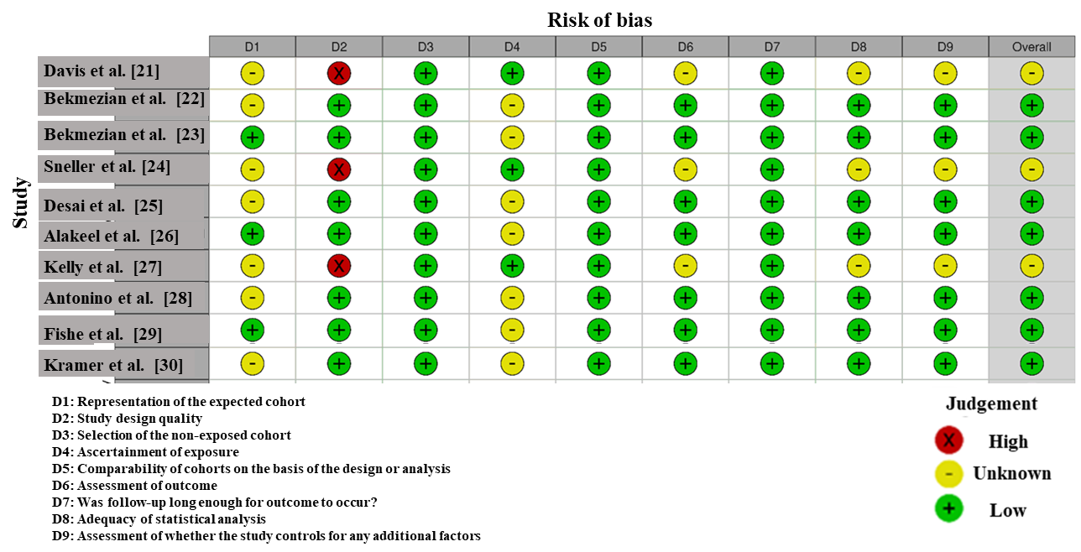

Figure 2: Intra-review bias assessment using NOS.

3.3.2 Publication Bias
Figure 3 below is a funnel plot that gives an evaluation of publication bias in the current meta-analysis. The data points which consist of the individual studies are used to generate the plot, with each point being the effect size and standard error. The asymmetry in the plot is moderate, with a number of studies moving towards the right. This implies that small studies that are bigger in their effects will be published more, which could cause publication bias. Such asymmetry generally suggests that smaller studies that do not have significantly found anything or have negative findings are not reported or published [33,34]. Additional support on the possible publication bias is presented in the regression analysis by Egger, whose slope is significant (p = 0.009) (Table 5). The intercept of 0.71 and slope as 0.34 with the p-value of 0.009 indicate that it has a little-study effect, which supports the idea that the data has been publication-biased. The heterogeneity statistics demonstrate that there is significant variation of studies with I² = 93.10% being the proportion of the variation in the study outcomes that can be attributed to significant differences rather than randomness. Missing studies were estimated by the trim-and-fill method and used to correct the possible bias. After this re-calculation, a new effect size was found which is more precise as an indicator of the overall effect of the treatment.

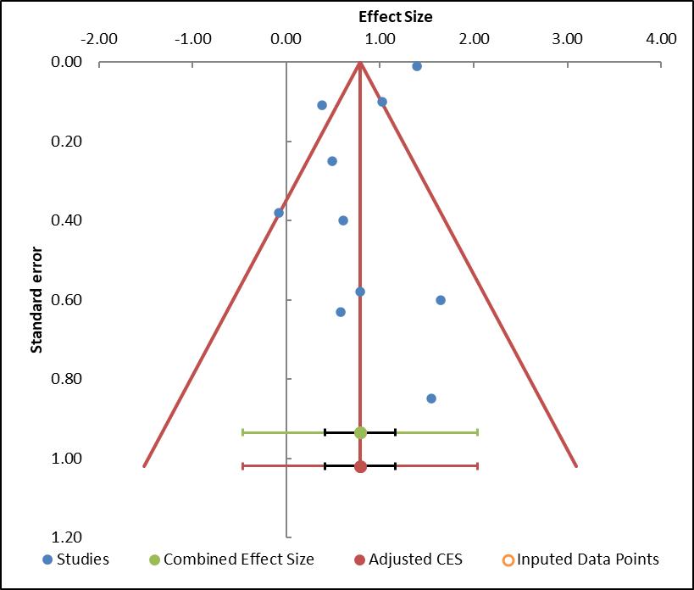

Figure 3: Funnel plot measuring publication bias in the studies.

Meta-Analysis model
Study name | Effect size | Standard error (z)
Davis et al. [21] | 0.79 | 0.58
Bekmezian et al. [22] | 0.61 | 0.40
Bekmezian et al. [23] | 1.65 | 0.60
Sneller et al. [24] | 1.02 | 0.10
Desai et al. [25] | -0.08 | 0.38
Alakeel et al. [26] | 1.39 | 0.01
Kelly et al. [27] | 1.55 | 0.85
Antonino et al. [28] | 0.38 | 0.11
Fishe et al. [29] | 0.58 | 0.63
Kramer et al. [30] | 0.49 | 0.25
Combined effect size
Correlation (z) | Observed
Correlation | 0.79
SE (z) | 0.17
CI Lower limit | 0.41
CI Upper limit | 1.17
PI Lower limit | -0.46
PI Upper limit | 2.04
Heterogeneity
Q | 130.38
p_{Q} | 0.000
I² | 93.10%
T² | 0.28
T | 0.53

Table 4: Information related to funnel plot.

Egger Regression
 | Estimate | SE | CI LL | CI UL
Intercept | 0.71 | 1.38 | -2.42 | 3.83
Slope | 0.34 | 0.90 | -1.69 | 2.36
t test | 0.51 | Not applicable | Not applicable | Not applicable
p-value | 0.622 | Not applicable | Not applicable | Not applicable

Table 5: Egger Regression.

3.3.3 Forest plot
Figure 4 shows the individual and pooled effect size of ten studies that utilized the effects of early versus late corticosteroid treatment on the effect on machine asthma in children. The meta-analysis resorts to a random-effects model so that the heterogeneity among the studies is taken into consideration. The aggregate effect size is 0.79 with confidence interval of -0.35 to 1.93, a moderate positive effect, which implies that there could be a positive effect on the length of stay (LOS) and hospital admissions rates as a result of early corticosteroid administration. The broad confidence interval however, does indicate high level of variability with some of the studies indicating no significant effect. In the single studies, Bekmezian et al. [22] demonstrated the most significant positive impact (effect size = 1.65), which shows the significant advantage of receiving corticosteroids early in terms of reducing the number of admissions and LOS. Desai et al., in their turn, showed a close to zero effect (effect size = -0.08), which suggests the possible inefficacy in some settings or patient populations. The analysis by Miiyoka et al. demonstrated the positive impact with a lesser weighting meaning that its contribution to the overall outcome was less even though it seemed to be advantageous to a particular group. On the whole, the forest plot shows the positive outcomes of early corticosteroid administration but the wide range of variability among the studies indicates the necessity to conduct additional studies to prove these results [35,36].

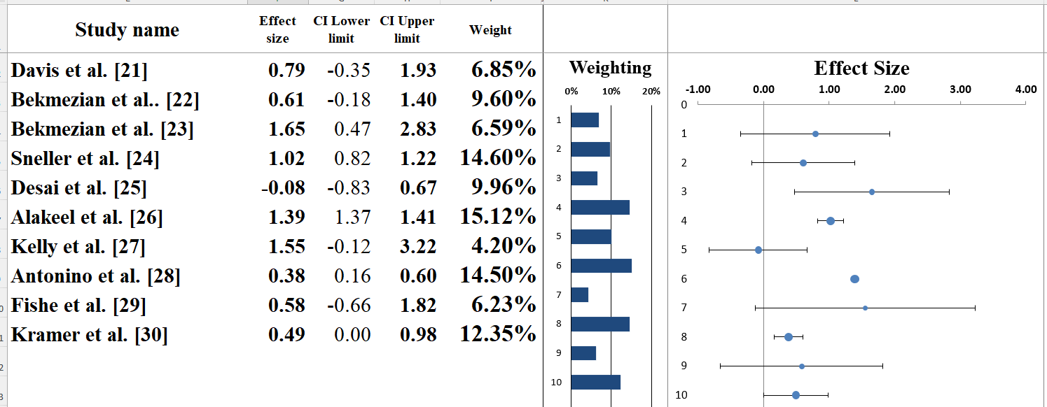

Figure 4: Displays a forest plot exemplifying the Effect size estimates from each study.

Meta-analysis model
Effect Size | 0.79
Standard error | 0.17
Confidence interval LL | 0.41
Confidence interval UL | 1.17
Prediction interval LL | -0.46
Prediction interval UL | 2.04
Z-value | 4.72
One-tailed p-value | 0.000
Two-tailed p-value | 0.000
Number of incl. subjects | 10811
Number of incl. studies | 10
Heterogeneity
Q | 130.08
p_{Q} | 0.000
I² | 93.10%
T² (z) | 0.28
T (z) | 0.53

Table 6: Information correlated with Forest plot.

3.4 Heterogeneity Assessment
In order to determine the variability among the studies, the heterogeneity measures were computed, Cochran Q, I ². Based on the output of the forest plot, the Cochran Q value was 130.28 and the p-value is less than 0.001, showing that the heterogeneity of the studies is statistically significant and not probable caused by chance (Table 6). This finding indicates that actual dissimilarity exists among the researches that are incorporated in the analysis, which may be because of dissimilarity in study design, population, or treatment regimens. The amount of the I² was 93.10, which means that the cumulative deviation of the research findings can be explained by actual heterogeneity, as opposed to random error. Since an I² greater than 75 means a high level of heterogeneity, the large value reveals the presence of important differences in the studies, which implies variability in the treatment procedures, dosage, and outcome measures. The τ² (squared tau) index, the between-study variance in a random-effects model, was found to be 0.55, establishing the fact that there is a significant variability, more than would be due to chance. These findings support the necessity of addressing the factors of heterogeneity, including the variation of samples size, the time of intervention, and the specifics of patients. Although this is varied, the general meta-analysis is positive in terms of pooled effect albeit with more sensitivity analysis or subgroup analysis would help in elucidating the causes of this heterogeneity [37,38].

3.5 Subgroup analysis
According to the subgroup analysis of the forest plot (Figure 5), the studies are classified into two groups including Group AA and BB which is, probably, due to the differences in the nature of studies, most probably, in the treatment regimes or the selection of patient population [39]. The pooled effect size of Group AA including such studies in Davis et al. [21], Bekmezian et al. [22], and Kramer et al. [30] is 0.76 (95% CI: 0.37 to 1.15) suggesting that there is a moderate effect of early corticosteroid use on asthma outcomes (e.g. length of stay (LOS), hospitalization) [95% confidence interval (CI): 0.37 to 1.15]. Group AA is very heterogeneous with an I2 = 73.73, Q = 22.84 and p = 0.001 which means that it is very varied. The high heterogeneity could be attributed to the factors such as variation in treatment time, asthma exacerbations severity or procedures in the hospital. The prediction interval (PI) of this group is +-0.20 and +-1.72, which shows much uncertainty concerning the actual effect in future research.

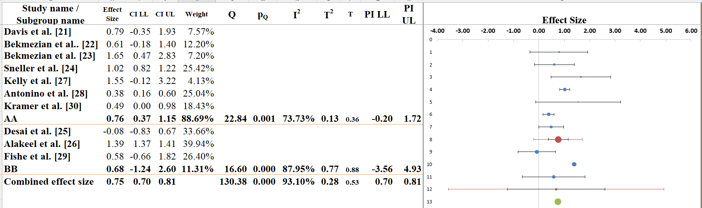
Figure 5: Subgroup analysis of studied papers which considered effect sizes of early and late corticosteroid use in asthma exacerbations among children, stratified by study features (e.g. study design, patient severity and study protocols).

Group BB, on the other hand, comprising of studies, such as Desai et al. [25] and Fishe et al. [29] has a significantly smaller pooled effect size of 0.68 (p= -1.24-2.60). The heterogeneity of this group is characterized as moderate and I2 = 87.95, Q = 16.60 and p = 0.000 indicate that the effect is more consistent within the studies and the variability is still significant. The PI is between -3.56 and 0.70 and it covers the null effect, which shows the results are mixed in the studies. The subgroup analysis indicates that there is a statistically significant difference in the groups (p = 0.005), It can be concluded that the difference in the effect size can be caused by differences in the study design or the patient characteristics (including the severity of asthma or the type of therapy). The implication of this observation is that such factors should be given significant attention when evaluating the efficacy of treatment in the management of asthma in children as well as informing future research and clinical practice [36]. (Table 7)

Meta-analysis model
Effect size | 0.75
Standard Error | 0.03
Confidence interval LL | 0.70
Confidence interval UL | 0.81
Prediction interval LL | 0.70
Prediction interval UL | 0.81
Number of incl. subjects | 10811
Number of subgroups | 2
Analysis of variance
Between / Model (Q*) | 0.02
Between / Model (Df) | 1
Between / Model (P) | 0.891
Within / Residual (Q*) | 5.62
Within / Residual (Df) | 8
Within / Residual (P) | 0.689
Total (Q*) | 5.64
Total (Df) | 9
Total (P) | 0.775
Pseudo R² | 0.33%

Table 7: Information related to Sub-group analysis.

3.6 Narrative analysis
This is a systematic review that explored 10 studies that determined the effects of early and late corticosteroid use in exacerbation of asthma in children. The papers also incorporated a combination of retrospective cohort, prospective cohort, quality improvement (QI) programs, and multicenter observational trials that can give a general picture of the treatment results in the real-world and clinical settings.

3.7 Clinical Outcomes
In the studies, the early administration of corticosteroids was found to be mostly correlated to better clinical outcomes. Indicatively, Davis et al. [21] and Bekmezian et al. [22] concluded that the length of stay (LOS) in the emergency department (ED) decreased significantly with early administration of corticosteroids with Davis et al. showing a 25-minute LOS reduction in patients attended to within 60 minutes. Equally, Sneller et al. [24] and Kramer et al. [30] have found that increased speed in the administration of corticosteroids led to early treatment and fewer hospitalizations. This evidence indicates that early intervention can assist in stabilizing the patients faster and minimize the need to spend long durations in the hospitals.

3.8 Hospital Admission and Readmission Rates
A number of studies such as Bekmezian et al. [23] and Desai et al. [25] have found that there was a decrease in hospital admissions after the initial treatment with corticosteroids. Desai et al. [25] pointed to the reduction of hospitalization by 21 to 13 percent after the intervention, whereas Bekmezian et al. [22] reported that the early administration of corticosteroids significantly decreased the possibility of patients receiving intensive care, which proves its beneficial influence on their recovery. Kelly et al. [27] however, did not find any significant difference in readmission rates between standardized and weight-based dosing strategies, implying that alternative variables, i.e., patient characteristics or the severity of asthma, may affect long-term outcomes.

3.9 Treatment Protocols and Practical Application
The studies which were comprised in this review differed in their timing and protocol of corticosteroids administration in terms of intervention strategy. The protocols applied by Alakeel et al. [26] and Kramer et al. [30] were focused on nurse-led systems and quality improvement programs and were effective in enhancing compliance with early treatment guidelines. The above findings support the relevance of standardized pathways in timely treatment.

3.10 Impact on Healthcare Systems
The findings of Fishe et al. [29] indicate that it was possible and safe to implement the early administration of corticosteroids in a pre-hospital environment (e.g., through Emergency Medical Services), but the effect was small on hospital admission or ED LOS. It underlines the fact that early intervention can probably enhance the timeliness of the treatment, but its impacts on the outcomes at large might be under the influence of such factors as severity of a patient and the hospital capacity.

4. Discussion
The purpose of this systematic review was to compare the impact of early versus late corticosteroid use in asthma exacerbation in children, most of the researches included in this review had positive outcomes of timely treatment [40]. The administration of corticosteroid early was constantly linked to better outcomes in length of stay (LOS) in the emergency department (ED), the reduction of hospitalization, and the speed of symptom management. The findings corroborate the existing guidelines that promote timely intervention in the acute asthma attacks [41].

Some of the researches such as Davis et al. [21] and Sneller et al. [24] also highlighted the significance of corticosteroid administration during the initial hour of ED visit, which showed a substantial decrease in both ED stay and hospitalization [42]. These findings are in line with other reviews and guidelines, which also indicate that early steroid treatment is a significant issue in enhancing the clinical outcome of children with asthma exacerbation. The importance of applying structured clinical pathways that facilitate prompt treatment of asthma was also demonstrated by Bekmezian et al. [23], and it fits the general trend in the sphere of managing asthma among children [43].
Our results are consistent with the results of Desai et al. [25], who reported substantial falls in unnecessary diagnostic tests and higher levels of treatment compliance of the introduction of standardized treatment regimes [44]. Likewise, Kelly et al. [27] and Fishe et al. [29] also supported the significance of following the early treatment protocols but reported that some treatments, like weight-based dosing, were not as beneficial as others.

This review is more convincing as compared to past researchers and systematic reviews of the research in terms of supporting early corticosteroids use to reduce hospital admissions and ED stay. Other reviews including the ones conducted by Puranik et al. [45] indicated that the advantages of early treatment were limited, particularly in terms of long-term outcomes. But we find improved short-term returns, particularly in environments where there are well structured care pathways. Such findings are strong arguments supporting the idea that corticosteroid early intervention should be viewed as the standard of care in asthma attacks in children, and the problem requires further investigation to examine long-term effects and improve the treatment regimens.

5. Limitations
This systematic review is faced with a number of limitations even though the results are positive. The generalizability of the results, first, may be limited by the heterogeneity of the studies, i.e., the differences in design of the studies, patient populations, and corticosteroid treatment regimes. The findings of most of the studies were positive, but the variation in timing of treatment, source and dosage of corticosteroids in various studies complicates the ability to draw conclusions on the best method to use in treating early. Also, certain studies were observational in nature and were included in this review and this heightens the chances of bias and makes it difficult to make causal associations. It also had limited coverage on long-term follow-ups such as readmission rates or chronic asthma care and this would be useful in determining the long-term outcomes of early corticosteroid use. Finally, the findings may have been biased by publication bias where studies reporting strong positive effect are more apt to be published giving a false perception of the actual effect of early treatment.

6. Future Research
Future studies ought to concentrate on the standardization of the treatment regimens in relation to the early corticosteroid administration in asthma exacerbations in children. Multi-center, large, randomized controlled trials (RCTs) are required in comparison of various types of corticosteroids, its doses, and route of administration to identify the most effective mode of administration. Also long-term effects, including readmission rates, asthma management on chronic basis, and quality of life, should be investigated in order to determine the long-term effectiveness of early corticosteroids. The cost-efficiency of early corticosteroid administration should also be explored in research to inform the healthcare policy and the allocation of resources. In addition, the intervention in the pre-hospital stage, e.g., corticosteroid use by emergency medical services (EMS), should be studied to assess whether pre-hospital interventions allow a decrease in hospitalization rates and an increase in clinical outcomes. Last but not the least, patient characteristics, such as age, asthma severity, and comorbidities, should be examined in order to find subgroups that could be served best through early intervention.

7. Conclusions
The article is a systematic review and meta-analysis that is well-supported to prove the usefulness of early corticosteroid use in asthma exacerbations in children. The results are in line with each other, showing that early corticosteroid intervention, which is carried out within the first 60 minutes of arrival at the emergency department (ED) better results in improved clinical outcomes, including shorter ED length of stay (LOS) and fewer hospital admissions. The benefits of early intervention were found with a variety of study designs, such as retrospective cohort studies, prospective cohort studies, and quality improvement programs. A majority of the studies emphasized the fact that early treatment resulted in the rapid resolution of symptoms, which minimized the length of stay in the ED and additional medical care. Although the findings are encouraging, the fact that the studies vary significantly with regards to the population of patients, treatment regimens, and the healthcare environment implies that further studies are required to tighten the treatment regimens and maximize the use of corticosteroids in the initial phases. The variability in this review points to the need to have standardized protocols so as to provide excellent and consistent treatment. The future researches must concentrate on the long-term results, cost-efficiency, and the effects of pre-hospital treatment with corticosteroids. Finally, the early corticosteroid therapy can be suggested as the standard of care concerning the asthma exacerbation in children, and the further attempts should be made to improve the treatment process and to investigate the further implication of this treatment on the health and medical care of patients.

References
- Merhej T, Zein JG. Epidemiology of asthma: prevalence and burden of disease. Adv Exp Med Biol 1426 (2023): 3-23.
- Pardue Jones B, Fleming GM, Otillio JK, et al. Pediatric acute asthma exacerbations: evaluation and management from emergency department to intensive care unit. J Asthma 53 (2016): 607-17.
- Pu X, Liu L, Feng B, et al. Efficacy and safety of different doses of systemic corticosteroids in COPD exacerbation. Respir Care 66 (2021): 316-26.
- Hu HS, Wang Z, Zhao LM, et al. Nebulized corticosteroids versus systemic corticosteroids for patients with acute exacerbation of chronic obstructive pulmonary disease: a systematic review and meta-analysis comparing the benefits and harms reported by observational studies and randomized controlled trials. Front Pharmacol 13 (2022): 966637.
- Melani AS, Croce S, Cassai L, et al. Systemic corticosteroids for treating respiratory diseases: less is better, but… when and how is it possible in real life? Pulm Ther 9 (2023): 329-44.
- Srivali N, De Giacomi F, Moua T, et al. Corticosteroid therapy for treating acute exacerbation of interstitial lung diseases: a systematic review. Thorax 80 (2025): 140-9.
- Ramgopal S, Naik VV, Komukai S, et al. The association of prehospital systemic corticosteroids with emergency department and in-hospital outcomes for patients with asthma exacerbations. Acad Emerg Med 31 (2024): 675-87.
- Abaya R, Jones L, Zorc JJ. Dexamethasone compared to prednisone for the treatment of children with acute asthma exacerbations. Pediatr Emerg Care 34 (2018): 53-8.
- Alqarni MA, Elzayat KA, Alqathama BR, et al. Asthma in children: principles of diagnosis and management. Rev Diabet Stud (2025): 423-31.
- Ahmad A. Pharmacological strategies and recent advancement in nano-drug delivery for targeting asthma. Life (Basel) 12 (2022): 596.
- Hay AD, Little P, Harnden A, et al. Effect of oral prednisolone on symptom duration and severity in nonasthmatic adults with acute lower respiratory tract infection: a randomized clinical trial. JAMA 318 (2017): 721-30.
- Mokra D, Mikolka P, Kosutova P, et al. Corticosteroids in acute lung injury: the dilemma continues. Int J Mol Sci 20 (2019): 4765.
- Cotter JM, Tyler A, Reese J, et al. Steroid variability in pediatric inpatient asthmatics: survey on provider preferences of dexamethasone versus prednisone. J Asthma 57 (2020): 942-8.
- Sekler O, Segev-Becker A, Interator H, et al. Paediatricians' practices and knowledge of corticosteroids: a national survey. Acta Paediatr 110 (2021): 711-7.
- Navanandan N, Moran E, Smith H, et al. Primary care provider preferences for glucocorticoid management of acute asthma exacerbations in children. J Asthma 58 (2021): 547-53.
- Briganti DF, D'Ovidio F. Long-term management of patients with end-stage lung diseases. Best Pract Res Clin Anaesthesiol 31 (2017): 167-78.
- Dahan E, El Ghazal N, Nakanishi H, et al. Dexamethasone versus prednisone/prednisolone in the management of pediatric patients with acute asthmatic exacerbations: a systematic review and meta-analysis. J Asthma 60 (2023): 1481-92.
- Luchini C, Stubbs B, Solmi M, et al. Assessing the quality of studies in meta-analyses: advantages and limitations of the Newcastle-Ottawa Scale. World J Meta-Anal 5 (2017): 80.
- Lin L, Chu H, Murad MH, et al. Empirical comparison of publication bias tests in meta-analysis. J Gen Intern Med 33 (2018): 1260-8.
- Afonso J, Ramirez-Campillo R, Clemente FM, et al. The perils of misinterpreting and misusing publication bias in meta-analyses: an education review on funnel plot-based methods. Sports Med 54 (2024): 257-69.
- Davis SR, Burke G, Hogan E, et al. Corticosteroid timing and length of stay for children with asthma in the emergency department. J Asthma 49 (2012): 862-7.
- Bekmezian A, Fee C, Bekmezian S, et al. Emergency department crowding and younger age are associated with delayed corticosteroid administration to children with acute asthma. Pediatr Emerg Care 29 (2013): 1075-81.
- Bekmezian A, Fee C, Weber E. Clinical pathway improves pediatrics asthma management in the emergency department and reduces admissions. J Asthma 52 (2015): 806-14.
- Sneller H, Keenan K, Hoppa E. A quality improvement initiative to improve the administration of systemic corticosteroids in the pediatric emergency department. Pediatr Qual Saf 5 (2020): e308.
- Desai M, Caldwell K, Gupta N, et al. Effectiveness of pediatric asthma pathways in community hospitals: a multisite quality improvement study. Pediatr Qual Saf 5 (2020): e355.
- Alakeel YS, Khader E, Altuwayli N, et al. An assessment of asthma exacerbations in pediatric patients using a long-acting β2-agonist plus inhaled corticosteroid versus an inhaled corticosteroid alone. Saudi Pharm J 30 (2022): 300-5.
- Kelly IR, Laudone T, Lichenstein R, et al. Evaluation of dexamethasone dosing strategies in pediatric asthma exacerbations. J Pediatr Pharmacol Ther 28 (2023): 735-40.
- Antonino L, Goossens E, van Olmen J, et al. Managing pediatric asthma exacerbations: the role of timely systemic corticosteroid administration in emergency care settings—a multicentric retrospective study. Children (Basel) 11 (2024): 164.
- Fishe JN, Garvan G, Bertrand A, et al. Early administration of steroids in the ambulance setting: an observational design trial (EASI-AS-ODT). Acad Emerg Med 31 (2024): 49-60.
- Kramer AW, Erlich J, Yaphockun K, et al. Reducing time from pediatric emergency department arrival to dexamethasone administration in wheezing patients. Pediatr Qual Saf 9 (2024): e738.
- Minozzi S, Cinquini M, Gianola S, et al. The revised Cochrane risk of bias tool for randomized trials (RoB 2) showed low interrater reliability and challenges in its application. J Clin Epidemiol 126 (2020): 37-44.
- Andrews I, Kasy M. Identification of and correction for publication bias. Am Econ Rev 109 (2019): 2766-79.
- Higgins JP, Savović J, Page MJ, et al. Assessing risk of bias in a randomized trial. In: Higgins JPT, Thomas J, Chandler J, et al., editors. Cochrane Handbook for Systematic Reviews of Interventions. 2nd ed. (2019): 205-28.
- Carra MC, Romandini P, Romandini M. Risk of bias evaluation of cross-sectional studies: adaptation of the Newcastle-Ottawa Scale. J Periodontal Res (2025).
- Favorito LA. Systematic review and meta-analysis in urology: how to interpret the forest plot. Int Braz J Urol 49 (2023): 775-78.
- Zhang Z, Kossmeier M, Tran US, et al. Rainforest plots for the presentation of patient-subgroup analysis in clinical trials. Ann Transl Med 5 (2017): 485.
- Schulzke S. Assessing and exploring heterogeneity. In: Principles and Practice of Systematic Reviews and Meta-analysis. Springer (2021): 33-41.
- Feczko E, Fair DA. Methods and challenges for assessing heterogeneity. Biol Psychiatry 88 (2020): 9-17.
- Sun X, Ioannidis JP, Agoritsas T, et al. How to use a subgroup analysis: users' guide to the medical literature. JAMA 311 (2014): 405-11.
- Ramadan AA, Gaffin JM, Israel E, et al. Asthma and corticosteroid responses in childhood and adult asthma. Clin Chest Med 40 (2019): 163-77.
- Pełka K, Buzun WH, Dudek J, et al. Exacerbation of asthma among pediatric patients presenting to the emergency department. J Clin Med 14 (2025): 8187.
- Hemani SA, Glover B, Ball S, et al. Dexamethasone versus prednisone in children hospitalized for acute asthma exacerbations. Hosp Pediatr 11 (2021): 1263-72.
- Sawanyawisuth K, Chattakul P, Khamsai S, et al. Role of inhaled corticosteroids for asthma exacerbation in children: an updated meta-analysis. J Emerg Trauma Shock 13 (2020): 161-66.
- Puranik S, Forno E, Bush A, et al. Predicting severe asthma exacerbations in children. Am J Respir Crit Care Med 195 (2017): 854-59.
- O'Byrne P, Fabbri LM, Pavord ID, et al. Asthma progression and mortality: the role of inhaled corticosteroids. Eur Respir J 54 (2019): 1900491.


This article is an open-access article distributed under the terms and conditions.
Creative Commons Attribution (CC-BY) license 4.0

