

Case Report

Transarticular High-Grade Conventional Chondrosarcoma of the Hip Mimicking a Cystic Intra-Articular Lesion: Diagnostic Challenge in Determining Osseous Origin

Amara Ahmed*, Diego A L Garcia
University of Florida, Department of Radiology, Gainesville, FL, USA

*Corresponding Author: Amara Ahmed, University of Florida, Department of Radiology, Gainesville, FL, USA

Received: 17 March 2026; Accepted: 23 March 2026; Published: 31 March 2026

Citation: Amara Ahmed, Diego A L Garcia. Transarticular High-Grade Conventional Chondrosarcoma of the Hip Mimicking a Cystic Intra-Articular Lesion: Diagnostic Challenge in Determining Osseous Origin. Journal of Radiology and Clinical Imaging 9 (2026): 29-32.

Abstract
High-grade conventional chondrosarcoma usually demonstrates chondroid matrix and solid enhancement, but atypical variants may resemble benign intra-articular cystic lesions. A 45-year-old man presented with acute hip pain and was found to have destructive lytic lesions of the femoral head and acetabulum with a large minimally enhancing intra-articular mass. Cystic morphology obscured the tumor’s origin, raising concern for synovial pathology. Biopsy confirmed high-grade chondrosarcoma with permeative medullary invasion. This case illustrates that aggressive osseous changes warrant biopsy even when imaging features appear deceptively benign.

Keywords: Chondrosarcoma; Femoral head; Acetabulum; Cystic intra-articular lesion; Musculoskeletal imaging; Bone tumor

1. Introduction
Conventional chondrosarcoma is a malignant cartilage-producing bone tumor that typically arises in the metaphysis or diaphysis of long bones in middle-aged and older adults. Characteristic imaging features include chondroid matrix mineralization, endosteal scalloping, and internal septal or nodular enhancement on MRI [1,2]. Epiphyseal involvement is distinctly uncommon, and primary acetabular origin is rare [2,3]. High-grade conventional chondrosarcoma exhibits aggressive permeative growth and a significant risk of recurrence and metastasis [1,4]. Atypical presentations may lack matrix mineralization or solid enhancement and instead demonstrate cystic morphology with intra-articular extension, mimicking benign synovial pathology such as ganglion cysts, synovial chondromatosis, or synovial neoplasms [5,6]. These imaging features can obscure the true osseous origin of a malignant lesion. This report describes a high-grade chondrosarcoma involving the femoral head and acetabulum, featuring a minimally enhancing intra-articular mass that closely simulated benign synovial disease.

2. Case Presentation
A 45-year-old man presented with sudden onset of severe left hip pain and inability to bear weight following minor trauma. He denied prior malignancy, constitutional symptoms, or a history of chronic hip discomfort. Pelvic computed tomography performed in the emergency setting revealed a displaced pathologic fracture of the left femoral neck. This fracture was associated with a destructive lytic lesion centered in the femoral head, along with a second lytic defect involving the acetabular roof. Both lesions demonstrated cortical thinning and focal cortical breach, and no chondroid matrix mineralization was identified. A large heterogeneous soft-tissue mass occupied the hip joint space between the femoral head and acetabulum, raising suspicion for an aggressive process (Figure 1).

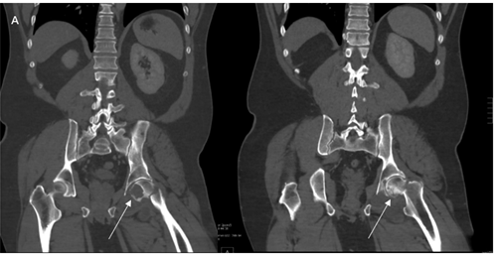
(A)
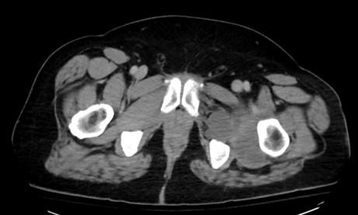
(B)
(C)
Figure 1: Coronal (A) and axial (B, C) CT images demonstrate a displaced pathologic fracture of the left femoral neck associated with a lytic lesion in the femoral head (arrows). A large soft-tissue mass occupies the hip joint space (B, arrow). A second lytic lesion is present on the acetabular roof (C, arrowhead). No chondroid matrix mineralization is identified.

Subsequent MRI further characterized the extent of disease, demonstrating low-to-intermediate T1 and markedly high T2 signal within both osseous lesions. The intra-articular soft-tissue component appeared prominently hyperintense on T2-weighted sequences, imparting a deceptively cystic morphology. Post-contrast fat-suppressed T1-weighted images showed only thin peripheral enhancement without internal nodular or septal enhancement, features that initially suggested benign synovial or cystic pathology despite the destructive appearance of the bone lesions (Figure 2). Given the presence of a pathologic fracture and cortical destruction, malignancy remained a strong concern.

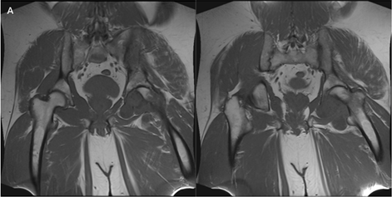
(A)
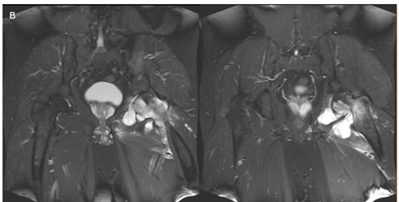
(B)
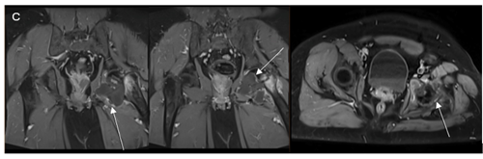
(C)
Figure 2: Coronal T1-weighted (A), T2-weighted (B), and post-contrast fat-suppressed T1-weighted (C) MRI images demonstrate low T1 and high T2 signal within both osseous lesions. A large intra-articular soft-tissue component shows predominantly cystic signal characteristics with only thin peripheral enhancement (arrows).

Comprehensive oncologic staging with whole-body bone scintigraphy and contrast-enhanced CT of the chest, abdomen, and pelvis identified no additional osseous or visceral lesions. Image-guided core needle biopsy was performed for definitive diagnosis. Histopathology revealed a malignant cartilaginous neoplasm composed of hypercellular lobules of hyaline cartilage with nuclear enlargement, hyperchromasia, frequent binucleation, atypical mitoses, and foci of necrosis. There was permeative infiltration of trabecular bone with entrapment and destruction of host lamellar bone, confirming a primary intraosseous malignant process. Prominent myxoid stromal change correlated with the lesion’s markedly T2-hyperintense and minimally enhancing MRI appearance. These findings established the diagnosis of high-grade (grade 3) conventional chondrosarcoma according to WHO criteria.

Following multidisciplinary discussion, the patient underwent wide oncologic resection including partial hemipelvectomy and proximal femoral resection. Reconstruction was performed using a custom proximal femoral arthroplasty. Postoperative radiographs demonstrated appropriate alignment and fixation of the reconstructive hardware (Figure 3).

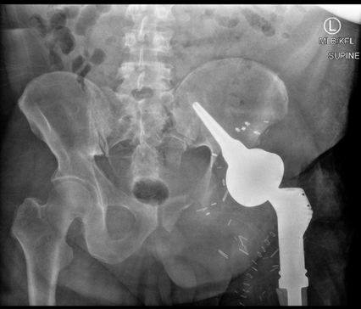

Figure 3: Postoperative anteroposterior radiograph of the pelvis demonstrates partial hemipelvectomy and reconstruction with custom proximal femoral arthroplasty.

3.Discussion
High-grade conventional chondrosarcoma is characterized by aggressive permeative growth and substantial metastatic potential [1,4]. Although it typically arises in the metaphyseal regions of long bones, primary epiphyseal involvement is uncommon, and simultaneous presentation within both the femoral head and acetabulum is especially rare [2,3]. In the present case, the unusual distribution of lesions created significant diagnostic uncertainty and raised the question of the tumor’s true anatomical origin.

The central challenge was determining whether the lesion arose primarily within bone or from a synovial-based process secondarily eroding adjacent structures. The coexistence of lytic lesions in the femoral head and acetabular roof, together with a large intra-articular soft-tissue mass, introduced several plausible diagnostic pathways: a primary femoral head tumor with aggressive transarticular extension, a primary acetabular lesion extending into the femur, or a primary extra-osseous intra-articular neoplasm eroding both articular surfaces. The prominent intra-articular component and relative lack of solid internal enhancement further complicated assessment, as these imaging features closely simulated synovial pathology. The differential diagnosis included benign and malignant synovial processes, including synovial chondromatosis, intra-articular ganglion, and cystic synovial sarcoma [5,6]. The presence of destructive lesions in two adjacent osseous structures also raised the possibility of metastatic disease.

Several key features, however, ultimately supported a primary intraosseous sarcoma with secondary transarticular spread rather than a synovial-based neoplasm. MRI demonstrated clear medullary involvement in both the femoral head and acetabulum, and CT identified cortical permeation at each site which are characteristic of primary bone malignancy. Histopathologic evaluation further revealed permeative trabecular invasion, a hallmark of intraosseous tumor origin. Additionally, systemic staging studies failed to identify distant lesions or an alternative primary malignancy, indicative of a single, contiguous bone tumor rather than multifocal disease.

Conventional chondrosarcomas typically demonstrate internal septal or nodular enhancement reflecting viable tumor cellularity and vascularized fibrous septa [1,2]. In contrast, this lesion displayed only thin peripheral enhancement without internal solid components. The predominantly cystic MRI appearance likely reflected extensive myxoid matrix production and tumor necrosis, both of which can suppress internal enhancement and obscure the aggressive nature of the tumor. Such atypical imaging features increase diagnostic uncertainty and may lead to underestimation of tumor aggressiveness if cortical destruction and marrow involvement are not carefully evaluated.

Multimodality imaging played an essential role in diagnosis. CT was valuable for demonstrating dual cortical destruction and confirming the absence of conspicuous chondroid mineralization. MRI provided superior delineation of marrow replacement and transarticular extension. Comprehensive staging excluded metastatic disease, further supporting a primary aggressive bone sarcoma. Ultimately, this case highlights the critical importance of integrating CT, MRI, and histopathologic correlation when atypical imaging features obscure the lesion’s origin.

4. Conclusion
High-grade conventional chondrosarcoma of the hip can present as dual destructive osseous lesions with a large minimally enhancing intra-articular mass, closely mimicking benign synovial pathology. Recognition of aggressive osseous characteristics—including cortical destruction and medullary invasion—is essential. Biopsy should be pursued in all cases where destructive features are present despite atypical, cystic-appearing imaging morphology.

Reference
- Murphey MD, Flemming DJ, Boyea SR, etal. Imaging of primary chondrosarcoma: radiologic-pathologic correlation. Radiographics 23 (2003): 1245-1278.
- Carrino JA, Murphey MD, Temple HT, et al. Imaging characteristics of conventional and variant chondrosarcomas. Skeletal Radiol 50 (2021): 123-136.
- Anderson SE, Murphey MD. Epiphyseal bone lesions: differentiating benign from malignant. Radiol Clin North Am 52 (2014): 555-572.
- Fletcher CDM, Bridge JA, Hogendoorn P, Mertens F. WHO Classification of Tumours of Soft Tissue and Bone. Lyon: IARC 5th edtn (2020).
- Shimizu J, Emori M, Nagoya S, et al. Chondrosarcoma mimicking MRI of osteonecrosis of the femoral head: a case report. BJR Case Rep 4 (2018): 20170098.
- Papanagiotou P, Karantanas AH, Zibis AH, et al. Clear cell chondrosarcoma of the femoral head: imaging features. Eurorad Case (2015): 2183.


This article is an open access article distributed under the terms and conditions of the
Creative Commons Attribution (CC-BY) license 4.0

